Six Animals – Answer sheet

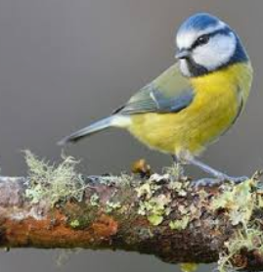 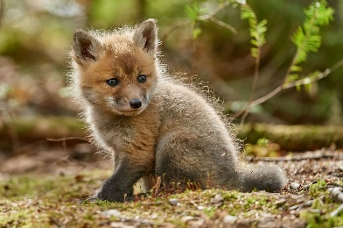 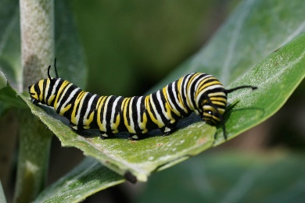 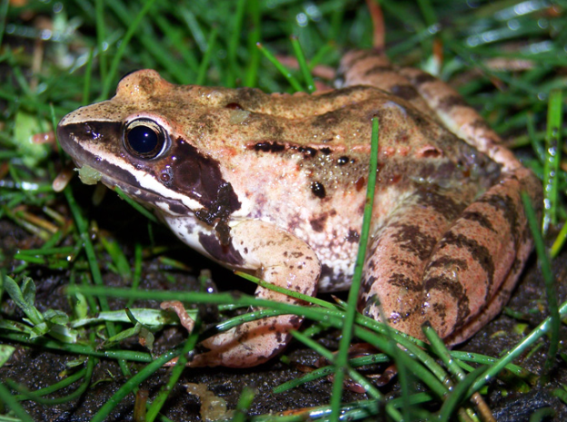 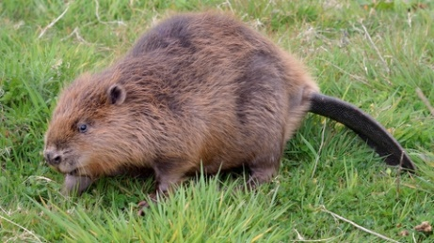 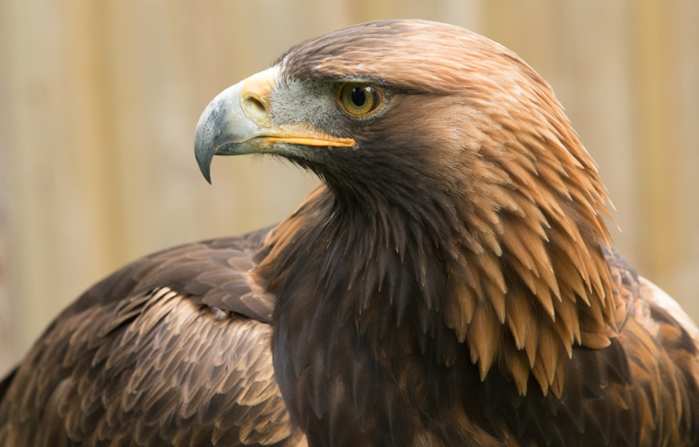

|  |  |  |  |  |
| --- | --- | --- | --- | --- |
| Animal | Picture | Food | Habitat | Footprint |
| Blue Tit |  |  |  |  |
| Fox Cub |  |  |  |  |
| Caterpillar |  |  |  |  |
| Frog |  |  |  |  |
| Beaver |  |  |  |  |
| Golden Eagle |  |  |  |  |