 | 

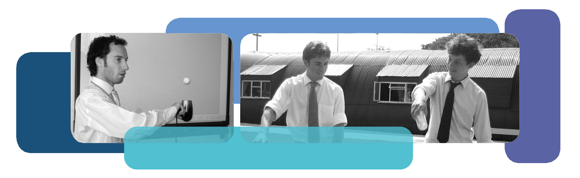
To Infinity and Beyond!

Using Space & Astronomy to Engage, Excite and Extend

Teaching of Mathematics


Saturday 13th March 2010


Centre Parcs, Elveden
IP27 0YZ


Seminar 10am-2pm
With free time afterwards

Lead Practitioner Seminar (Cost £80)
The event will be led by Mr Graham Colman, SSAT Lead Practitioner for Mathematics & Computing and NCETM Ambassador.
The Lead Practitioner network supports the transfer of effective and innovative practice in schools through seminars run by teachers for teachers.

Who should attend?
This event is ideal for all Secondary Maths teachers - from Key Stage 3 through to A Level Mechanics – with any interest in Space, Astronomy or Physics.

Main Content
- Take away many exciting and engaging resources and ideas to extend your students understanding and appreciation of Mathematics
- Satisfy new curriculum developments with real life applications of Mathematics in Space Science.
- Fulfill your Gifted & Talented obligations with exciting investigations and internet supported rich tasks.

☺ Includes Tea, Coffee & Cakes! ☺

Bring friends and family to spend time using the Centre Parcs facilities for the day for just £15 each. (Contact colmangr.staff@wymondhamcollege.org for ‘daypass’ requests.)

For further information:

 | SSAT - 0207 802 0789 |  | colmangr.staff@wymondhamcollege.org
☑ | www.schoolsnetwork.org.uk/lpseminars  Register / login, then use event code / SVN-1009768

