AQA Core 2 Revision Notes

What is not in the formula booklet:

$u_{n+1}=f(u_{n})$ given by $L=f(L)$

Arc length of sector = $rθ$
Area of sector = $\frac{1}{2}r^{2}θ$

$${\text{sin}}^{2}x+{\text{cos}}^{2}x=1$$
$$\text{tan}x=\frac{\text{sin}x}{\text{cos}x}$$
$$\frac{a}{\text{sin}A}=\frac{b}{\text{sin}B}$$
$$\text{Area}=\frac{1}{2}\text{ab}\text{sin}C$$

$$\text{log}\text{ab}=\text{log}a+\text{log}b$$
$$\text{log}\frac{a}{b}=\text{log}a−\text{log}b$$
$$n\text{log}a=\text{log}a^{n}$$

$$\text{log}1=0$$ | $${\text{log}}_{x}x=1$$

Reflection in y axis
Reflection in x axis
← 3 | ↑ 3
→ 3 | ↓ 3
Stretch vertical scale factor 3
Stretch horizontal scale factor$\frac{1}{3}$
$$\frac{d^{2}y}{{\text{dx}}^{2}}<0⇒\text{max}$$
$$\frac{d^{2}y}{{\text{dx}}^{2}}>0⇒\text{min}$$

$$m_{1}m_{2}=−1$$

$$y=a^{x}$$
$$a>1$$ | $$a<1$$
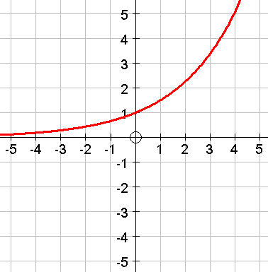 | 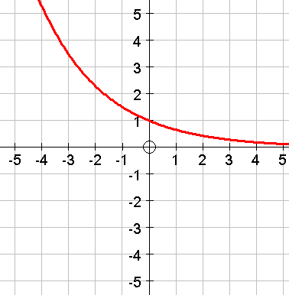

$$\int_{a}^{c}{f(x)\text{dx}=\int_{a}^{b}{f(x)\text{dx}+\int_{b}^{c}{f(x)\text{dx}}}}$$
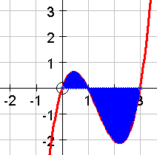

2
2
2
2
2

What is in the formula booklet:

Arithmetic series:
$$u_{n}=a+(n−1)d$$
$$S_{n}=\frac{n}{2}(a+l)=\frac{1}{2}n[2a+(n−1)d]$$

Geometric series:
$$u_{n}={\text{ar}}^{n−1}$$
$$S_{n}=\frac{a(1−r^{n})}{1−r}$$ | $S_{∞}=\frac{a}{1−r}$for $\left|x\right|<1$

$$a^{2}=b^{2}+c^{2}−2\text{bc}\text{cos}A$$

$\int_{a}^{b}{\text{ydx}}≈\frac{1}{2}h\left\{(y_{0}+y_{n})+2(y_{1}+y_{2}+\text{.}\text{.}\text{.}+y_{n−1})\right\}$ where $h=\frac{b−a}{n}$

$(a+b)^{n}=a^{n}+\left(\begin{matrix}n \\ 1\end{matrix}\right)a^{n−1}b+\left(\begin{matrix}n \\ 1\end{matrix}\right)a^{n−2}b^{2}+\text{.}\text{.}\text{.}\text{++}\left(\begin{matrix}n \\ 1\end{matrix}\right)a^{n−r}b^{r}+\text{.}\text{.}\text{.}+b^{n}$ where $\left(\begin{matrix}n \\ r\end{matrix}\right)=C_{r}=\frac{n!}{r!(n−r)!}$

