Essential Notes on AQA Mechanics 1

Newtons Laws of Motion

- Every particle continues in a state of uniform motion unless acted upon by an external force.
- The net force is equal to the rate of change of momentum. $F=\text{ma}$
- Every action has an equal and opposite reaction

Suvat

$$v=u+\text{at}$$ | (no $s$)
$$s=\text{ut}+\frac{1}{2}{\text{at}}^{2}$$ | (no $u$)
$$s=\text{vt}−\frac{1}{2}{\text{at}}^{2}$$ | (no $v$)
$$s=\frac{1}{2}(u+v)t$$ | (no $a$)
$$v^{2}=u^{2}+2\text{as}$$ | (no $t$)

Projectiles

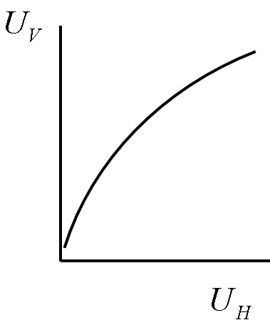

$U_{H}$ acts constantly | $U_{V}$ subject to $g$ms⁻²
Care required with stating which is positive vertical direction.

Friction

$F=μR$ where $0<μ<1$

Equilibrium

Result force equals zero

Principal of Conservation of Momentum

The total momentum in a system before an impact is equal to the total momentum in the system after the impact. $m_{1}v_{1}=m_{2}v_{2}$

Common Modelling Assumptions

Ignore air resistance
Force of gravity acts constantly

Inextensible | ⇒ | no stretching
Thin | ⇒ | no diameter or thickness
Light | ⇒ | no mass
Rigid | ⇒ | no bending
Smooth | ⇒ | no friction
Particle | ⇒ | no size

Vectors

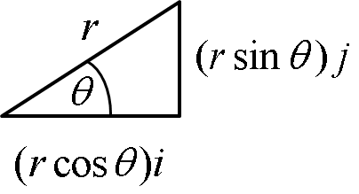

$$r=\text{ai}+\text{bj}$$ | $$\left|r\right|=\sqrt{a^{2}+b^{2}}$$ | $$\text{tan}θ=\frac{b}{a}$$

Pulleys and Tension

