Essential Notes on AQA Mechanics 2

Calculus in Kinematics

Differentiate | Displacement | $$x$$ | $$x$$ | Integrate
 | Velocity | $$v=\frac{dx}{dt}$$ | $$v=\dot{x}$$
 | Acceleration | $$a=\frac{dv}{dt}=\frac{d^{2}x}{dt^{2}}$$ | $$a=\dot{v}=\ddot{x}$$

Note that when $t=0$, $displacement=0$.
When integrating, use initial/boundary conditions to find the $c$ value.

$$r=xi+yj+zk=\left(\begin{matrix}x \\ y \\ z\end{matrix}\right)$$

$$v=\frac{dx}{dt}i+\frac{dy}{dt}j+\frac{dz}{dt}k$$

$$a=\frac{d^{2}x}{dt^{2}}i+\frac{d^{2}y}{dt^{2}}j+\frac{d^{2}z}{dt^{2}}k$$

$$\left|v\right|=\sqrt{{\dot{x}}^{2}+{\dot{y}}^{2}+{\dot{z}}^{2}}$$

Moments (turning forces, torque, Nm)

Anticlockwise = +ve Clockwise = -ve

$$Moment= perpendicular distance×force= \left|F\right|∙d$$

Forces through the pivot exert no moment/torque.

Most problems involve finding resultant (translational) force and resultant moment around one or more points, then using these to determine unknown forces or distances. It is possible to use resultant force and resultant moment to calculate position of resultant moment.

Equilibrium ⇒

resultant moment = 0 | and | resultant force = 0
(no turning effect) |  | (no translational effect)

For a system of three forces to be in equilibrium, lines of action of all three forces will meet at a single point.

Resultant of Parallel Forces…

 | Sum of forces | Sum of moments | E.g.
Equilibrium | 0 | 0 | 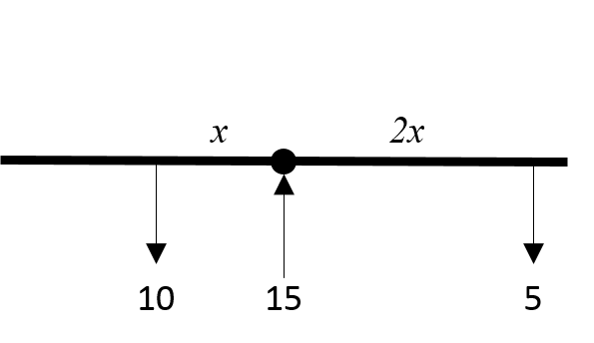
Move and turn | Not zero | Not zero | 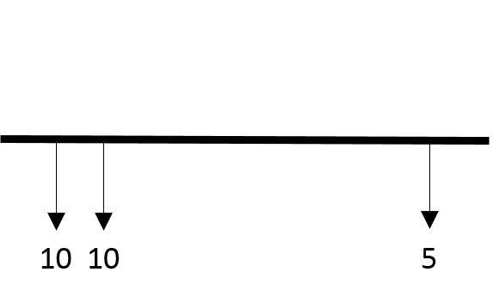
Turn only  (forces are ‘a couple’) | 0 | Not zero | 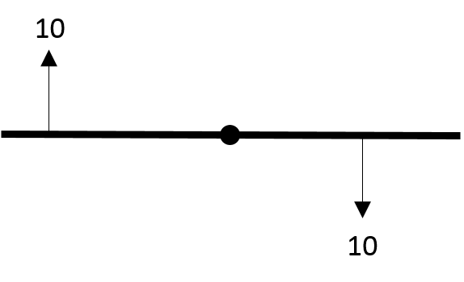

Centre of Mass

$$centre of mass=\overline{R}=\frac{\sum{\left(mass×distance\right)}}{\sum{distances}}=\frac{\sum{mr}}{\sum{r}}≈\frac{\sum{{moments}^{*}}}{\sum{distances}}$$

*ignoring gravity!

- Uniform rod = centre
- Uniform rectangular lamina = centre
- Uniform circular lamina = centre
- Uniform triangular lamina = on median line, vertex: base = 2:1
- Uniform semi-circular lamina = on line of symmetry where $h=\frac{4r}{3π}$

To find centre of mass of composite body, find centre of mass of each composite then find centre of mass of these.

Work, Energy, Power

$work done=W=Fs$
$$GPE=mgh$$
$$KE=\frac{1}{2}mv^{2}$$
(unit is joules where 1j = work required to lift 1kg 1m)

Principle of conservation of energy states that mechanical energy in a closed system remains constant. Therefore any change in energy is due to work done on, or by, the system.

$$power=\frac{dW}{dt}$$
$$Average power=\frac{work done}{t}=\frac{Fs}{t}=Fv$$
(unit is Watts, or kilowatts, where 1w = 1js⁻¹)

Solve problems via the ‘work done’ method or the GPE/KW method. Often useful to consider work done per second as this also equals power.

Elasticity

Hooke’s Law...

$$T=ke$$ | $$T=\frac{λe}{l}$$

$$T=tension \left(N\right)$$
$$k=\text{stiffness} \left(Nm^{-1}\right)$$
$$e=extension \left(m\right)$$
$$λ=modulus of elasticity \left(N\right)$$
$$l=natural length$$

Note that when $e=l$, $T=λ$.

$$work done \left(EPE\right)=\int{T}de=\frac{1}{2}ke^{2}$$ |  | $$work done (EPE)=\int{T}de=\frac{λe^{2}}{2l}$$

$$GPE+KE+EPE=constant$$

Circular Motion

Typical modelling assumptions for circular motion…

- The object is a particle
- Unless told otherwise, the object is moving at uniform speed
- String is light and inextensible
- Air resistance is ignored

Radial | Linear
$$angular speed \left(ω\right)=\frac{dθ}{dt} rad s^{-1}=\frac{2π}{T}$$
 | $$distance travelled (s)=rθ$$
 | $$linear velocity (v)=rω$$

Note that $ω$ here is a constant number and represents a constant angular speed, or a particular angular speed at a specific instant.

$$r=r cosωt i+r sinωt j$$
$$v=-rω sinωt i+rω cosωt j$$
$$a=-rω^{2} cosωt i-rω^{2} sinωt j=-ω^{2}r$$

Note that v is perpendicular to r (ie in direction of travel) and that a is in opposite direction to r (ie towards centre of circle).
$$\left|a\right|={rω}^{2}$$ | $$\left|a\right|=\frac{v^{2}}{r}$$
$$F=m{rω}^{2}$$ | $$F=\frac{mv^{2}}{r}$$
This is known as centripetal force

For conical pendulums, resolve forces horizontally and vertically.

$$θ$$ |  | $$s$$
$$\dot{θ}=ω$$ | $$v=rω$$ | $$\dot{s}=v$$
$$\ddot{θ}=\dot{ω}=α$$ | $$a=rα$$ | $$\ddot{s}=\dot{v}=a$$

$$a=r\ddot{θ}\hat{t}-r{\dot{θ}}^{2}\hat{r}$$

For motion in a vertical circle and non-constant angular velocity problems, use energy equations.

Vertical Circles
The body cannot leave the circle  eg attached to the end of a rod | The body can leave the circle  eg attached to the end of a string, on the inside of loop-the-loop track, on the outside of a circle
If energy is sufficient, the body will rotate the complete circle. | If energy is sufficient, the body will rotate the complete circle.
 | If energy is a little insufficient, the body will reach above horizontal centre of circle, leave the circle and follow a projectile path (to somewhere).
If energy is insufficient, the body will oscillate between two symmetrical points on the circle ($v=0$ at each points as body changes direction) | If energy is very insufficient, the body will remain below horizontal centre of circle and oscillate between two symmetrical points on the circle ($v=0$ at each point as body changes direction)

Differential Equations

$$x$$ | $$v=\frac{dx}{dt}$$ | $$a=\frac{dv}{dt}=\frac{d^{2}x}{dt^{2}}$$

Equations in M2 that could be used in differential equations…

$$F=ma$$
$$F=μR$$
$$P=Fv$$
$$T=ke$$
$$T=\frac{λe}{l}$$
$$T=\frac{mv^{2}}{r}$$
$$T=mrω^{2}$$

