Fractions and Algebraic Fractions

Recap algebra…

$$3x×x=$$ | $$\frac{8x^{2}}{12x}=$$ | $$2x^{2}\left(x+3\right)=$$ | $$\left(x+2\right)\left(x+3\right)=$$ | $$\left(2x+3\right)\left(x-2\right)=$$

Cancelling down fractions…

$$\frac{10}{40}=$$ | $$\frac{27}{63}=$$ | $$\frac{21}{7}=$$ | $$\frac{5}{8}=\frac{?}{24}$$ | $$\frac{24}{40}=\frac{?}{100}$$

Cancelling down algebraic fractions…

$$\frac{10x^{3}}{35x^{2}}=$$ | $$\frac{27x^{2}y^{3}}{18xy^{4}}=$$ | $$\frac{3x^{2}-9x}{2x-6}=$$ | $$\frac{x^{2}+5x+6}{x^{2}+7x+12}=$$ | $$\frac{x^{2}-9}{x^{2}-x-6}=$$

Multiplying fractions…

$$\frac{1}{4}×\frac{3}{5}=$$ | $$\frac{2}{7}×\frac{2}{9}=$$ | $$\frac{2}{7}×\frac{5}{6}=$$ | $$\frac{3}{8}×\frac{4}{9}=$$ | $$\frac{12}{25}×\frac{5}{24}=$$

Multiplying algebraic fractions…

$$\frac{x}{4}×\frac{3x}{5}=$$ | $$\frac{2x}{7}×\frac{2}{x}=$$ | $$\frac{2x^{2}}{7}×\frac{x+1}{6}=$$ | $$\frac{x-1}{8}×\frac{4}{x+1}=$$ | $$\frac{x+2}{x-2}×\frac{x+3}{x+4}=$$

Dividing fractions…

$$\frac{1}{4}÷\frac{3}{5}=$$ | $$\frac{2}{7}÷\frac{2}{9}=$$ | $$\frac{2}{7}÷\frac{5}{21}=$$ | $$\frac{3}{8}÷\frac{9}{16}=$$ | $$\frac{12}{25}÷\frac{12}{35}=$$

Dividing algebraic fractions…

$$\frac{x}{4}÷\frac{3}{5x}=$$ | $$\frac{2x}{7}÷\frac{2}{x}=$$ | $$\frac{x+3}{7}÷\frac{5}{x+4}=$$ | $$\frac{x-1}{8}÷\frac{x+1}{x+2}=$$ | $$\frac{12}{x-1}÷\frac{x-1}{x+2}=$$

Adding and subtracting fractions…

$$\frac{7}{15}+\frac{8}{15}=$$ | $$\frac{2}{7}+\frac{1}{21}=$$ | $$\frac{7}{8}-\frac{1}{6}=$$ | $$\frac{3}{8}+\frac{8}{9}=$$ | $$\frac{5}{7}-\frac{2}{9}=$$

Adding and subtracting algebraic fractions…

$$\frac{3}{x-1}+\frac{2}{x+3}=$$ | $$\frac{2}{x+4}+\frac{1}{x-3}=$$ | $$\frac{x}{x-3}-\frac{2}{x+2}=$$ | $$\frac{2x}{x+2}-\frac{1}{x-2}=$$ | $$\frac{2x+1}{x-2}+\frac{3x}{x+4}=$$

Fractions and Algebraic Fractions - Answers

Recap algebra…

$$3x×x=3x^{2}$$ | $$\frac{8x^{2}}{12x}=\frac{2}{3x}$$ | $$2x^{2}\left(x+3\right)=2x^{3}+6x^{2}$$ | $$\left(x+2\right)\left(x+3\right)=x^{2}+5x+6$$ | $$\left(2x+3\right)\left(x-2\right)=2x^{2}-x-6$$

Cancelling down fractions…

$$\frac{10}{40}=\frac{1}{4}$$ | $$\frac{27}{63}=\frac{3}{7}$$ | $$\frac{21}{7}=3$$ | $$\frac{5}{8}=\frac{15}{24}$$ | $$\frac{24}{40}=\frac{60}{100}$$

Cancelling down algebraic fractions…

$$\frac{10x^{3}}{35x^{2}}=\frac{2x}{7}$$ | $$\frac{27x^{2}y^{3}}{18xy^{4}}=\frac{3x}{2y}$$ | $$\frac{3x^{2}-9x}{2x-6}=\frac{3-x}{2}$$ | $$\frac{x^{2}+5x+6}{x^{2}+7x+12}=\frac{x+2}{x+4}$$ | $$\frac{x^{2}-9}{x^{2}-x-6}=\frac{x+3}{x+2}$$

Multiplying fractions…

$$\frac{1}{4}×\frac{3}{5}=\frac{3}{20}$$ | $$\frac{2}{7}×\frac{2}{9}=\frac{4}{63}$$ | $$\frac{2}{7}×\frac{5}{6}=\frac{10}{42}=\frac{5}{21}$$ | $$\frac{3}{8}×\frac{4}{9}=\frac{12}{72}=\frac{1}{6}$$ | $$\frac{12}{25}×\frac{5}{24}=\frac{1}{10}$$

Multiplying algebraic fractions…

$$\frac{x}{4}×\frac{3x}{5}=\frac{3x^{2}}{20}$$ | $$\frac{2x}{7}×\frac{2}{x}=\frac{4x}{7x}=\frac{4}{7}$$ | $$\frac{2x^{2}}{7}×\frac{x+1}{6}=\frac{2x^{3}+2x^{2}}{42}=\frac{x^{3}+x^{2}}{21}$$ | $$\frac{x-1}{8}×\frac{4}{x+1}=\frac{4\left(x-1\right)}{8\left(x+1\right)}=\frac{x-1}{2x+2}$$ | $$\frac{x+2}{x-2}×\frac{x+3}{2x+3}=\frac{x^{2}+5x+6}{{2x}^{2}+2x-6}$$

Dividing fractions…

$$\frac{1}{4}÷\frac{3}{5}=\frac{5}{12}$$ | $$\frac{2}{7}÷\frac{2}{9}=\frac{9}{7}=1\frac{2}{7}$$ | $$\frac{2}{7}÷\frac{5}{21}=\frac{6}{5}=1\frac{1}{5}$$ | $$\frac{3}{8}÷\frac{9}{16}=\frac{2}{3}$$ | $$\frac{12}{25}÷\frac{12}{35}=\frac{7}{5}=1\frac{2}{5}$$

Dividing algebraic fractions…

$$\frac{x}{4}÷\frac{3}{5x}=\frac{5x^{2}}{12}$$ | $$\frac{2x}{7}÷\frac{2}{x}=\frac{2x^{2}}{14}=\frac{x^{2}}{7}$$ | $$\frac{x+3}{7}÷\frac{5}{x+4}=\frac{x^{2}+7x+12}{35}$$ | $$\frac{x-1}{8}÷\frac{x+1}{x+2}=\frac{x^{2}+x-2}{8x+8}$$ | $$\frac{12}{x-1}÷\frac{x-1}{x+2}=\frac{12x+24}{x^{2}-2x+1}$$

Adding and subtracting fractions…

$$\frac{7}{15}+\frac{8}{15}=\frac{15}{15}=1$$ | $$\frac{2}{7}+\frac{1}{21}=\frac{7}{21}=\frac{1}{3}$$ | $$\frac{7}{8}-\frac{1}{6}=\frac{17}{24}$$ | $$\frac{3}{8}+\frac{8}{9}=\frac{91}{72}=1\frac{19}{72}$$ | $$\frac{5}{7}-\frac{2}{9}=\frac{31}{63}$$

Adding and subtracting algebraic fractions…

$$\frac{5x+7}{\left(x-1\right)\left(x+3\right)}$$ | $$\frac{3x-2}{\left(x-3\right)\left(x+4\right)}$$ | $$\frac{x^{2}+6}{\left(x-3\right)\left(x+2\right)}$$ | $$\frac{{2x}^{2}-5x-2}{x^{2}-4}$$ | $$\frac{5x^{2}+3x+4}{\left(x-2\right)\left(x+4\right)}$$

Exam type questions
(These ones taken from Justmaths)

1 | 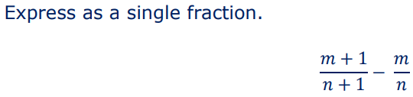
2 | 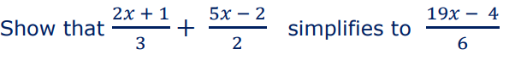
3
4 | 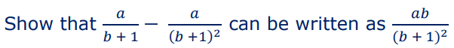
5 | 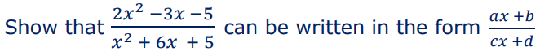
6 | 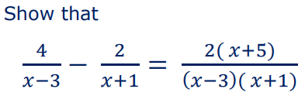
7 | 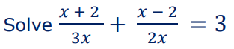
8 | 