Angles in Circles

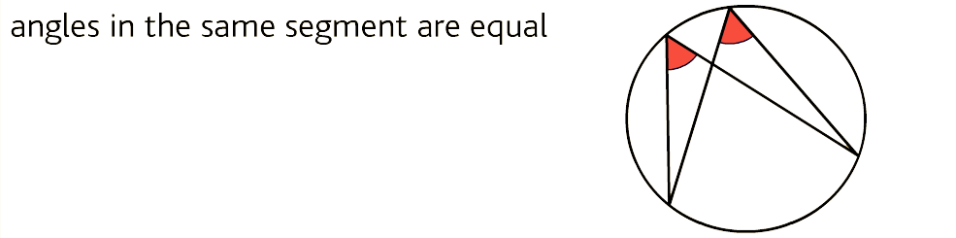

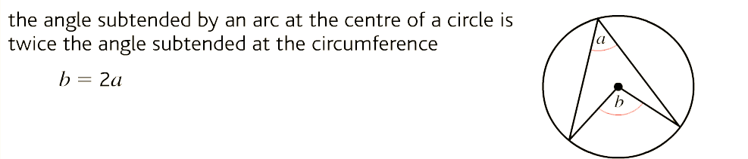

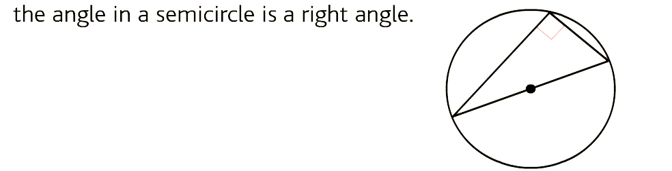

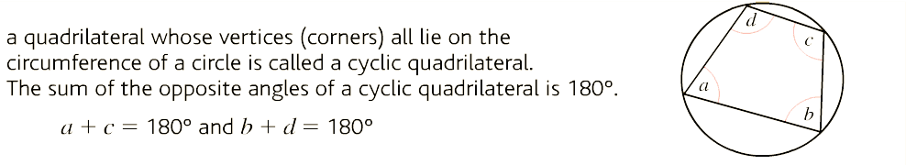

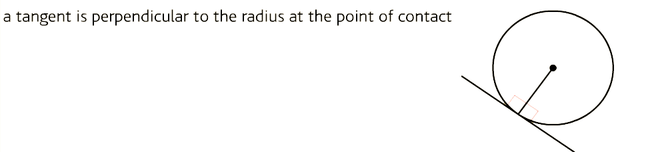

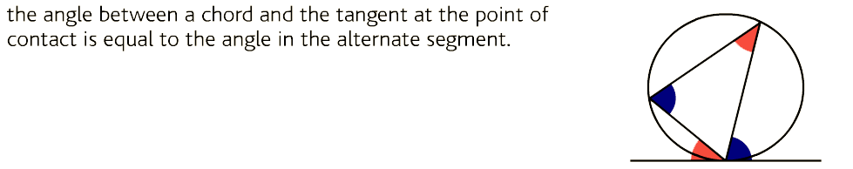
(also known as ‘Alternate segment theorem’.)

