Bottles

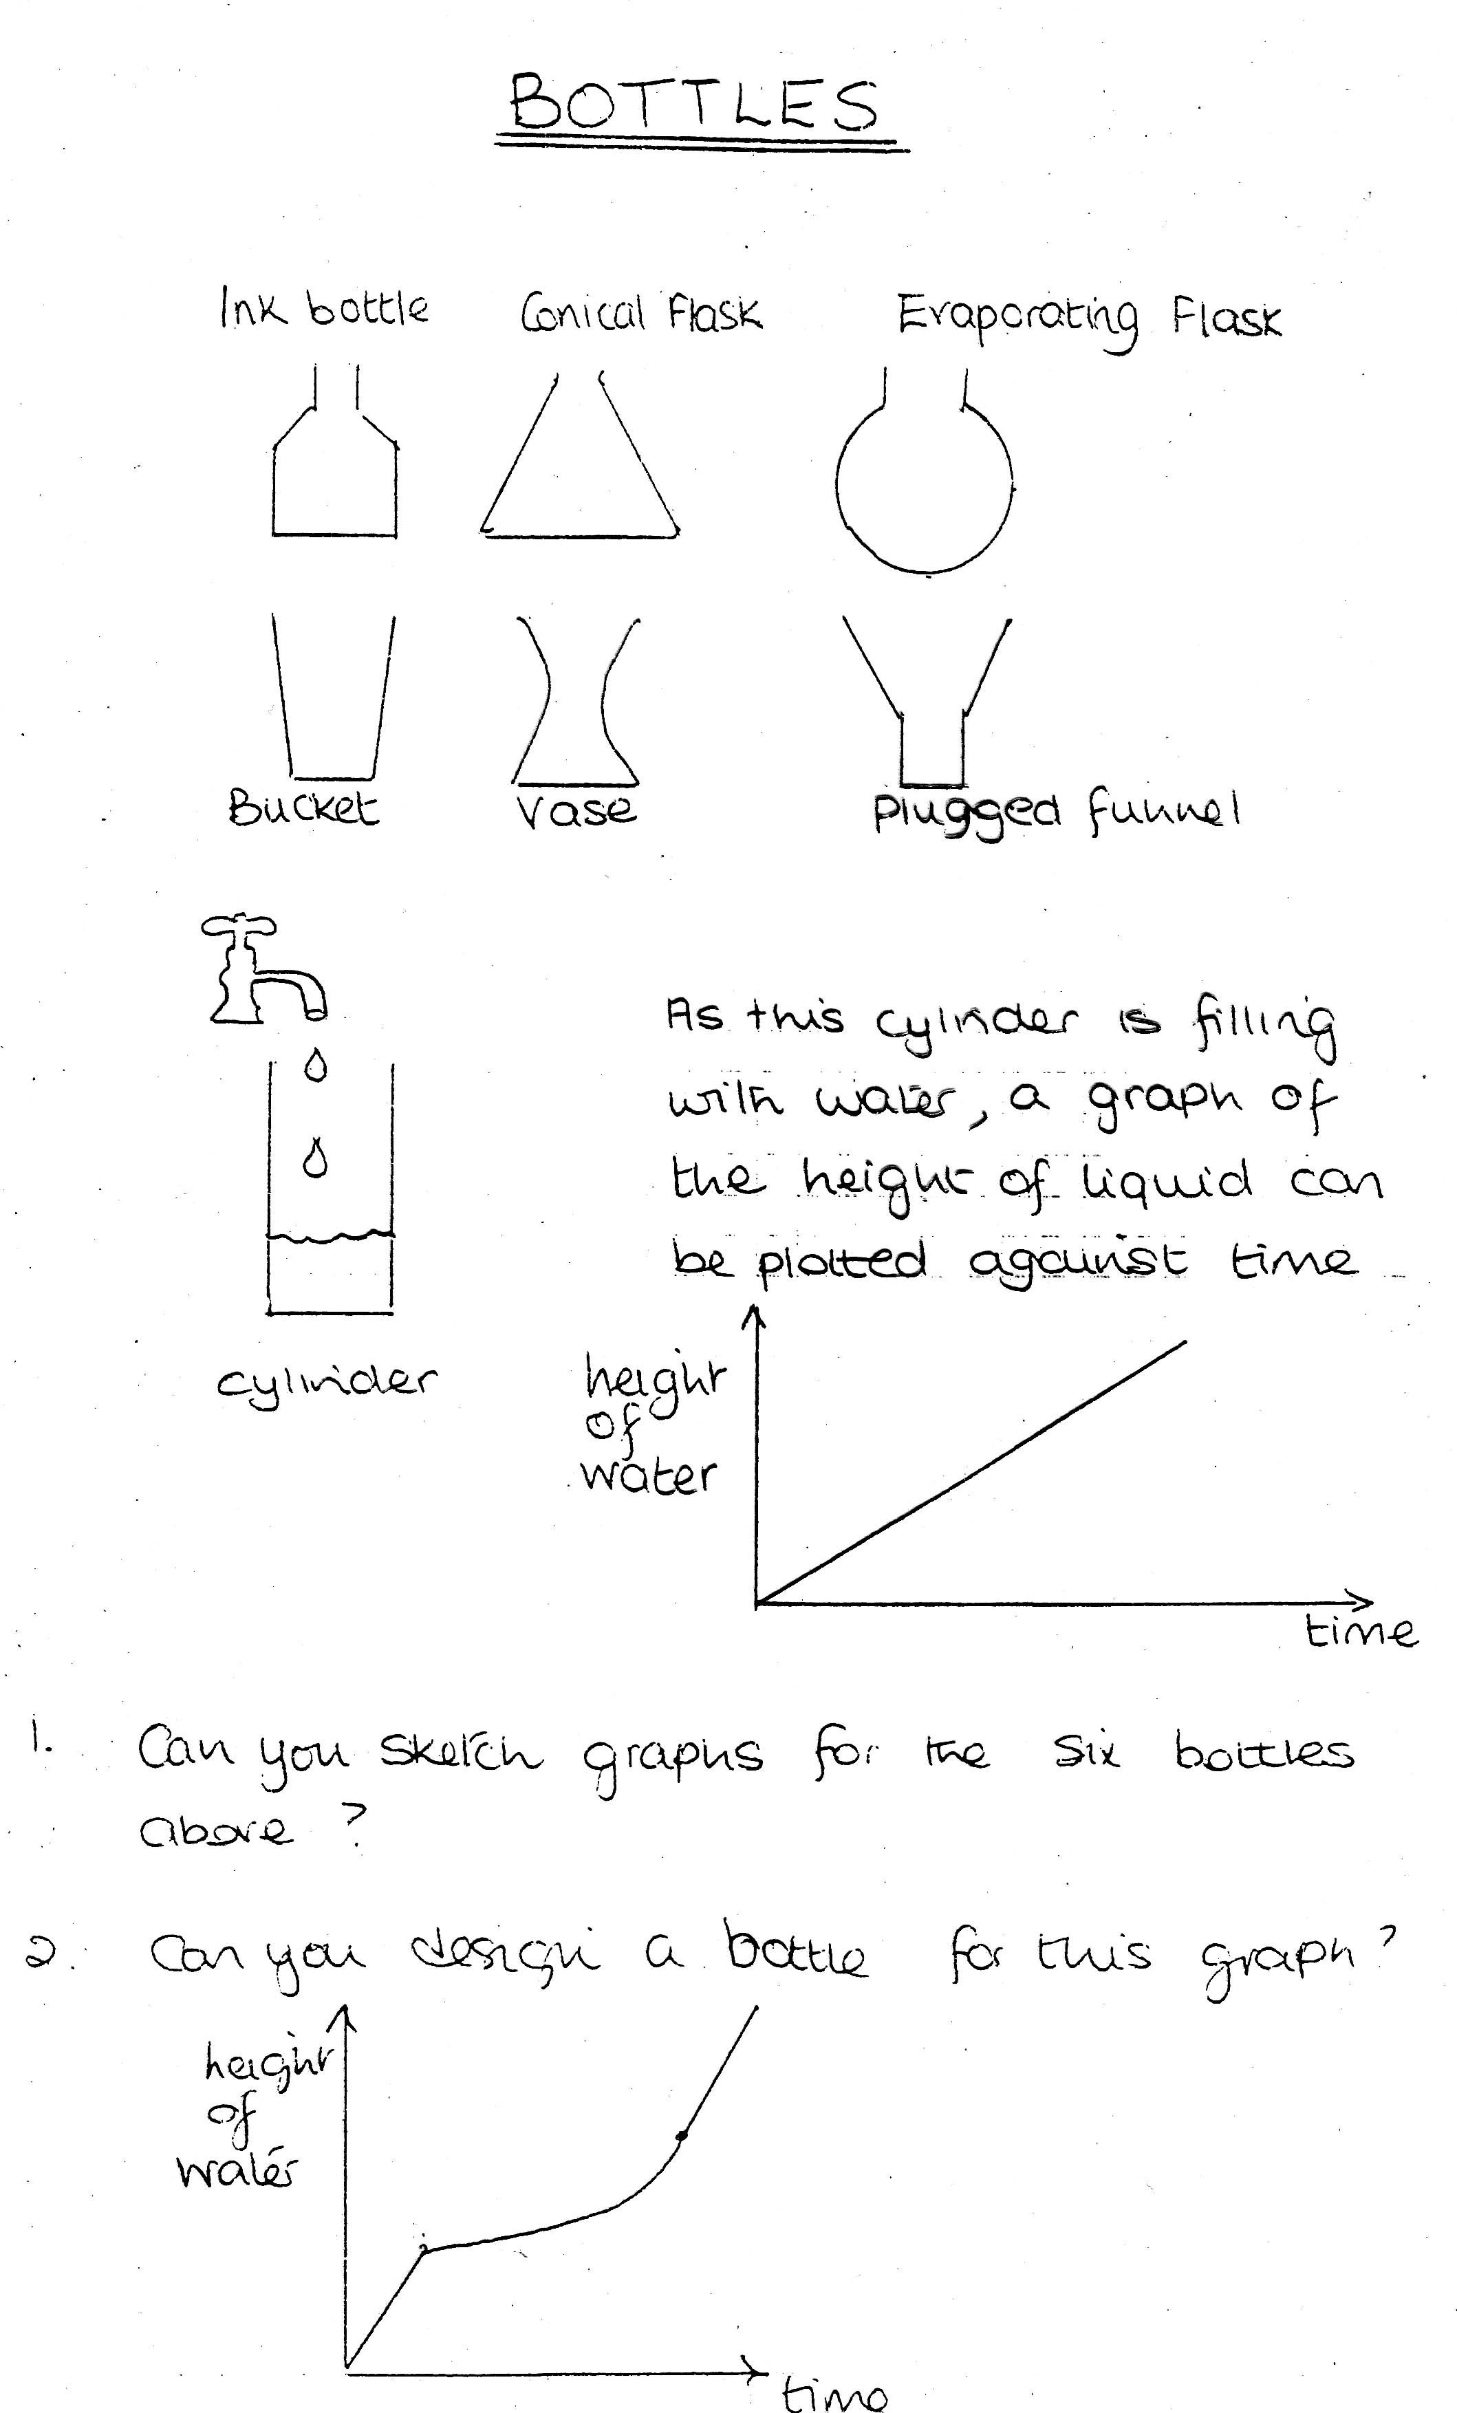

As this cylinder if filling with water, a graph of the height of liquid can be plotted against time.

- Sketch the graphs for the six bottles above.

- What do you think this bottle would look like?

