Know Your Cards

What types of cards are each of the following and what are the differences between them?
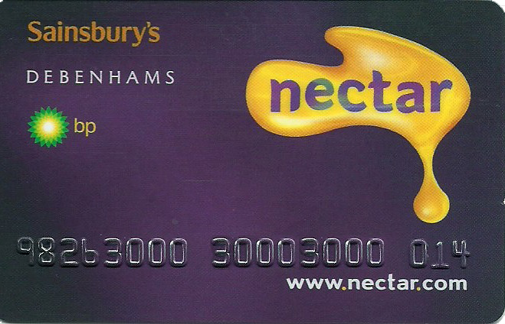

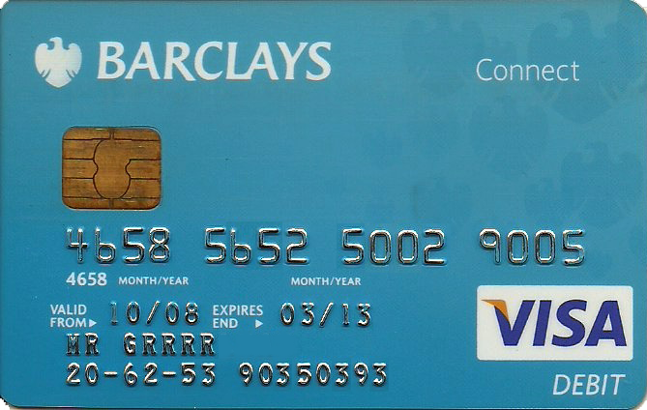

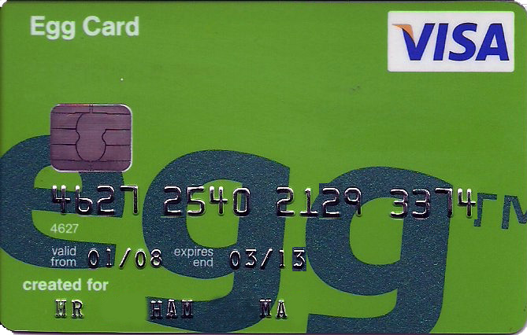

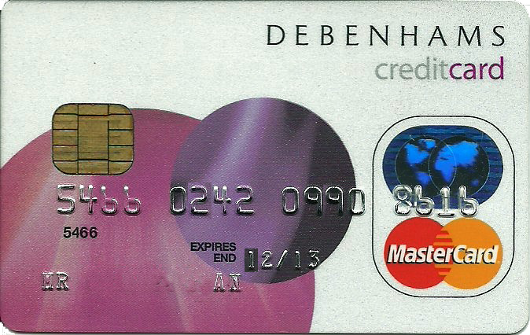
Know Your Cards – Notes

What types of cards are each of the following and what are the differences between them?

Card 1 – Sainsburys Nectar card

This is a reward card, mainly used by the retailer to collect information about its customers in order to better target adverts and encourage more spending. Information collected would typically include products and groups of products brought, frequency of shop, amount spent etc. The retailer would ‘reward’ its customers by offering points per £1 spent which can then be exchanged for discount vouchers etc. Anyone can get one of these with no credit check required.

Card 2 – Barclays debit card

Standard debit card as offered with most current accounts. Use to withdraw money at ATM, pay in shops, online etc. Takes money from current account immediately. No credit check required. This one happens to be a VISA card.

Card 3 – Egg credit card

Credit cards are used to defer payment for shopping. Typically consumers use the card to pay for goods or services and then ‘pay off’ the credit when billed after a period of, usually, around a month or so. Provides opportunity to either pay in full, pay regular amount or pay minimum payment. Typical credit APR is 15-20%. Credit check required.

Card 4 – Debenhams store card

A store card is a combination of a credit card and reward card. Operates same as credit card but offers minimal rewards for spending, and spending particularly at named retailer. Credit check required. Costs same as for credit card.

