Circles

Draw the graphs below:

- $$x^{2}+y^{2}=9$$
- $$x^{2}+y^{2}=\text{25}$$
- $$(x+2)^{2}+(y+2)^{2}=4$$
- $$(x+3)^{2}+(y−3)^{2}=4$$
- $$(x−1)^{2}+(y−1)^{2}=\text{49}$$

Write the equations of the circles below:

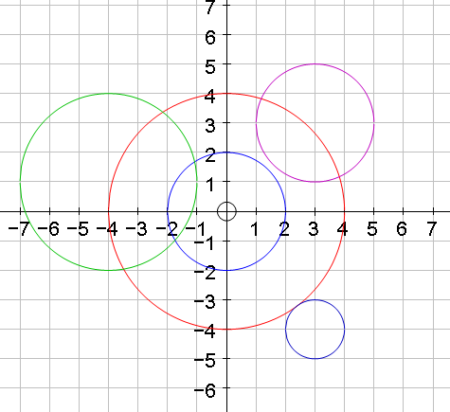

Circles - Answers

Draw the graphs below:

- $$x^{2}+y^{2}=9$$
- $$x^{2}+y^{2}=\text{25}$$
- $$(x+2)^{2}+(y+2)^{2}=4$$
- $$(x+3)^{2}+(y−3)^{2}=4$$
- $$(x−1)^{2}+(y−1)^{2}=\text{49}$$

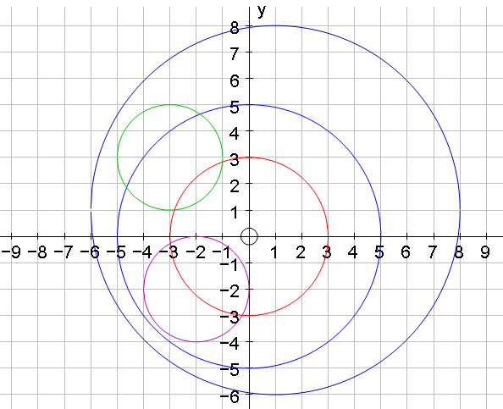

Write the equations of the circles below:

$$x^{2}+y^{2}=4$$
$$x^{2}+y^{2}=\text{16}$$
$$(x−3)^{2}+(y−3)^{2}=4$$
$$(x+4)^{2}+(y−1)^{2}=9$$
$$(x−3)^{2}+(y+4)^{2}=1$$

