Mixed Circles Questions

Show all the workings, write down the calculations that you do.

- Find the circumference of a circle with:

  - radius 7cm
  - diameter 20cm

- A circle has circumference 12cm, what is its diameter?

- Find the perimeter of this semicircle

12cm

- Find the area of a circle with

  - radius 14cm
  - radius 5cm
  - diameter 9cm
  - diameter 7cm

- Find the shaded area

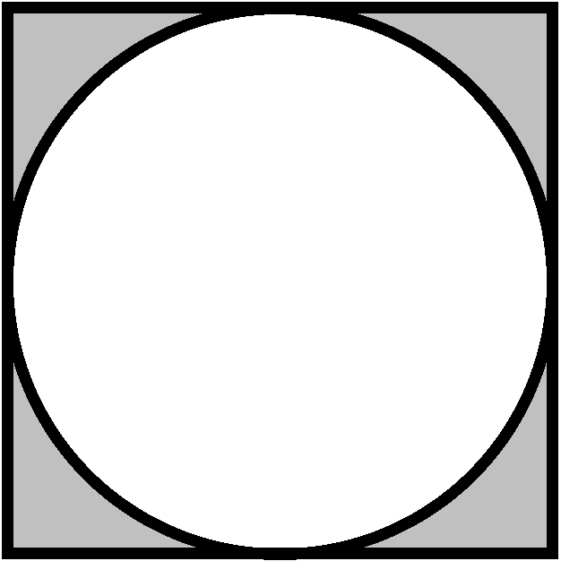

7cm
7cm

- Find the radius of a circle with

  - area 90cm²
  - area 25cm²

- Find the areas

10cm
10cm
5cm

10cm
Mixed Circles Questions - Answers

Show all the workings, write down the calculations that you do.

- Find the circumference of a circle with:

  - radius 7cm
  - diameter 20cm

43.98cm 62.83cm
- A circle has circumference 12cm, what is its diameter?
3.82cm
- Find the perimeter of this semicircle
30.85cm

12cm

- Find the area of a circle with

  - radius 14cm
  - radius 5cm
  - diameter 9cm
  - diameter 7cm

615.75cm², 78.54cm², 63.62cm², 38.48cm²
- Find the shaded area
10.52cm²

7cm
7cm

- Find the radius of a circle with

  - area 90cm²
  - area 25cm²

5.35cm, 2.82cm
- Find the areas 139.27cm², 58.91cm²

10cm
10cm
5cm

10cm

