The Fairy Godmothers Magical Circles Practice

- The minute hand of a giants watch is 2.5 m long. What distance does the tip of the hand travel and what area does the hand cover in 1 hour?

- A farmer has a circular field which is 250 metres across. He wishes to put a fence around it to keep out foxes, elves & naughty children. What length of fence would he need? He then wishes to cover it with white plastic sheeting so that his magic beans grow bigger and stronger. How much sheeting would he need?

- Daniel, a small make believe pixie, is tied to a make believe post in the middle of a make believe garden with a make believe rope that is 12 feet long. Over what area can the small make believe pixie explore?

- A tyre from the car in Chitty Chitty Bang Bang has a radius of 80 cm. If it rotates once along the ground how far will it travel? How many rotations does it do when travelling a distance of 1 km?

- Find the area & perimeter of each of the interesting shapes below.
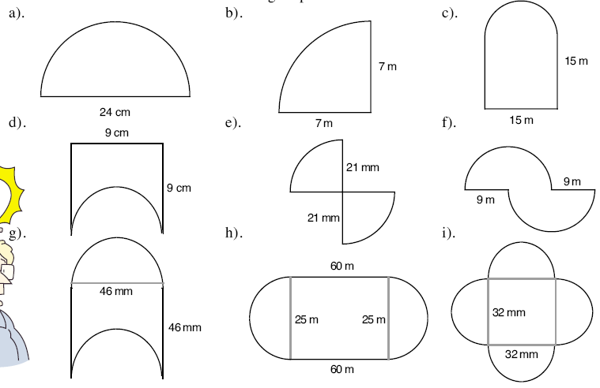

The Fairy Godmothers Magical Circles Practice - Answers

- The minute hand of a giants watch is 2.5 m long. What distance does the tip of the hand travel and what area does the hand cover in 1 hour?
Distance = 15.7m, Area = 19.63m²

- A farmer has a circular field which is 250 metres across. He wishes to put a fence around it to keep out foxes, elves & naughty children. What length of fence would he need? He then wishes to cover it with white plastic sheeting so that his magic beans grow bigger and stronger. How much sheeting would he need? 785m, 49,087m²

- Daniel, a small make believe pixie, is tied to a make believe post in the middle of a make believe garden with a make believe rope that is 12 feet long. Over what area can the small make believe pixie explore? 452m²

- A tyre from the car in Chitty Chitty Bang Bang has a radius of 80 cm. If it rotates once along the ground how far will it travel? How many rotations does it do when travelling a distance of 1 km?
502cm or 5.02m, 199 rotations

- Find the area & perimeter of each of the interesting shapes below.
  - A = 226, P = 61 b) A = 38, P = 25 c) A = 313, P = 686
d) A = 49, P = 41 e) A=693, P = 150 f) A = 24, P = 74.5
g) A = 2116, P =236.5 h) A = 1991, P = 198 i) A = 2632, P = 201

