Combinations

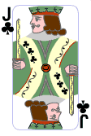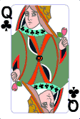

1. From 3 cards, in how many different ways can you choose:

- 0 cards
- 1 card
- 2 cards
- 3 cards

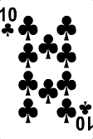

2. From 4 cards, in how many different ways can you choose:

- 0 cards
- 1 card
- 2 cards
- 3 cards
- 4 cards

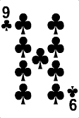

3. From 5 cards, in how many different ways can you choose:

- 0 cards
- 1 card
- 2 cards
- 3 cards
- 4 cards
- 5 cards

