**Combinations**

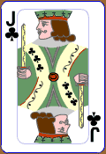 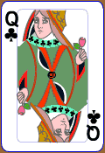 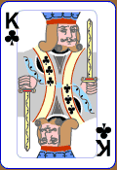

1. From 3 cards on the table. In how many different ways can you pick up…

1. 0 cards
2. 1 card
3. 2 cards
4. 3 cards

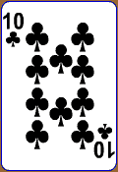   

2. From 4 cards on the table. In how many different ways can you pick up…

1. 0 cards
2. 1 card
3. 2 cards
4. 3 cards
5. 4 cards

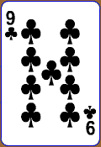    

3. From 5 cards on the table. In how many different ways can you pick up…

1. 0 cards
2. 1 card
3. 2 cards
4. 3 cards
5. 4 cards
6. 5 cards

**Arrangements**

How many ways can you arrange 3 cards in a row?…

  

How many ways can you arrange 4 cards in a row?…

   

How many ways can you arrange 5 cards in a row?…

    

How many ways can you arrange the five cards in a row so that the king and queen are together?

How many ways can you arrange **three** of the five cards in a row?

**Getting Harder**

How many ways can you arrange these cards in a row?…

    

How many ways can you arrange these cards in a row?…

    

How many ways can you arrange these cards in a row?…

   

How many ways can you arrange **three** of these cards in a row?…

    

How many ways can you arrange the letters M I S S I S S I P P I ?

**Combinations - Answers**

  

1. From 3 cards on the table. In how many different ways can you pick up…

1. 0 cards 1
2. 1 card 3
3. 2 cards 3
4. 3 cards 1

   

2. From 4 cards on the table. In how many different ways can you pick up…

1. 0 cards 1
2. 1 card 4
3. 2 cards 6
4. 3 cards 4
5. 4 cards 1

    

3. From 5 cards on the table. In how many different ways can you pick up…

1. 0 cards 1
2. 1 card 5
3. 2 cards 10
4. 3 cards 10
5. 4 cards 5
6. 5 cards 1

**Arrangements - Answers**

How many ways can you arrange 3 cards in a row?… $3!=6$

  

How many ways can you arrange 4 cards in a row?… $4!=24$

   

How many ways can you arrange 5 cards in a row?…

    

How many ways can you arrange the five cards in a row so that the king and queen are together? $4!2!=24×2=48$

How many ways can you arrange **three** of the five cards in a row? $5×4×3=60$

**Getting Harder - Answers**

How many ways can you arrange these cards in a row?… $\frac{5!}{2!}=60$

    

How many ways can you arrange these cards in a row?… $\frac{5!}{3!}=20$

    

How many ways can you arrange these cards in a row?…

   

How many ways can you arrange **three** of these cards in a row?…

    

How many ways can you arrange the letters M I S S I S S I P P I ?