Complete Graphs

In each of the network diagrams, or graphs, below every node (vertex) is connected by exactly one arc (line) to every other node to form a complete graph.

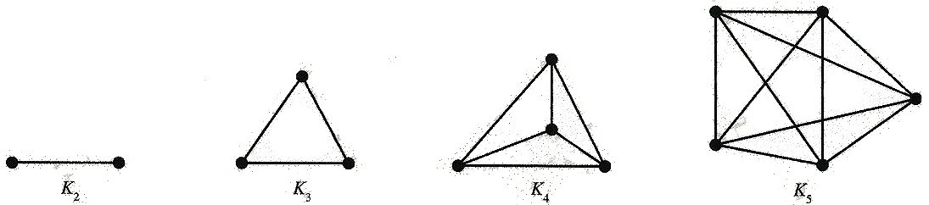
K₂ | K₃ | K₄ | K₅

The K₂ graph has 2 nodes, the K₃ graph has 3 nodes etc.

Task 1

What is the algebraic rule connecting the number of nodes to the number of arcs in each pattern?
Similar Graphs

In each of these sets of four diagrams, three represent the same graph whilst the fourth is different.

Task 1

Identify the odd one out by considering the number of arcs joined to each node, known as the order of each node.

(You could also use matrices to help if you wish.)

Set A:

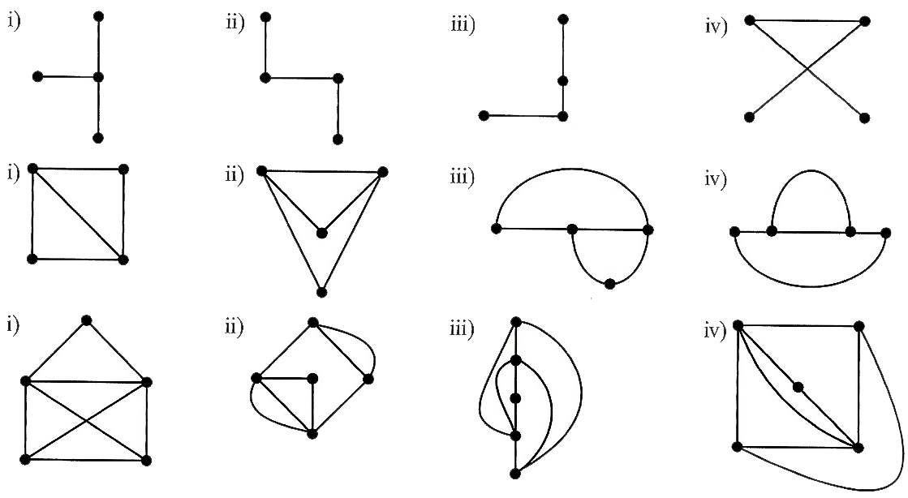

Set B:

Set C:

Minimum Spanning Trees

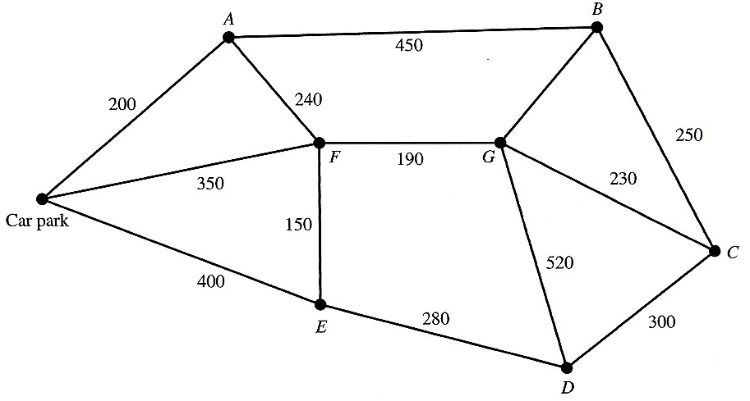

The network diagram, or weighted graph, above represents a country park with seven picnic areas and a car park joined by rough paths. The numbers shown are distances in metres. The company that owns the country park would like to make it wheelchair friendly by laying tarmac along some of the routes so that wheelchair users can access all of the picnic areas.

Tarmac is expensive and so the choice of which paths to tarmac is important.

Task 1

Find the shortest combinations of paths required in order to join all seven picnic sites and the car park together, known as the minimum spanning tree. Think carefully about your method.

Task 2

Find the minimum spanning trees for each of the graphs on the following page.

Task 3

Write a set of instructions (or recipe), known as an algorithm, to find the minimum spanning tree for any graph. Your algorithm must be easily understandable and must work for all graphs.
Find the minimum spanning trees for these graphs:

Graph 1: | Graph 2:
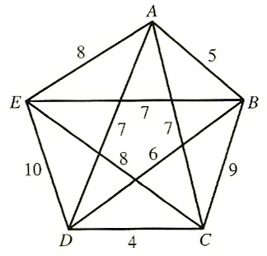
Graph 3: | Graph 4:
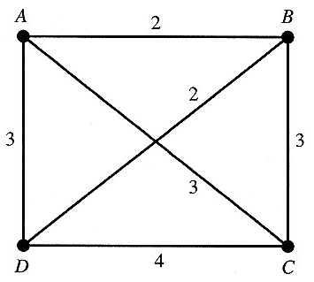 | 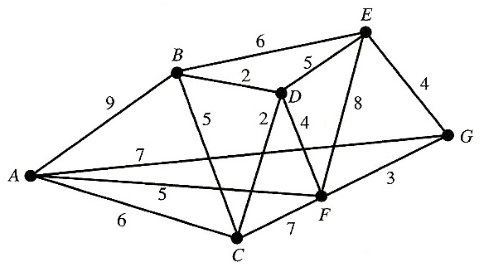
Graph 5: | Graph 6:
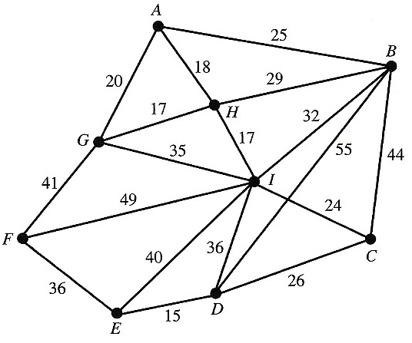 | 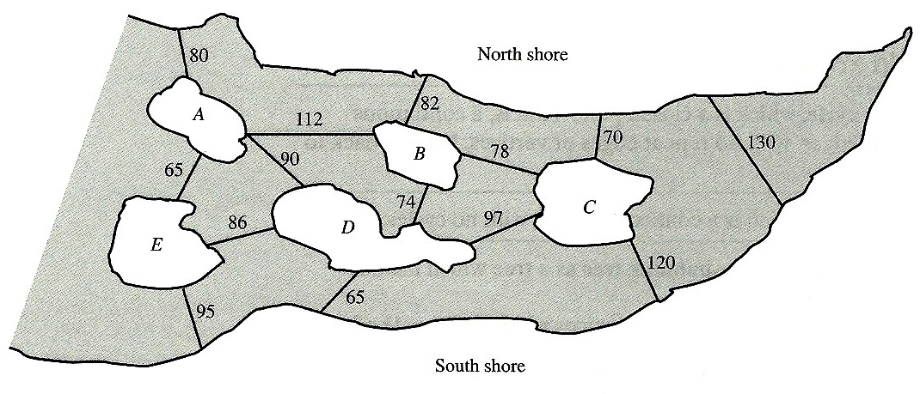

Route Inspection (The Chinese Postman Problem)

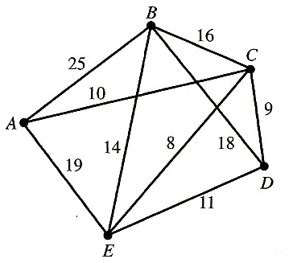
Task 1

The diagram above represents a set of streets that must be gritted in preparation for a winters day. What is the minimum distance required to travel along all arcs and return to your original starting position?

Task 2

What are the minimum distances required in order to travel along all arcs and return home for each of the graphs below?

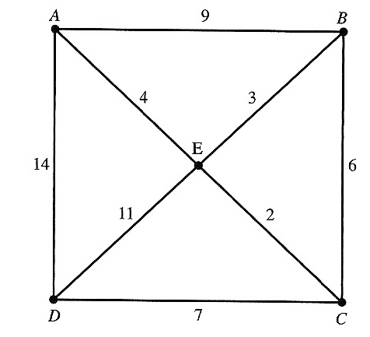 | 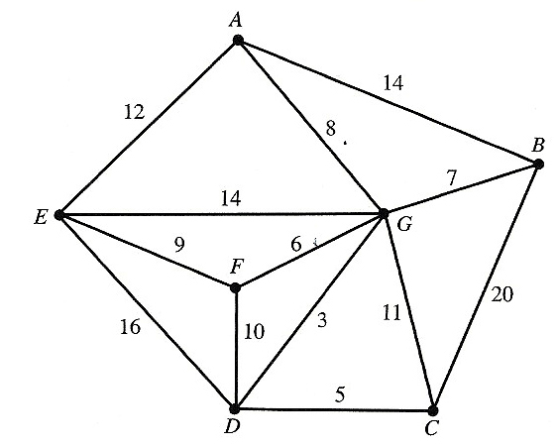
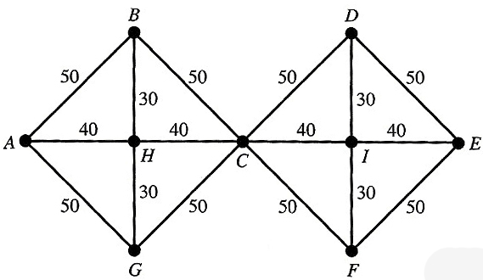

Task 3

Write an algorithm, to find the minimum distance required in order to travel along all arcs and return home for any graph. Your algorithm must be easily understandable and must work for all graphs.
The Travelling Salesman Problem

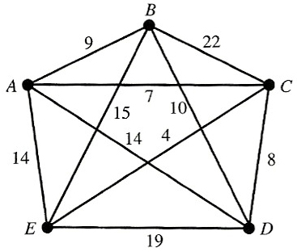

Task 1

The graph above shows a group of cities joined by roads that make up the tour for a rock band. What is the minimum distance required to visit all nodes and return to your original starting position? (You don’t have to travel along all arcs).

Task 2

What are the minimum distances required to visit all nodes and return home for each of the graphs on the following page.

Task 3

Write an algorithm, to find the minimum distances required to visit all nodes and return home for any graph. Your algorithm must be easily understandable and must work for all graphs.
Complete the Travelling Salesman Problem for these graphs:

Graph 1: | Graph 2:
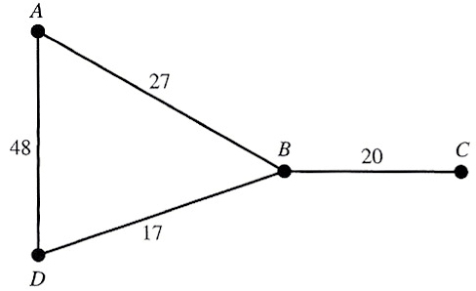 | 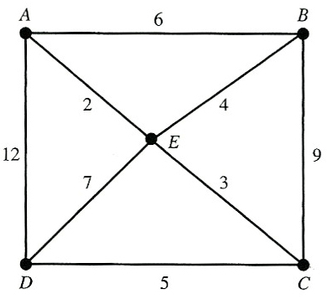
Graph 3: | Graph 4:
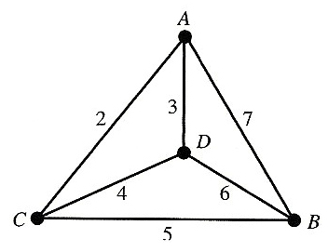 | 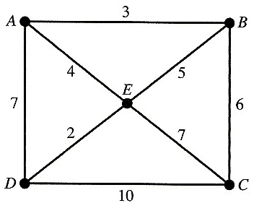
Graph 5:
