Core 1 Quadratic Problem Solving Questions

Preliminary:

2x + 3y = 18
5x - y = 11

3x + 2y = -14
-2x - 6y = 7

4x + 7y = 22
y = 10 - 2x

x + y = 33
xy = 200

Questions:

- The sum of two numbers is 21 and their product is 90.
Write a quadratic equation and use it to find the two numbers.

- A company models its annual profits using the function
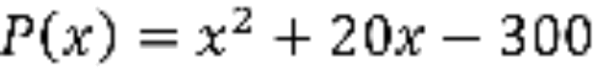, where P represents profits and x gives the number of units sold.
One year, their profits were £167,700. How many units of their product did they sell?

- The perimeter of a rectangle is 50 cm and its area is 144 cm².
Find the dimensions of the rectangle.

- An open top box is made by cutting 3 inch squares from each corner of a square piece of cardboard and then folding up the flaps.
The volume of the box is to be 1083 cubic inches.
Find the dimensions of the original piece of cardboard.

- A homeowner wants to install a deck around her swimming pool.
The swimming pool is a rectangle and measures 25 feet by 32 feet.
The deck is to have the same width all the way around the pool.
What should be the width of the deck if she has 310 square feet of decking material?

Adapted from and answers at http://www.math.uh.edu/~mmarksc/2303/Notes/2303-Section-57.pdf
Answers to preliminary are on next page
1 x = 3, y = 4
2 x = -5, y = ½
3 x = 4.8, y = 0.4
4 (8, 25) and (25, 8)

