Crisps & Pies!

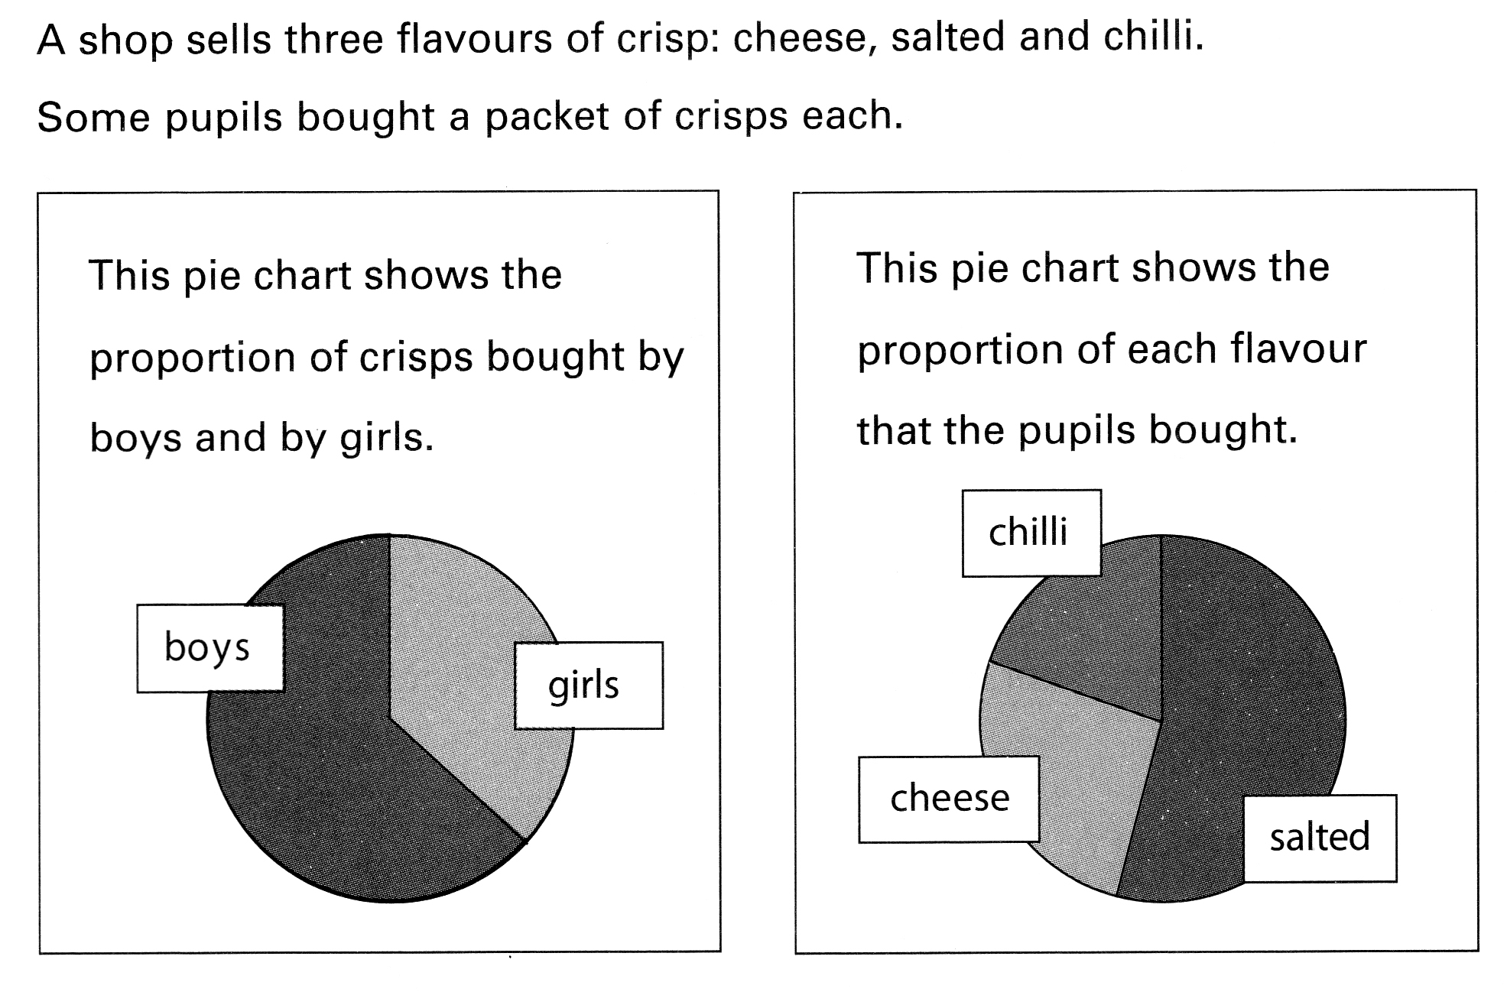

For each statement below decide, with a reason, if it is always true, always false or could be either.

- All of the girls had salted crisps
- All of the boys had chilli crisps
- Some of the girls had chilli crisps
- Some of the boys had salted crisps

- Some of the girls… had salted crisps
- Some of the boys… had salted crisps
- None of the girls… had salted crisps
- All of the boys… had salted crisps
- None of the boys… had salted crisps
- All of the girls… had salted crisps
- Most of the boys… had salted crisps
- One of the girls… had salted crisps
- Some of the people… had salted crisps
- Most of the children… had salted crisps
- Half of the boys… had salted crisps
- A Quarter of the girls… had salted crisps

