Displacement, Velocity, Acceleration Graphs

s
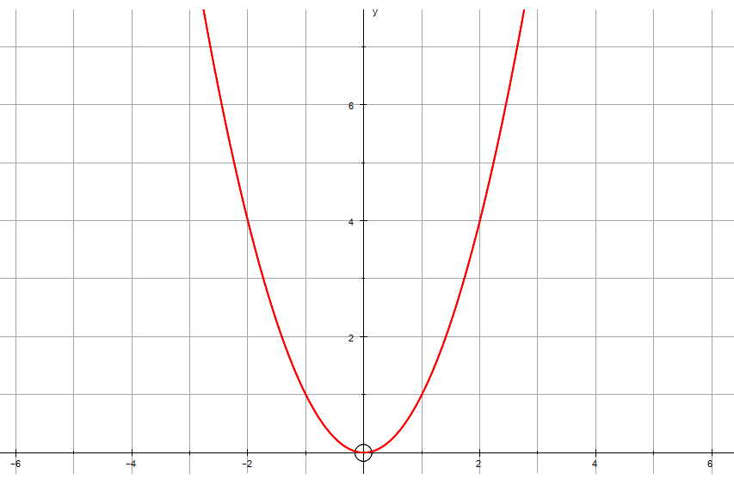
Displacement
Differentiate
Differentiate
Integrate
v
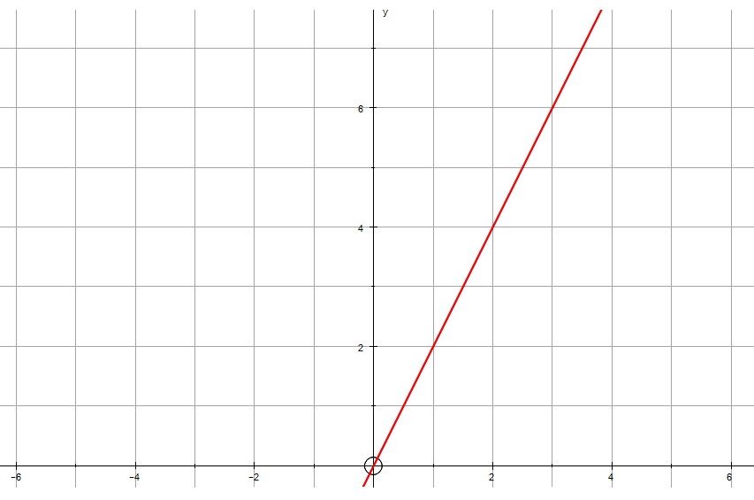
Velocity
Integrate
a
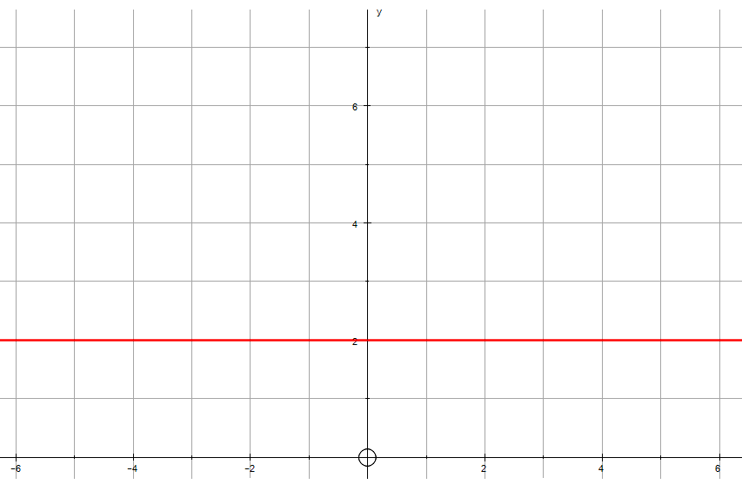
Acceleration

On the velocity-time graph below, the gradient () of the sloped section is acceleration and the area under the graph () is the distance travelled.

