Distribution Approximations

Approximation | Conditions
Normal distribution as approximation to the binomial  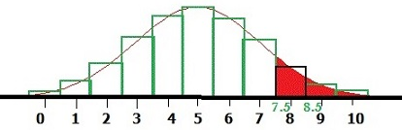  If X ~ B(n, p) and if n is large and/or p is close to ½, then X ~ N(np, npq) approximately.  Include continuity correction | np > 5  nq > 5  p ≈ ½
Poisson distribution as approximation to the binomial  If X ~ B(n, p) and if n is large and p is small, then X ~ Po(np) approximately. | n > 50  np < 5
Normal distribution as approximation to the Poisson  If X ~ Po(λ) and if λ is large, then X ~ N(λ, λ) approximately.  Include continuity correction | λ >15

