Further Trig Graphs

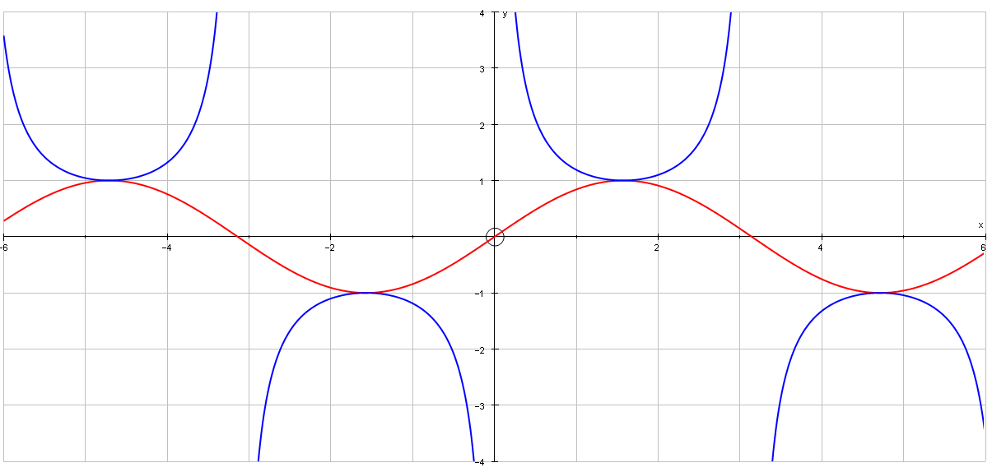
$y=\text{sin }x$ and $y=\text{cosec }x$

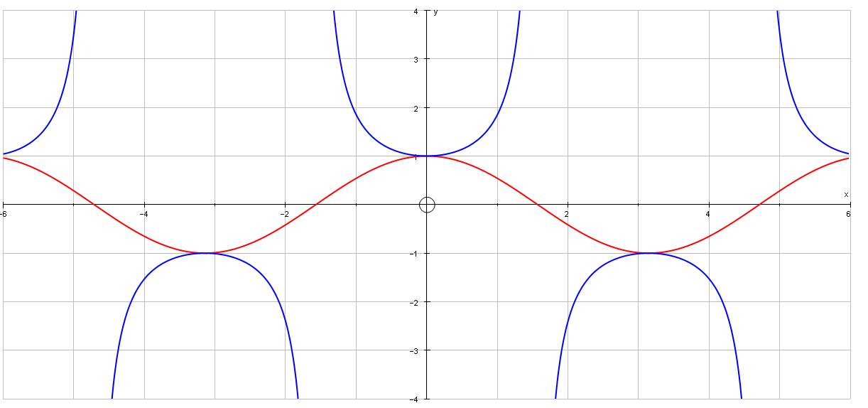
$y=\text{cos }x$ and $y=\text{sec }x$

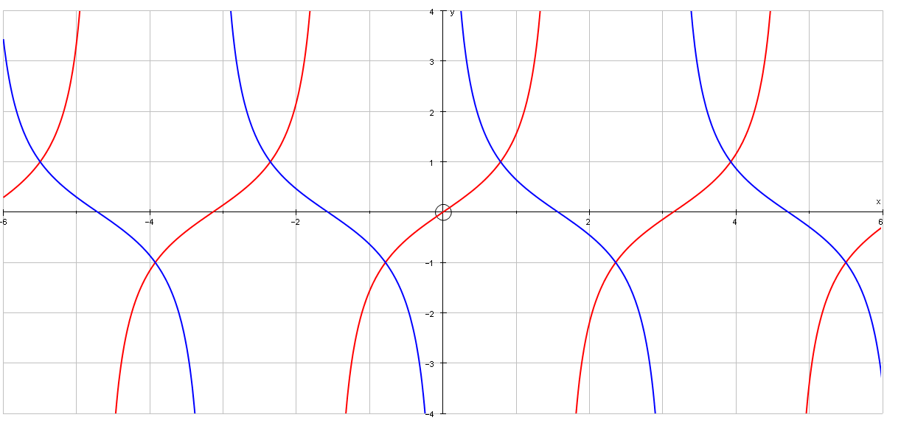
$y=\text{tan }x$ and $y=\text{cot }x$

