Impossible Shapes

Which of these are possible and which aren’t? Why?

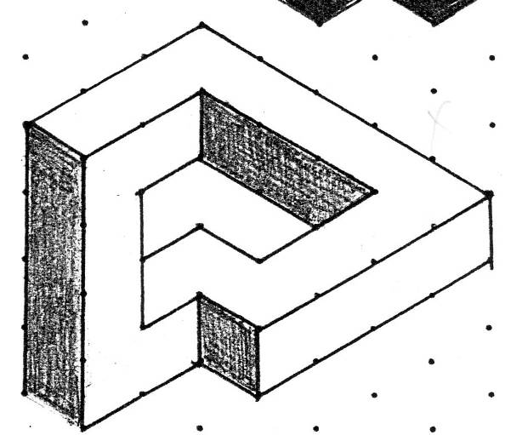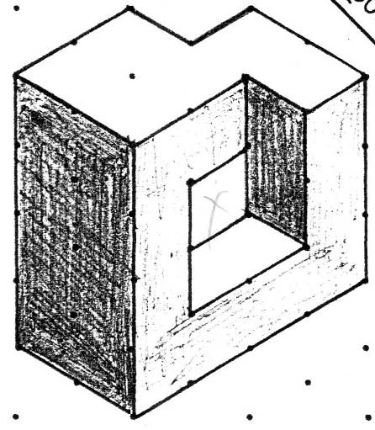

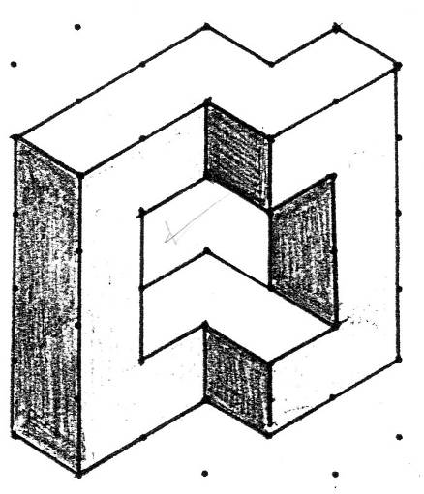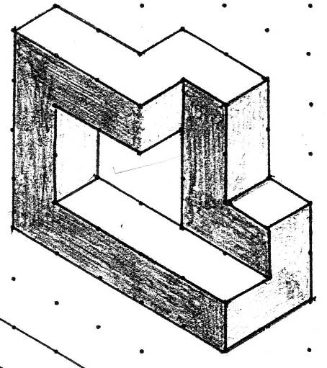

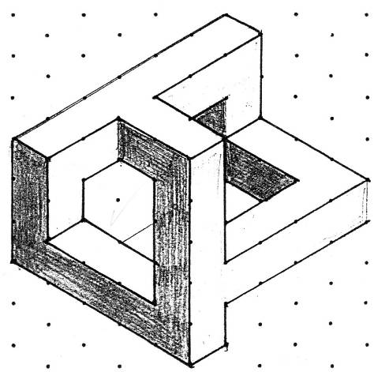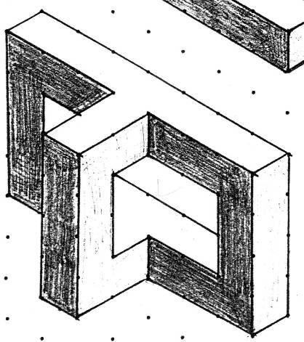
Differentiated tasks

Easy | Copy one of these designs  (using cubes if you wish to).
Medium | Draw a design of your own that can be built  (using cubes if you wish to).
Difficult | Draw an impossible design of your own.

