How to Calculate Income Tax & National Insurance

Items covered here…

- What is Income Tax?
- Calculating Income Tax
- What is PAYE?
- Calculating PAYE
- What is National Insurance?
- Calculating National Insurance
- Increasing your personal allowance and other tax free benefits

What is Income Tax?

Income tax is a tax paid on income, from earnings and/or savings in the UK. The amount you pay depends on the amount of your income and is a proportion, or a percentage, of your income. People with higher incomes pay proportionally more income tax.

Income Tax Rates and Limits 2018/19

Limit | Tax Rate | Notes
Under £11,850 | 0% | Known as the Personal Allowance  May be different for different circumstances, see below
£11,850 and up to £46,350 | 20% | Basic rate of tax
Above £46,350 and up to £150,000 | 40% | Higher rate of tax
Above £150,000 | 45% | Additional rate of tax

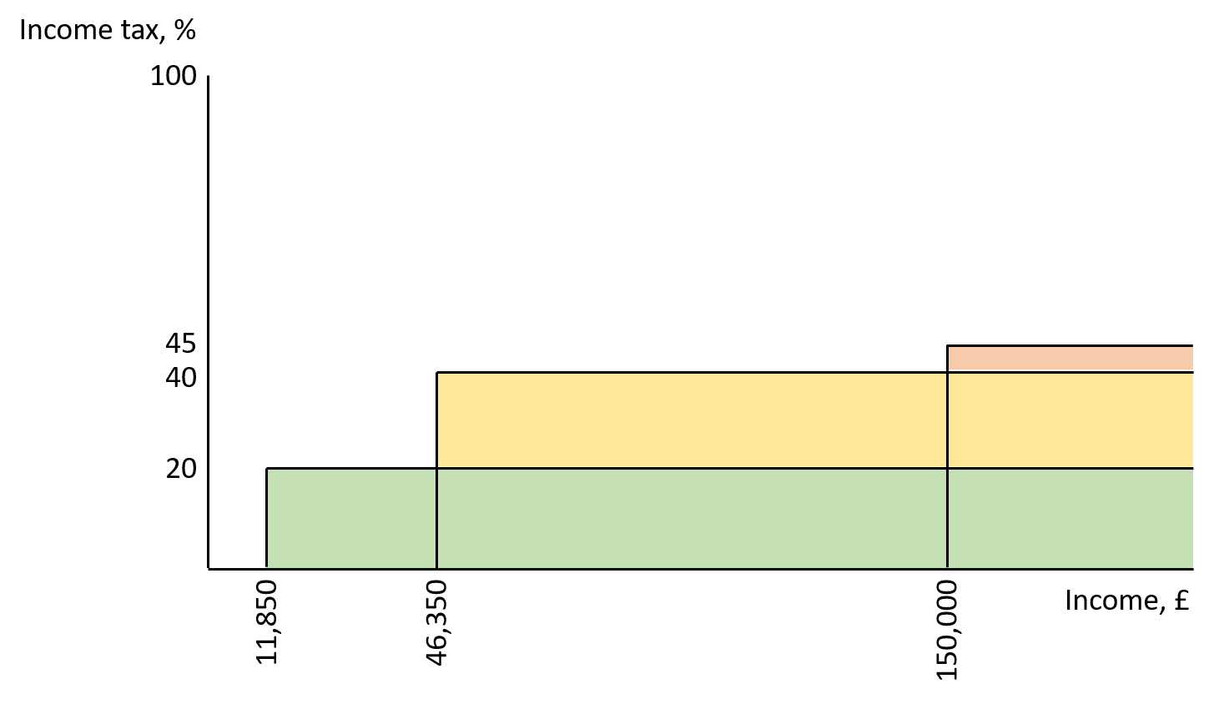

Calculating Income Tax

See separate document for how to calculate income tax.

Example 1. An employee earning £30,000 per year and making 5% pension contributions.

- Total taxable income = £30,000 - £1,500 = £28,500. (note pension contribution of £1,500)
- This is above the personal allowance but less than £46,350 so all tax will be taken at 20%.
- Less personal allowance = £28,500 - £11,850 = £16,650
- 20% of £16,650 = £3,330
- Total income tax = £3,330

Example 2. An employee earning £55,000 and making 10% pension contributions.

- Total taxable income = £55,000 - £5,500 = £49,500. (note pension contribution of £5,500)
- This is above the basic rate of tax limit so most tax will be paid at 20% and some at 40%.
- Basic rate = 20% of (£46,350 - £11,850) = £6,900
- Higher rate = 40% of (£49,500 - £46,350) = £1,260
- Total income tax = £8,160

Example 3. An employee earning £55,000, paying teachers union subscriptions of £183 per annum, having received transfer of marriage allowance and making pension contributions in order to avoid higher rate tax. See notes at end of document for more info on these oddities.

- Pension contributions required = £55,000 - £183 - £46,350 = £8,467 (this is approx. 15%)
- Total taxable income = £46,350
- All at 20%.
- Increased personal allowance due to transfer of marriage allowance = £11,800 + £1,190 = £13,040
- Basic rate = 20% of (£46,350 - £13,040) = £6,662
- Total income tax = £6,662

Note example 3 vs example 2. Example 3 pays £1,498 less tax and £2,917 more pension. Effectively, doubling the value of the voluntary pension contribution.

Graph below shows amount of income tax paid, and from which brackets, for different incomes up to £200,000

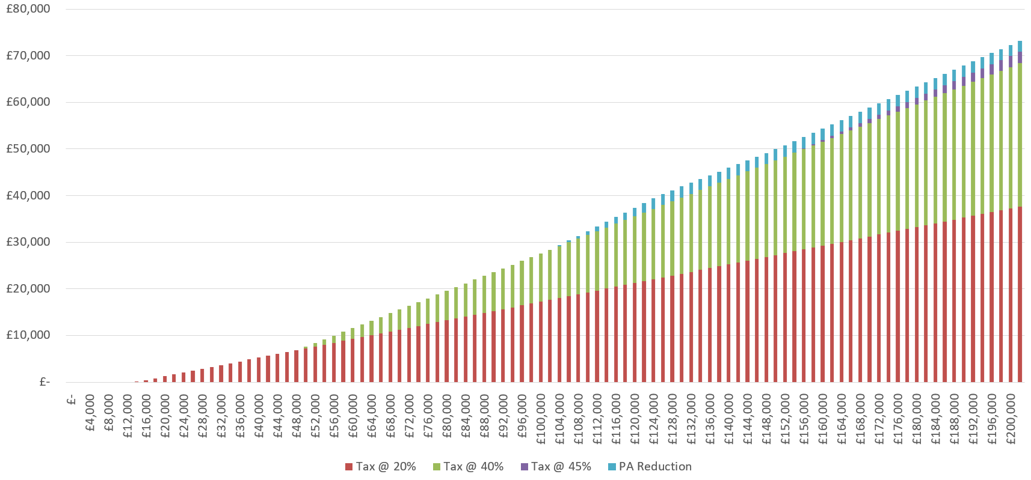
What is PAYE?

PAYE stands for Pay As You Earn and is the method by which employers deduct income tax from an employee’s salary, and pass it onto the government, before they get paid. It effectively automates tax payments of employees.

PAYE does not cover income tax payments of self-employed people nor income tax payments due on other incomes of employed people. This is done via income tax self-assessment tax returns.

Calculating PAYE

n = Number of pay periods remaining in tax year

$$Tax due this period =$$

$$\frac{\left[tax due on\left(income to date+n×income this period\right)\right]-tax paid to date}{n}$$

The crucial part of the equation above is the part in red “$n×income this period$”. This is best explained via the example of someone earning overtime in May whilst April and June remain at their normal level. Let’s assume regular taxable pay of £30,000 per annum less 5% pension (£2,375 per month) and overtime earnings of £1,000 in June (incurring increased pension payment of £50).

- Income tax in April = $$\frac{\left[tax due on\left(£0+12×£2,375\right)\right]-£0}{12}=tax due on £2,375=£277.50$$

Note that $12×£2,375=£28,500$.

- Income tax in May = $$\frac{\left[tax due on\left(£2,375+11×£3,325\right)\right]-£277.50}{11}=£467.50$$

Note that $£2,375+11×£3,325=£38,950$ since the calculation assumes that earnings would continue at this rate.

- Income tax in June = $$\frac{\left[tax due on\left(£5,700+10×£2,375\right)\right]-£754}{10}=£276.60$$

Note that $£5,700+10×£2,375=£29,450$. The calculation now re-adjusts to the regular income figure and although tax for May was higher than usual, tax for June is lower than usual.

The tax will revert to its regular amount in July. As the tax year progresses, the higher tax figure in middle month of this situation will become less extreme and the lower tax figure in later month will become more extreme.

The Most Important Factor in the PAYE System

The calculation assumes that earnings continue at the most recent income period for remainder of tax year and re-evaluates this each and every period until the end of the tax year.

What is National Insurance?

Employed people, and their employers, also pay National Insurance. National Insurance contributions help to build your entitlement to certain state benefits, such as the State Pension and Maternity Allowance. A point to note here is that the NHS is funded both from general taxation and National Insurance with general taxation accounting for about 80% of NHS funding.

Unlike income tax, National Insurance is not an annual tax. It applies to your pay each pay period (monthly, weekly etc.). This means if you earn extra in one month, you’ll pay extra National Insurance, but you won’t be able to claim the extra back even if your pay is lower during the other months of the tax year.

National Insurance Rates and Limits 2018/19

Limit (annual equivalent) | Employee Rate | Employer Rate | Notes
Under £8,424 | 0% | 0% | There is also lower earnings limit of £6,036 required to qualify for some benefits
£8,424 and up to £46,356 | 12% | 13.8 | This upper limit is known as the upper earnings limit
Above £46,356 | 2% | 13.8%

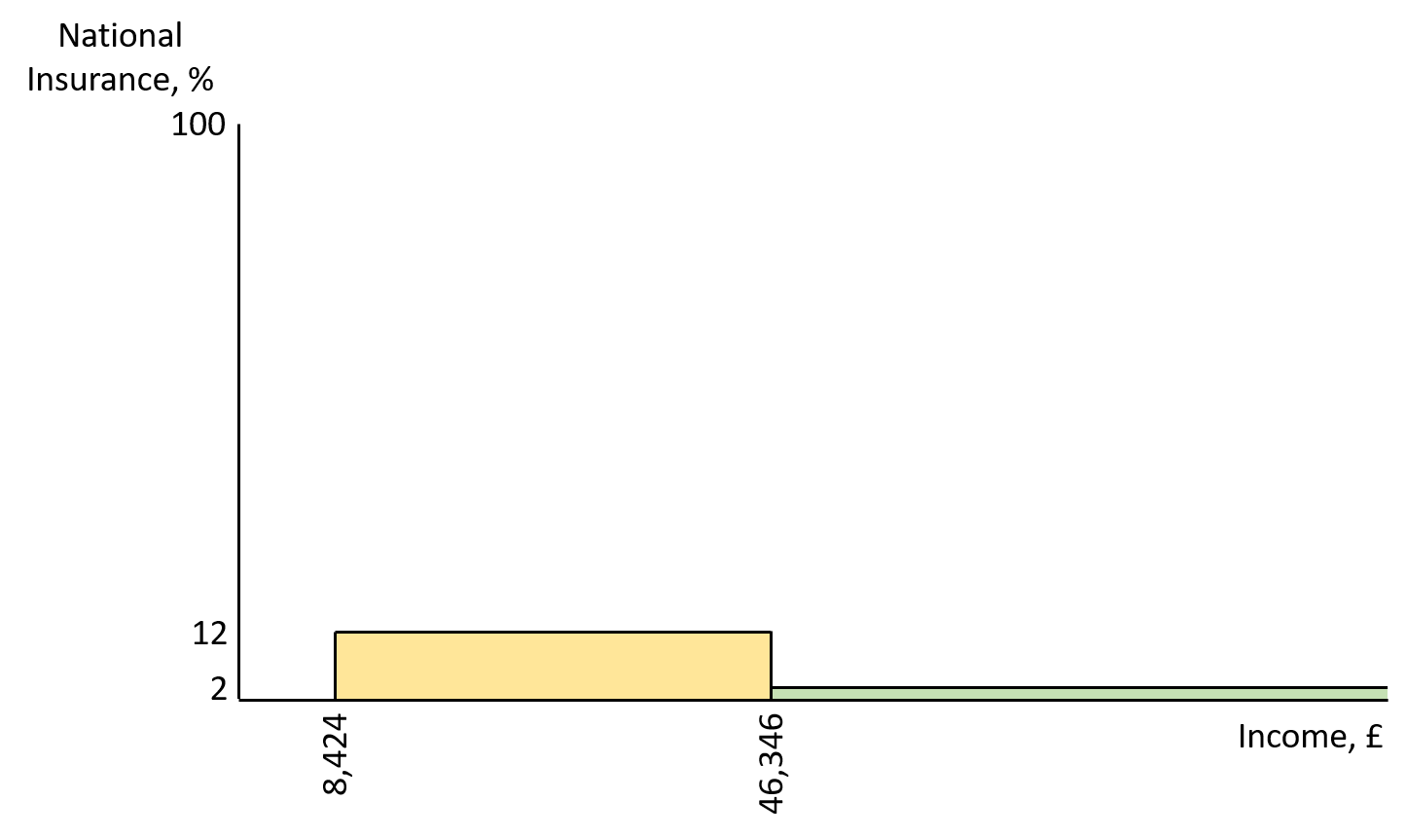

Calculating National Insurance

How to calculate how much National Insurance you’ll pay – a basic model (all 2018/19 figures).

- If your total gross income for the month/week etc. is less than £8,424 equivalent per annum, you won’t pay any National Insurance this time around.
- If your total gross income for the month/week etc. is more than £8,424 equivalent per annum and less than £46,356, you’ll pay 12% on everything between these limits.
- If your total gross income for the month/week etc. is more than £46,356 equivalent per annum, you’ll pay 12% on everything between these £8,424 and £46,356 plus 2% on everything above this.

Increasing your personal allowance and other tax free benefits

- Pension contributions are tax free. If you earn just over the 40% threshold, consider increasing your pension contributions instead of paying 40% tax on earnings above this threshold (£46,350). 60% of that money now vs 100% of that money when you retire.

- Union subscriptions are tax free. If you pay these, contact the tax office to amend your tax code. Better still, you can get this backdated by up to four years.

- If you’re married (or in a civil relationship) and have a taxable income below the personal allowance limit of £11,850, you can transfer unused allowance of up to £1,190 to your partner. This could be worth up to £238.

- If either you or your partner have a taxable income of more than £50,000 then you’ll lose out on some, or all, of your Child Benefit entitlement. Note that this is taxable income and pension payments are not taxable. Therefore, if you’re in the situation above, consider increasing pension payments to reduce your taxable income to £50,000. Work the maths on this first though.

- If your employer requires you to purchase, clean and repair a uniform for work, you can claim tax relief on this. See here for more details.

Links and Further Reading

https://www.moneysavingexpert.com/banking/tax-rates/
https://www.gov.uk/government/publications/income-tax-personal-allowance-and-basic-rate-limit-from-2019-to-2020/income-tax-personal-allowance-and-basic-rate-limit-from-2019-20
https://www.gov.uk/topic/personal-tax/self-assessment
https://www.gov.uk/national-insurance-rates-letters
https://www.gov.uk/national-insurance-rates-letters/category-letters
https://www.moneysavingexpert.com/reclaim/uniform-tax-refund/
https://www.gov.uk/tax-relief-for-employees

