Inscribed Regular Polygons

In your books copy and write the answers to the following questions:

360 ÷ 3 =
360 ÷ 4 =
360 ÷ 5 =
360 ÷ 6 =
360 ÷ 8 =
360 ÷ 9 =
360 ÷ 10 =
360 ÷ 12 =
360 ÷ 15 =

Now, using your answers above together with protractor, compass, pencil and ruler construct your own versions of the diagrams below.

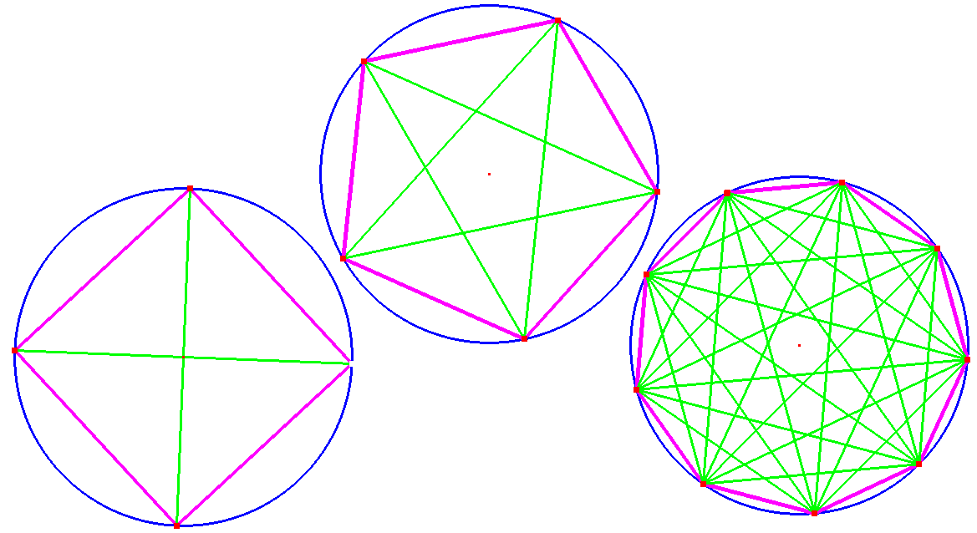

Hint: use your protractor to measure the positions of each corner of the polygon on the circle.

Try polygons with fewer sides before attempting more complicated ones.

Don’t forget to colour them to look nice!

