Interesting Questions

Qu 1… Edexcel unit tests, Parametric Equations -Qu 3. (Link to markscheme)
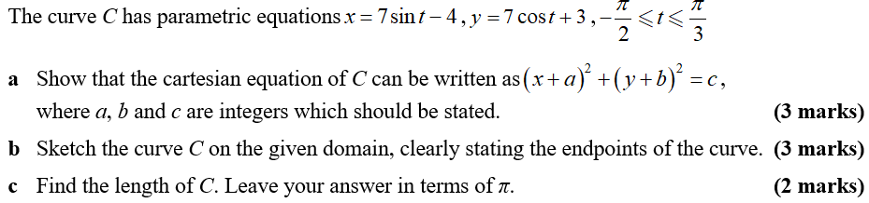

Qu 2… AQA A2 Paper 1, June 2018 -Qu 5. (Link to markscheme)
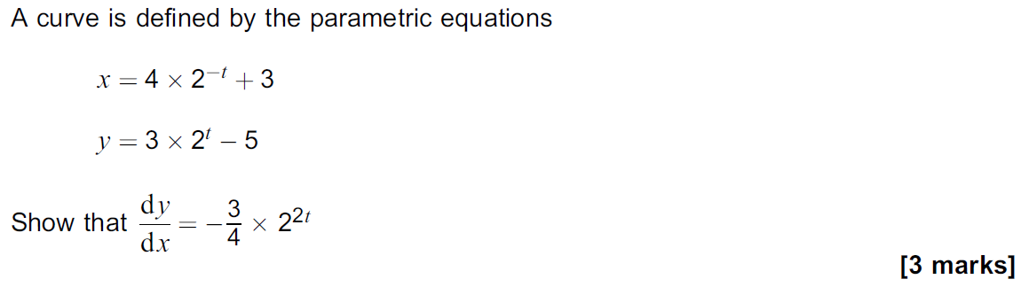
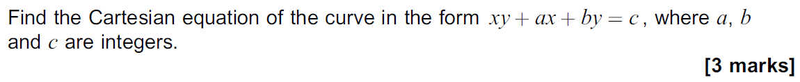

Qu 3… AQA A2 Paper 1, June 2018 – Qu 12. (Link to markscheme)
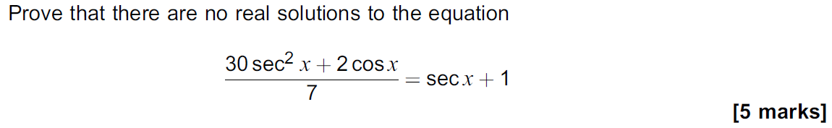

Qu 4… AQA A2 Paper 1, June 2018 – Qu13. (Link to markscheme)
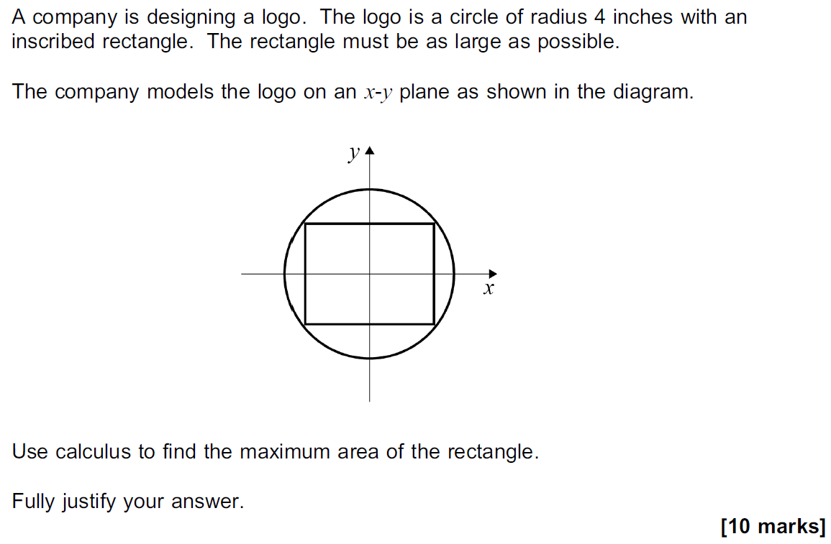

Qu 5… AQA A2 Paper 2, June 2018 -Qu 8. (Link to markscheme)
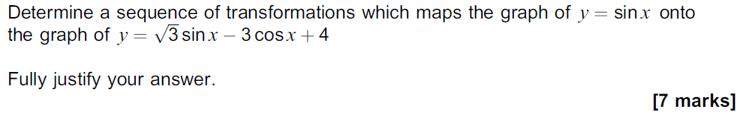
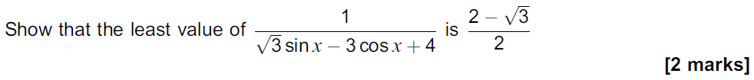
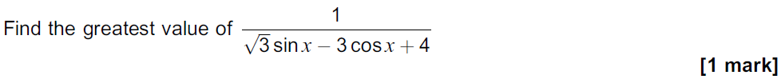

Qu 6… AQA A2 Paper 2, June 2018 - Qu 7. (Link to markscheme)

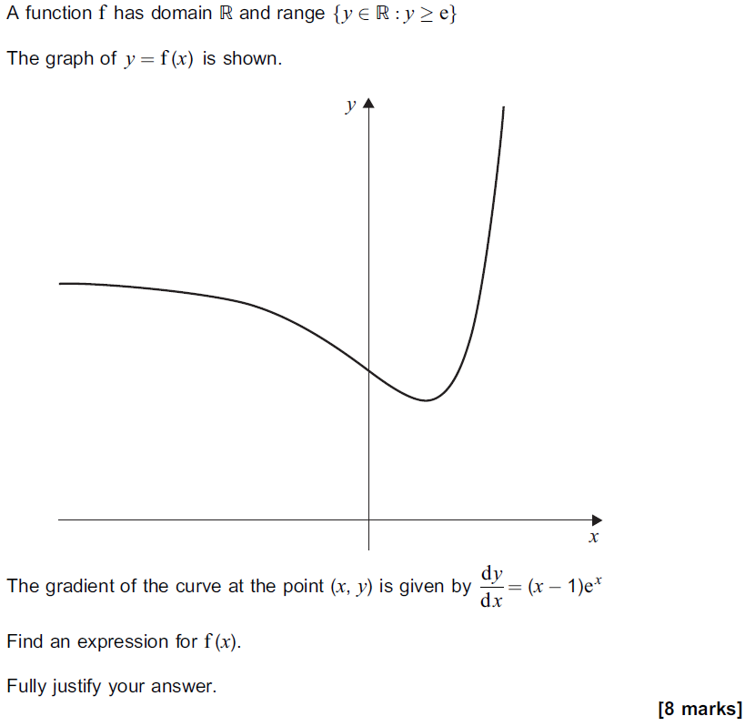

Qu 7… Edexcel unit tests, parametric Equations -Qu 6. (Link to markscheme)
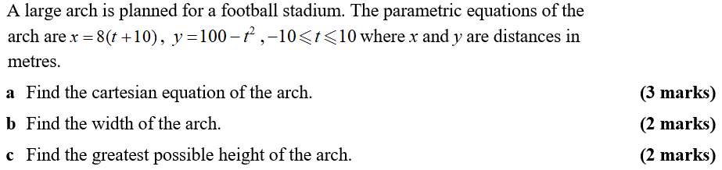

Qu 8… Edexcel Paper 1, June 2018 - Qu7. (Link to markscheme)
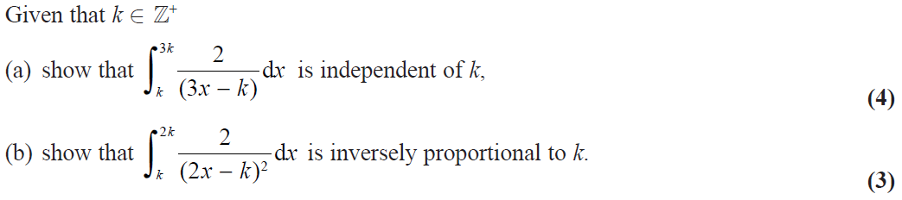

Qu 9… AQA Paper 3, June 2018 – Qu 6. (Link to markscheme)
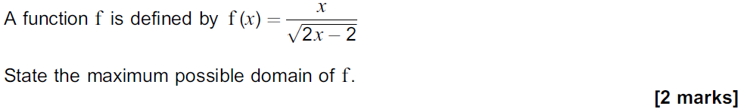

Qu 10… AQA Paper 3, June 2018 – Qu 8. (Link to markscheme)
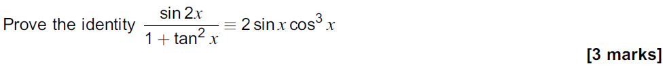

Qu 11… OCR A, Paper 2, June 2018. (Link to markscheme)

Qu 12… OCR A, Paper 2, June 2018. (Link to markscheme)
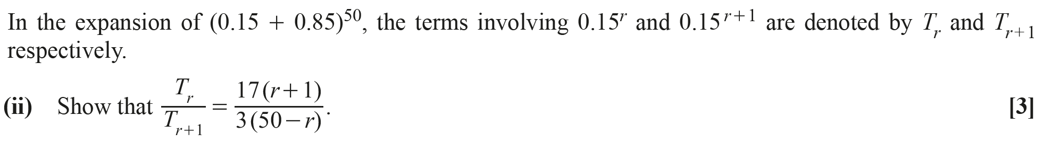

Qu 13… OCR, Paper 1, June 2018. (Link to markscheme)
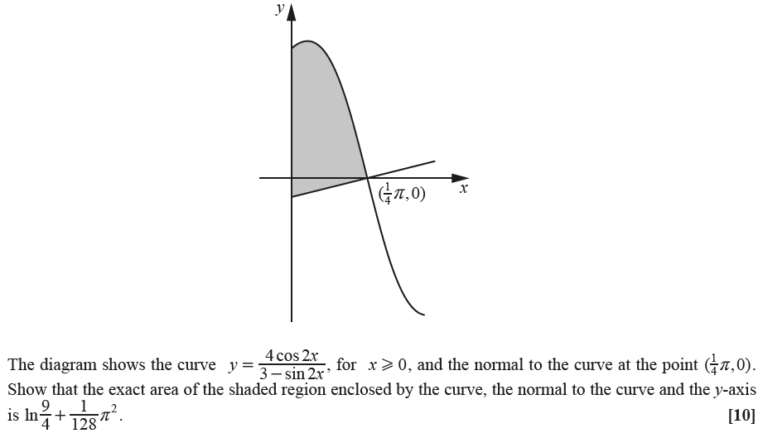

Qu 14… OCR, Paper 2, June 2018. (Link to markscheme)
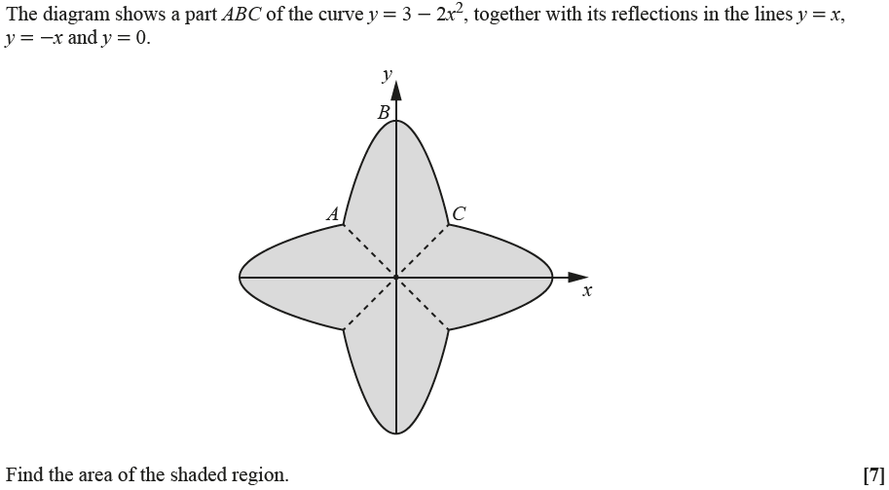

Qu 15… OCR Practice Papers, Set 2, Paper 3 - Qu3. (Link to markscheme)

Qu 16… OCR Practice Papers, Set 4, Paper 1. (Link to markscheme)

Qu 17… AQA Core 3, June 2013. (Link to markscheme)
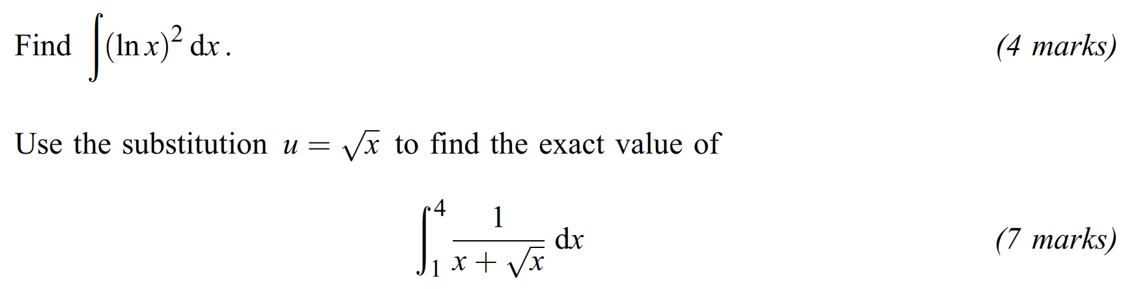

Qu 18… MEI, Paper 1, June 2018 – Qu 10. (Link to markscheme)
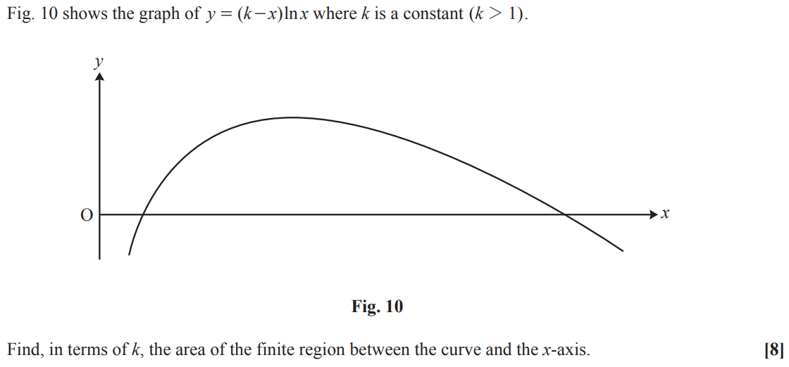

Qu 19… MEI, Paper 1, June 2018 -Qu 11. (Link to markscheme)
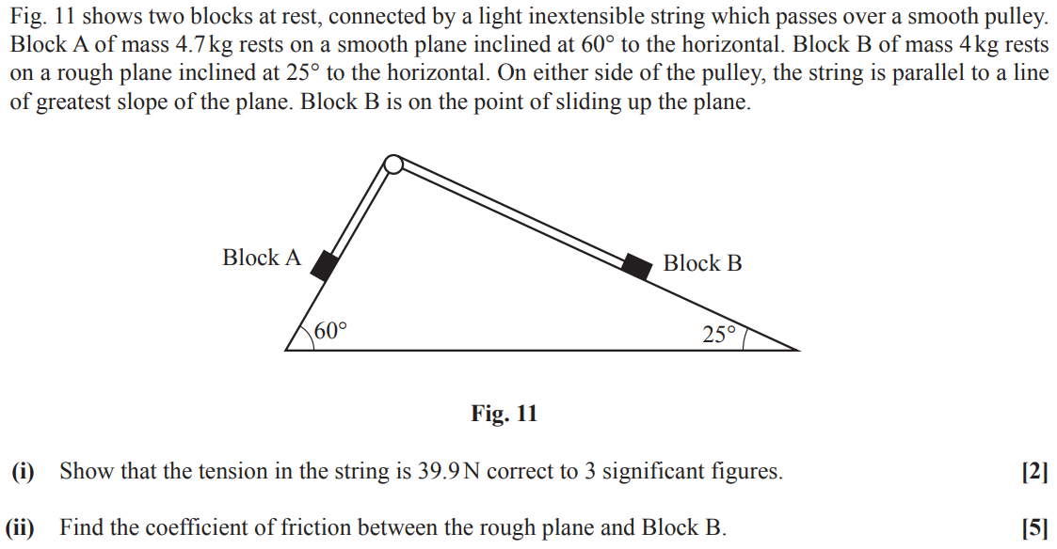

Qu 20… MEI, Paper 3, June 2018 – Qu 10. (Link to markscheme)
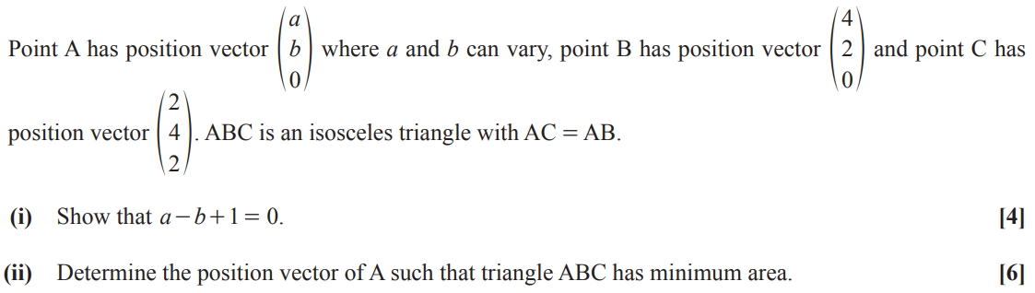

Qu 21… Edexcel Mock Papers, Paper 1 – Qu 11. (Link to markscheme)
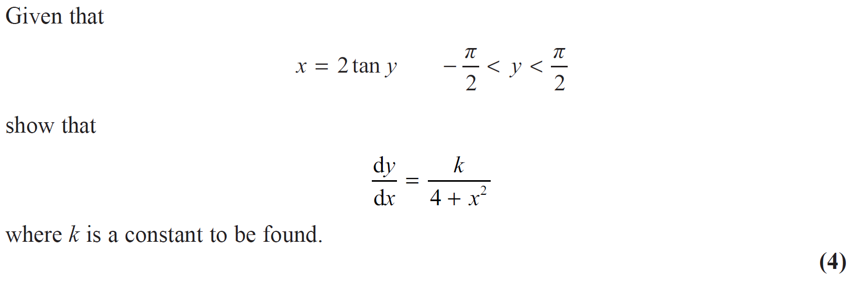

Qu 22… Edexcel Mock Papers, Paper 1 - Qu 10. (Link to markscheme)
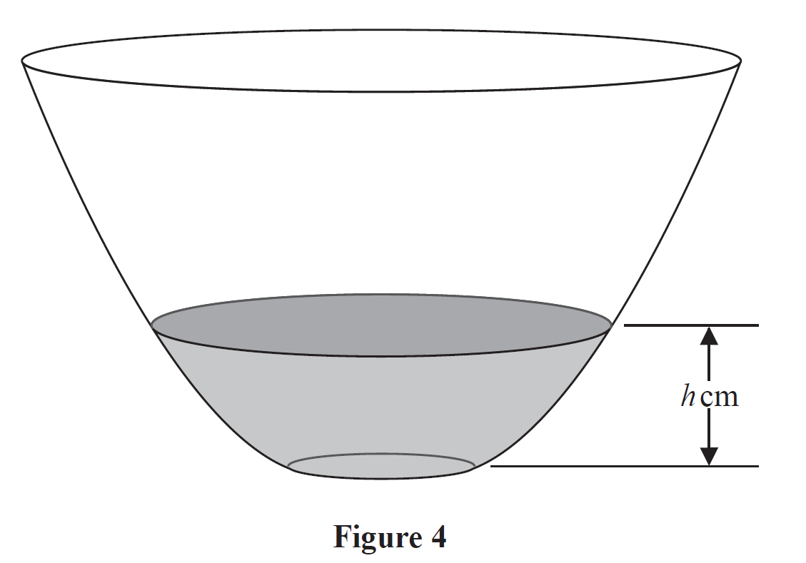
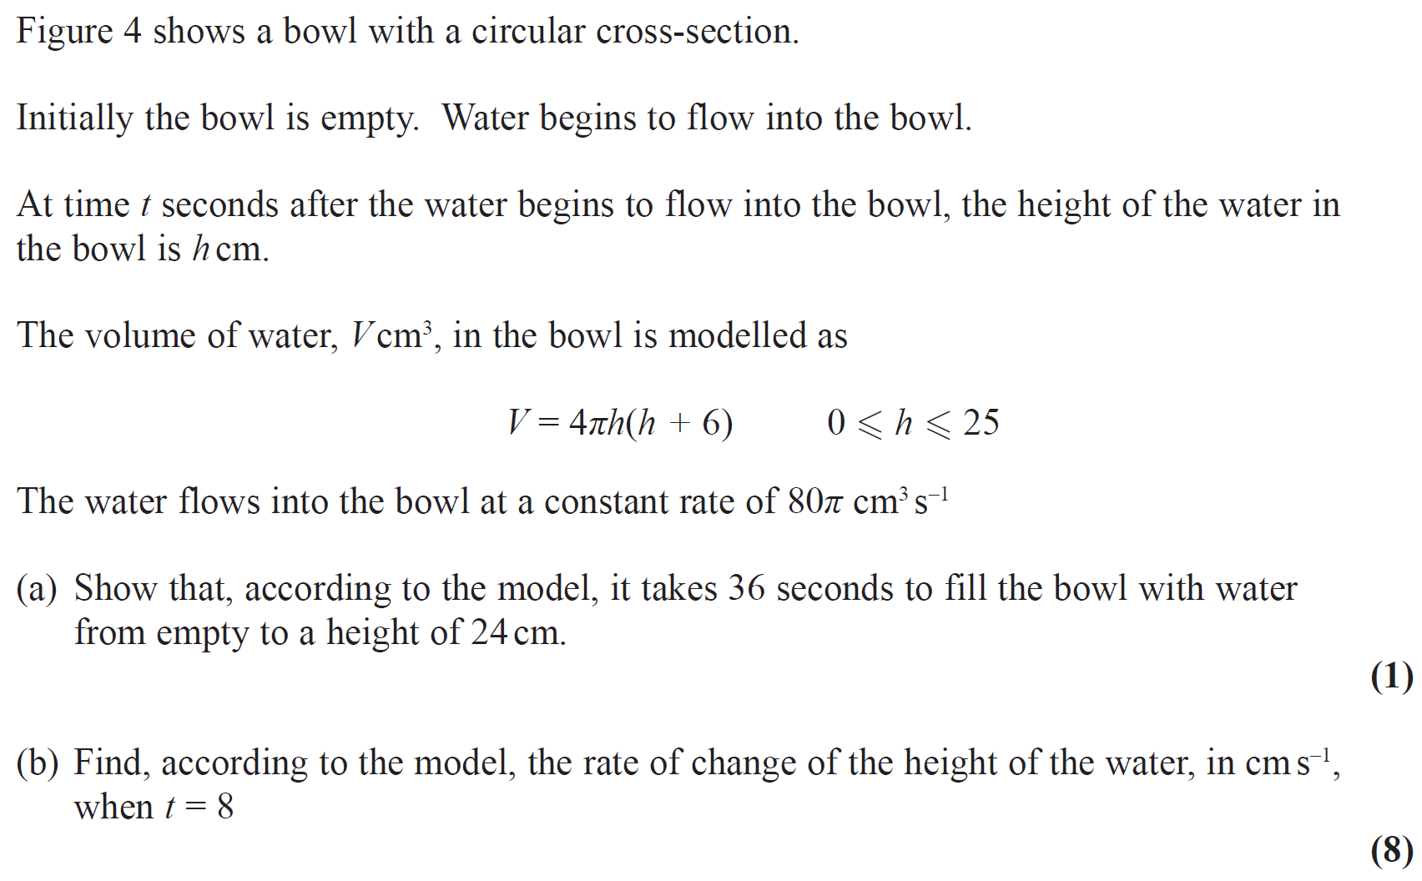

Qu 23… Edexcel, A2 Paper 1, June 2019 – Qu 9. (Link to markscheme)
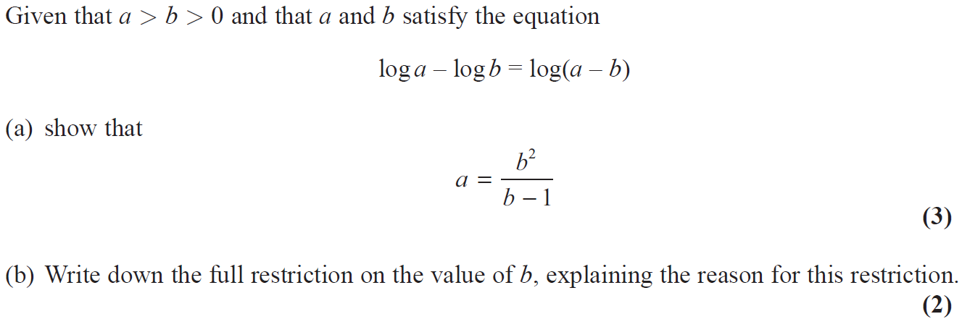
Qu 24… Edexcel Mock Papers, Paper 1 – Qu 13. (Link to markscheme)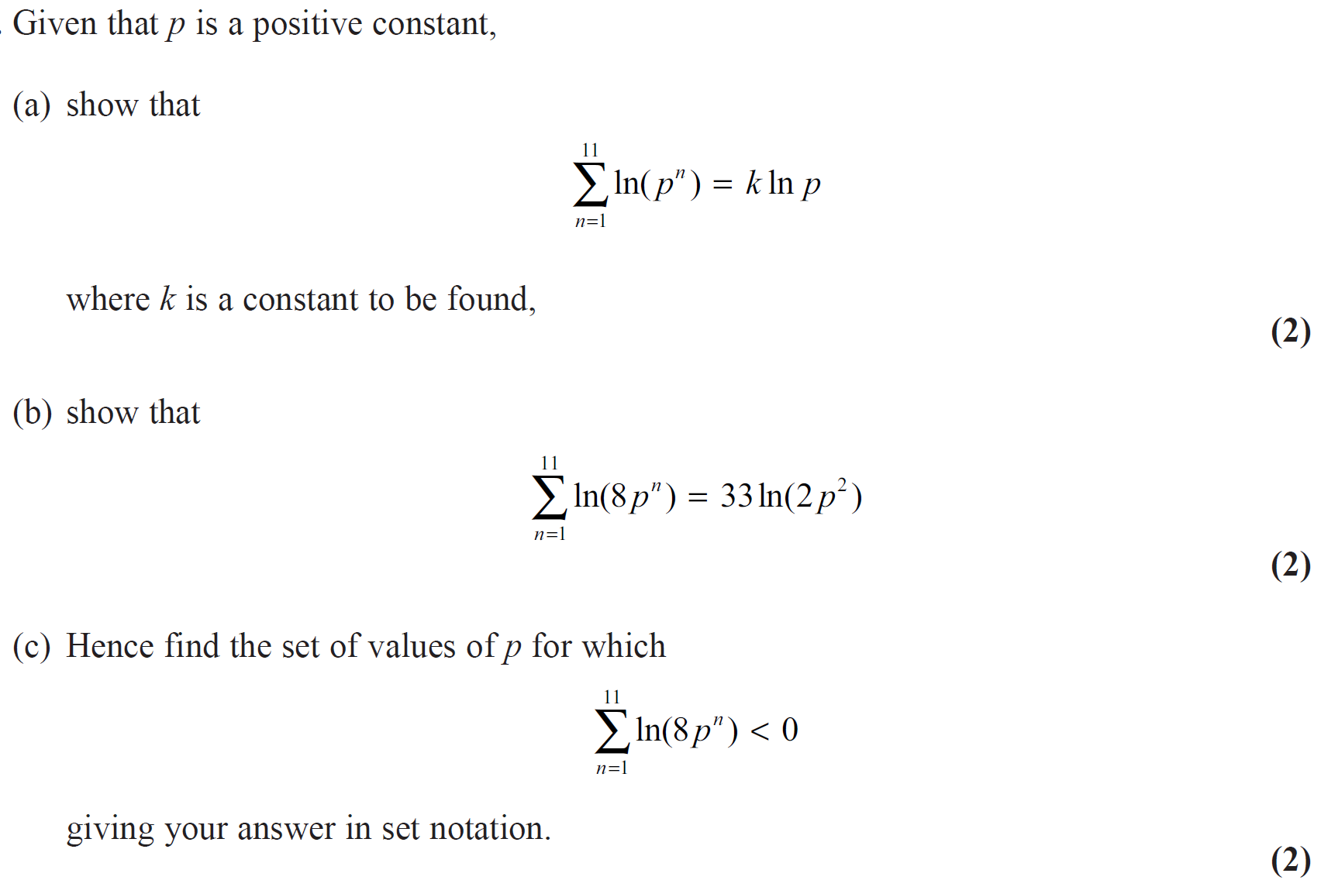

Qu 25… OCR AS Paper 2, 2019. (Link to markscheme)
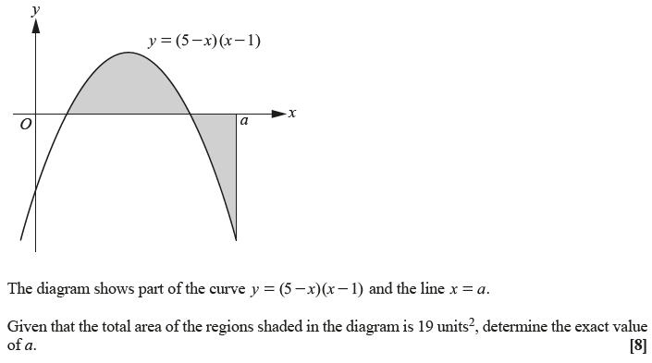

Qu 26… Edexcel Mock Papers, Paper 1 -Qu 14. (Link to markscheme)
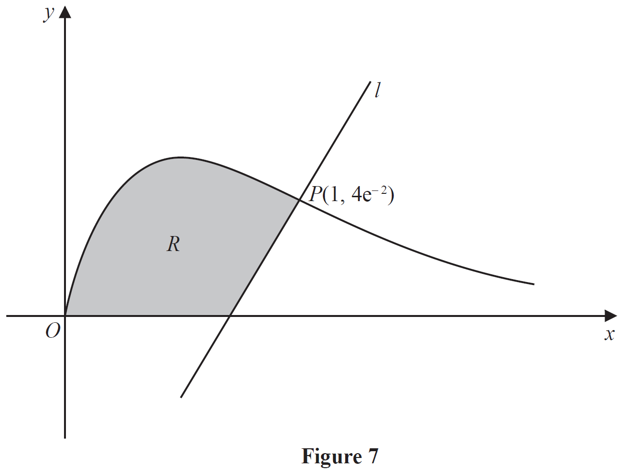
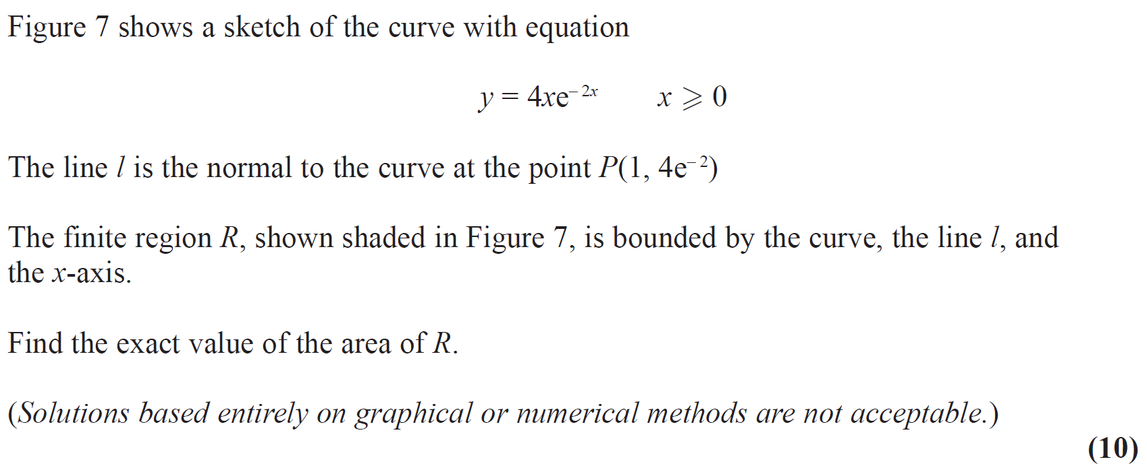

Qu 27… Edexcel A2 Paper 2, 2018 – Qu 4. (Link to markscheme)
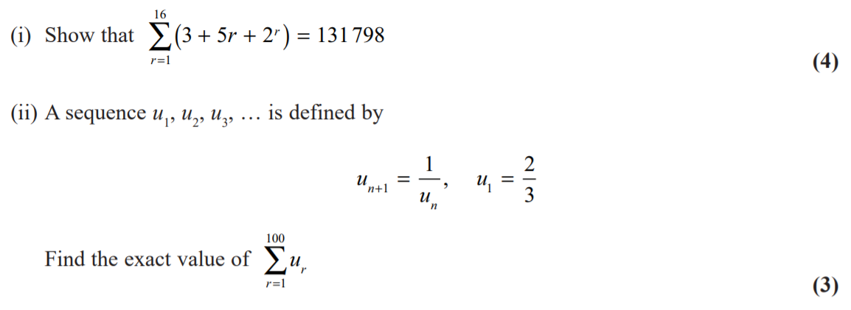

Qu 28… AQA, A2 Paper 2, 2019. (Link to markscheme)
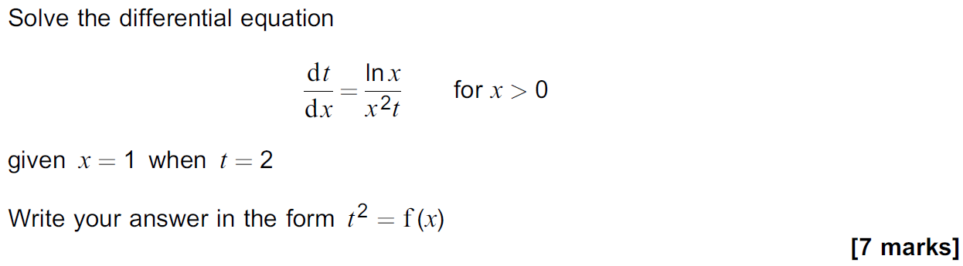

Qu 29… Edexcel, A2 Paper 1, June 2019 – Qu 5. (Link to markscheme)

Qu 30… Edexcel unit tests, Integration – Qu 8. (Link to markscheme)
Use the substitution $x=4\sin^{2}θ$ to find

,

giving your answer in the form $aπ+b$, where $a$ and $b$ are exact constants.
(9)

Qu 31… Edexcel, A2 Paper 1, June 2019 – Qu 4. (Link to markscheme)
The binomial expansion of
$$\frac{1}{\sqrt{4-x}}$$

Can be used to find an approximation to $\sqrt{2}$.

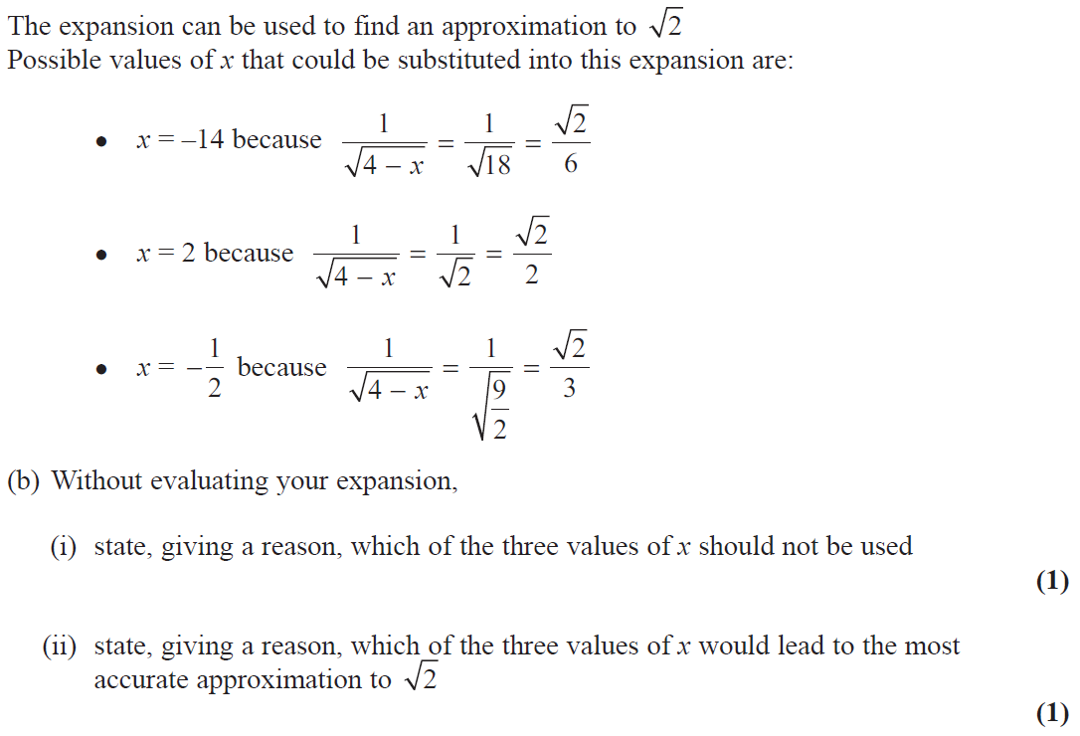

Qu 32… Edexcel, A2 Paper 1, June 2019 – Qu 14. (Link to markscheme)

Qu 33… AQA, A2 Paper 2, 2019. (Link to markscheme)
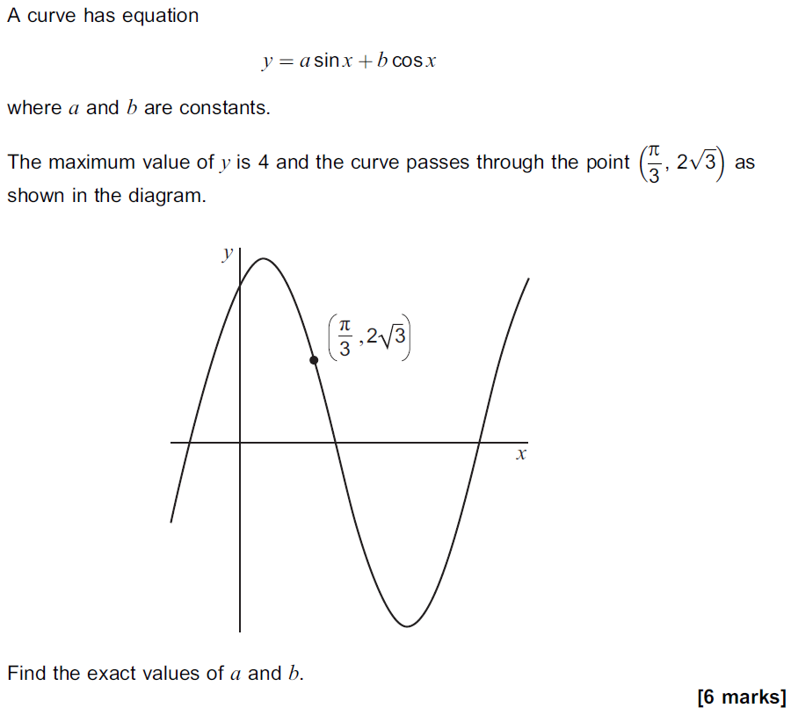

Qu 34… Edexcel Unit Tests, A2 Stats, Topic 2, Hypothesis Testing. (Link to markscheme)
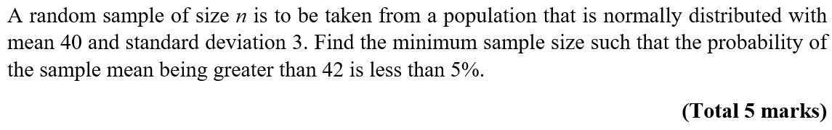

Interesting Questions - Answers

Qu 1… Edexcel unit tests, Parametric Equations - Qu 3. (Link back to question)
$$\frac{35}{6}π$$

Qu 2… AQA A2 Paper 1, June 2018 -Qu 5. (Link back to question)
$$xy+5x-3y=27$$

Qu 3… AQA A2 Paper 1, June 2018 – Qu 12. (Link back to question)
$$(2x+1)(5x-2)(3x-1)$$

Qu 4… AQA A2 Paper 1, June 2018 – Qu13. (Link back to question)
32 sq in

Qu 5… AQA A2 Paper 2, June 2018 -Qu 8. (Link back to question)

Qu 6… AQA A2 Paper 2, June 2018 - Qu 7. (Link back to question)

Qu 7… Edexcel unit tests, parametric Equations -Qu 6. (Link back to question)
Width = 160m
Height = 100m

Qu 8… Edexcel Paper 1, June 2018 - Qu7. (Link back to question)
-

Qu 9… AQA Paper 3, June 2018 – Qu 6. (Link back to question)

Qu 10… AQA Paper 3, June 2018 – Qu 8. (Link back to question)

Qu 11… OCR A, Paper 2, June 2018. (Link back to question)
0.0668 or 0.067

Qu 12… OCR A, Paper 2, June 2018. (Link back to question)
-

Qu 13… OCR, Paper 1, June 2018. (Link back to question)
-

Qu 14… OCR, Paper 2, June 2018. (Link back to question)
$$\frac{44}{3}$$

Qu 15… OCR Practice Papers, Set 2, Paper 3 - Qu3. (Link back to question)

Qu 16… OCR Practice Papers, Set 4, Paper 1. (Link back to question)
$$(ln7, ln2)$$

Qu 17… AQA Core 3, June 2013. (Link back to question)

Qu 18… MEI, Paper 1, June 2018 – Qu 10. (Link back to question)

Qu 19… MEI, Paper 1, June 2018 -Qu 11. (Link back to question)
$$μ=0.656$$

Qu 20… MEI, Paper 3, June 2018 – Qu 10. (Link back to question)

Qu 21… Edexcel Mock Papers, Paper 1 – Qu 11. (Link back to question)

Qu22… Edexcel Mock Papers, Paper 1 - Qu 10. (Link back to question)

Qu 23… Edexcel, A2 Paper 1, June 2019 – Qu 9. (Link back to question)

Qu 24… Edexcel Mock Papers, Paper 1 – Qu 13. (Link back to question)
$$66lnp$$

Qu 25… OCR AS Paper 2, 2019 – Qu7. (Link back to question)

Qu 26… Edexcel Mock Papers, Paper 1 -Qu 14. (Link back to question)
or

Qu 27… Edexcel A2 Paper 2, 2018 – Qu 4. (Link back to question)

Qu 28… AQA, A2 Paper 2, 2019. (Link back to question)

Qu 29… Edexcel, A2 Paper 1, June 2019 – Qu 5. (Link back to question)
Qu 30… Edexcel unit tests, Integration – Qu 8. (Link back to question)

Qu 31… Edexcel, A2 Paper 1, June 2019 – Qu 4. (Link back to question)

Qu 32… AQA, A2 Paper 2, 2019. (Link back to question)

Qu 33… Edexcel, A2 Paper 1, June 2019 – Qu 14. (Link back to question)
$$a=2, b=2\sqrt{3}$$

Qu 34… Edexcel Unit Tests, A2 Stats, Topic 2, Hypothesis Testing. (Link to question)
