Intersection of Three Planes

Type | Image | Example | Normals Parallel? | Coefficient Multiples? | Normals Coplanar? | $$Det\left(M\right)=$$ | Planes Consistent? | Number of Solutions | Other Notes
All Parallel | 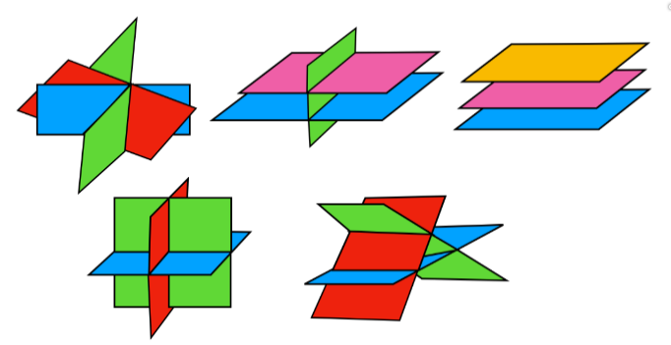 | $$6x-15y-3z+9=0$$  $$2x-5y-z-1=0$$  $$4x-10y-2z-4=0$$ | All normals parallel | Coefficients are multiples, (constants not multiples) |  | $$Det\left(M\right)=0$$  $$n_{1}⋅n_{2}×n_{3}=0$$ | Planes are inconsistent | No solutions
Two Parallel  and the other not | 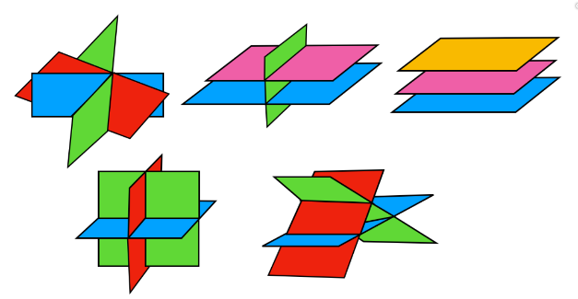 | $$6x-15y-3z+9=0$$  $$2x-5y-z-1=0$$  $$5x-10y-3z-4=0$$ | Only two normals parallel | Only two sets of coefficients are multiples |  | $$Det\left(M\right)=0$$  $$n_{1}⋅n_{2}×n_{3}=0$$ | Planes are inconsistent | No solutions
Triangular Prism | 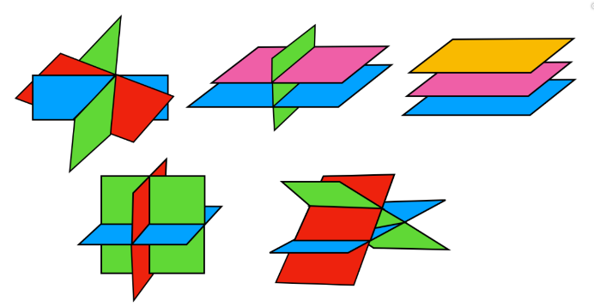 | $$6x-5y+3z-1=0$$  $$4x+y-z+5=0$$  $$x-3y+2z+7=0$$ | No normals parallel | No coefficient multiples | All three normals coplanar | $$Det\left(M\right)=0$$  $$n_{1}⋅n_{2}×n_{3}=0$$ | Planes are inconsistent | No solutions | One normal is a combination of multiples of the other normals
A Sheaf | 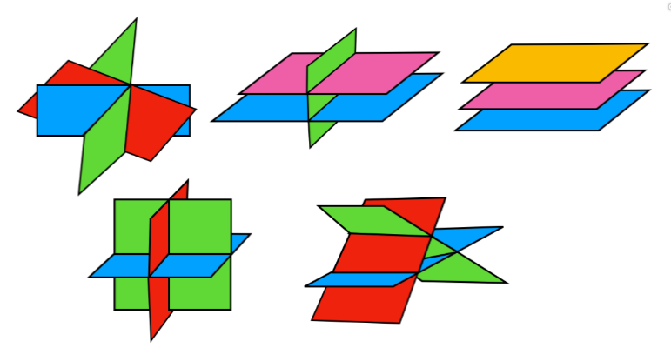 | $$6x-5y+3z+19=0$$  $$4x+y-z+5=0$$  $$x-3y+2z+7=0$$ | No normals parallel | No coefficient multiples | All three normals coplanar | $$Det\left(M\right)=0$$  $$n_{1}⋅n_{2}×n_{3}=0$$ | Planes are consistent | Infinite solutions, equation of a line | One full equation is a combination of multiples of the other two
Single Point | 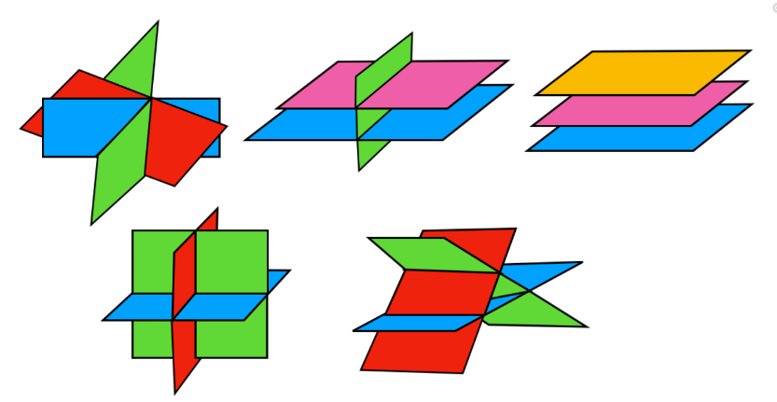 | $$6x-5y+3z+19=0$$  $$4x+y-z+5=0$$  $$x-3y+z+7=0$$ | No normals parallel | No coefficient multiples | Normals not coplanar | $$Det\left(M\right)≠0$$  $$n_{1}⋅n_{2}×n_{3}≠0$$ | Planes are consistent | One unique solution

Intersection of Three Planes

All Parallel
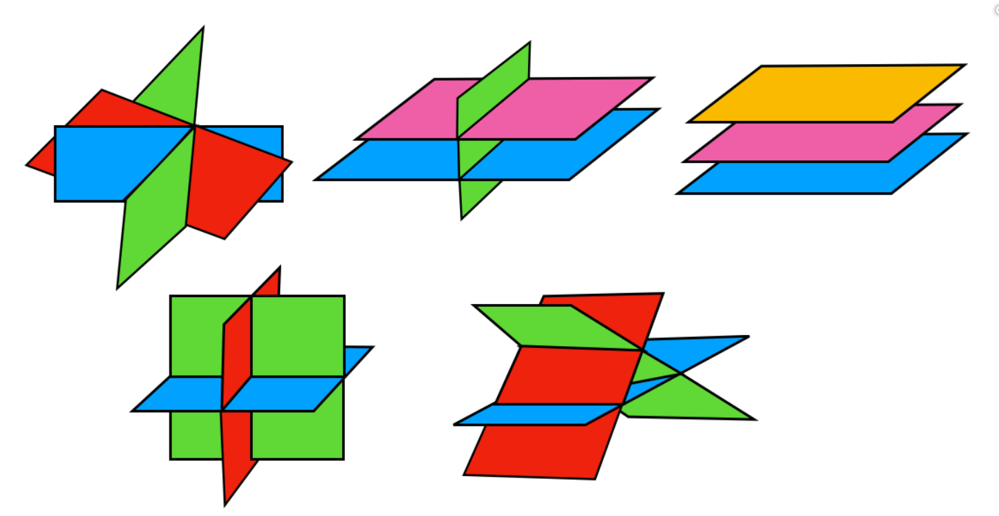 | $$6x-15y-3z+9=0$$  $$2x-5y-z-1=0$$  $$4x-10y-2z-4=0$$
- All normals parallel so are multiples of each other. In example above, the blue numbers are all multiples.
- The constants are not in the same multiples as, if they were, the equations would represent the same plane
- $Det\left(M\right)=0$
- Planes are inconsistent since no points on all three planes, i.e no solutions

Two Parallel (and the other not)
$$6x-15y-3z+9=0$$
$$2x-5y-z-1=0$$
$$5x-10y-3z-4=0$$
- Two normals parallel so are multiples of each other. In example above, the blue numbers are all multiples but the greens aren’t.
- The third plane crosses the others along two parallel lines
- $Det\left(M\right)=0$
- Planes are inconsistent since no points on all three planes, i.e no solutions

Triangular Prism
$$6x-5y+3z-1=0$$
$$4x+y-z+5=0$$
$$x-3y+2z+7=0$$
- Planes intersecting in pairs of parallel lines
- No normals parallel so no multiples of each other. In example above, the blues, greens and oranges aren’t multiples of each other.
- One of the normals is a combination of multiples of the other two normals. In example above,
$$blue normal = 2×green normal+orange normal$$
- All three normals are coplanar, i.e they all lie in the same plane.
- $Det\left(M\right)=0$
- Planes are inconsistent since no points on all three planes, i.e no solutions
A Sheaf
$$6x-5y+3z+19=0$$
$$4x+y-z+5=0$$
$$x-3y+2z+7=0$$
- All three planes intersecting in a line
- Similar to triangular prism but with the prism reduced to a single line
- No normals parallel so no multiples of each other. In example above, the blues, greens and oranges aren’t multiples of each other.
- One full equation is a combination of multiples of the other two. In example above,
$$blue= 2×green +orange$$
- As with the triangular prism, all three normals are coplanar, i.e they all lie in the same plane.
- $Det\left(M\right)=0$
- Planes are consistent since there are points that lie on all three planes.
- The solution is the equation of a line and there are infinite solutions along this line

Single Point
$$6x-5y+3z+19=0$$
$$4x+y-z+5=0$$
$$x-3y+z+7=0$$
- All three planes intersect at a single point so there is one specific solution
- Planes are consistent since there is a point that lies on all three planes.
- No normals parallel so no multiples of each other. In example above, the blues, greens and oranges aren’t multiples of each other.
- The normals aren’t coplanar
- The triple scalar product isn’t zero, i.e. $n_{1}⋅\left(n_{2}×n_{3}\right)≠0$. This is because the triple scalar product represents the volume of the 3D object formed by these three vectors. If this isn’t zero then the normals aren’t coplanar and this volume exists.
- $Det\left(M\right)≠0$

https://www.youtube.com/watch?v=duFRYId7kNU&t=8s
https://www.youtube.com/watch?v=zga9_x-rh3E
https://www.youtube.com/watch?v=V9Lo9M7gwCg

