Scatter Graphs (and Least Squares Regression Lines)

The scatter graph shows information about the height and the arm length of some students in Year 11.
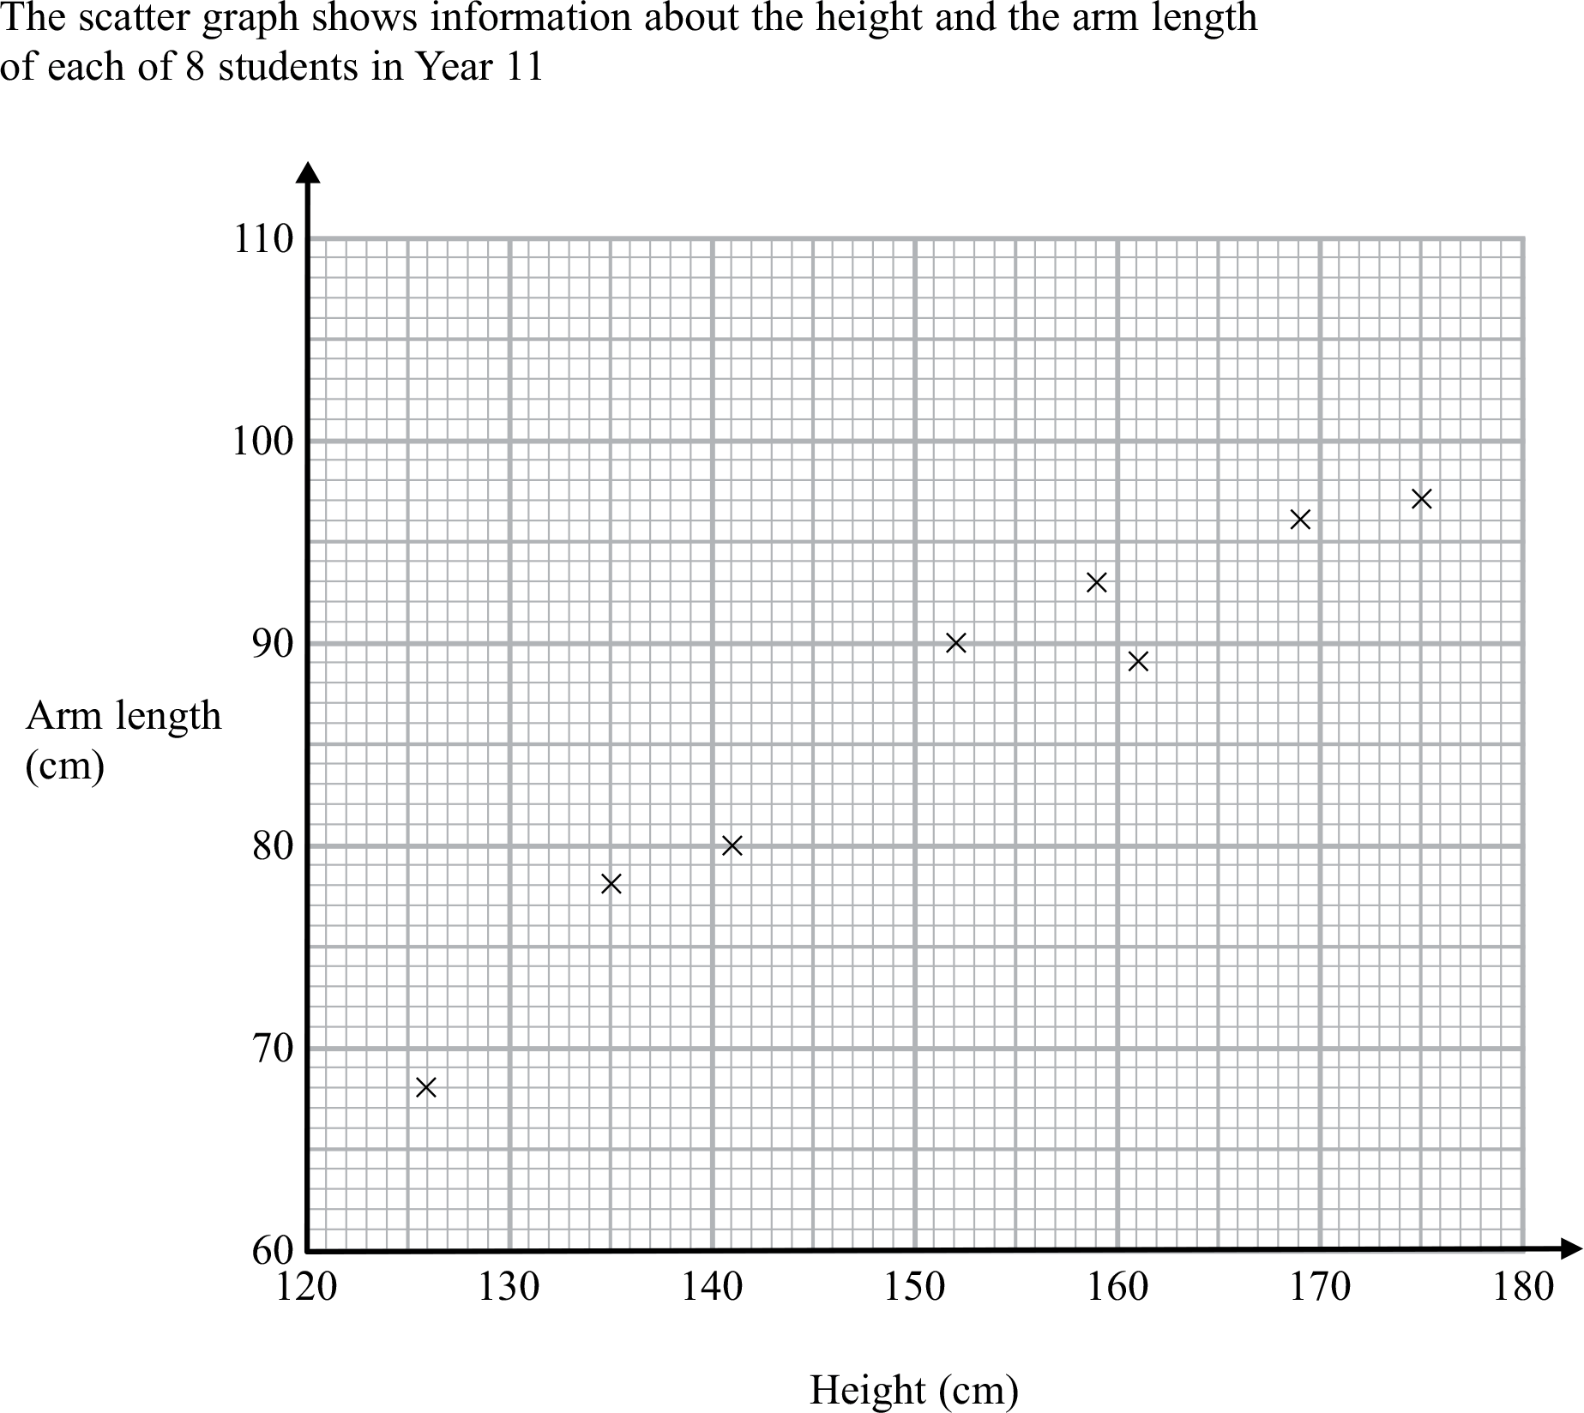

- On the scattergraph, plot the remaining information from the table below.

Height (cm) | 126 | 132 | 135 | 141 | 152 | 159 | 161 | 166 | 169 | 175
Arm length (cm) | 68 | 75 | 78 | 80 | 90 | 93 | 89 | 93 | 96 | 97

- What type of correlation does this scatter graph show?

- Draw in a line of best fit

A different student in Year 11 has a height of 148 cm.

- Estimate the arm length of this student.

(Exam question adapted from Edexcel higher tier paper 1, November 2012)

x_{i} | 126 | 132 | 135 | 141 | 152 | 159 | 161 | 166 | 169 | 175
x_{i}²
y_{i} | 68 | 75 | 78 | 80 | 90 | 93 | 89 | 93 | 96 | 97
y_{i}²
x_{i} y_{i}

Find:

- $\overline{x}$
- $\overline{y}$
- $\sum{x_{i}}$
- $\sum{y_{i}}$
- $\sum{{x_{i}}^{2}}$
- $\sum{{y_{i}}^{2}}$
- $\sum{x_{i}y_{i}}$
- $\sum{{x_{i}}^{2}}-\frac{{\left(\sum{x_{i}}\right)}^{2}}{n}$
- $\sum{{y_{i}}^{2}}-\frac{{\left(\sum{y_{i}}\right)}^{2}}{n}$
- $\sum{x_{i}y_{i}}-\frac{\left(\sum{x_{i}}\right)\left(\sum{y_{i}}\right)}{n}$

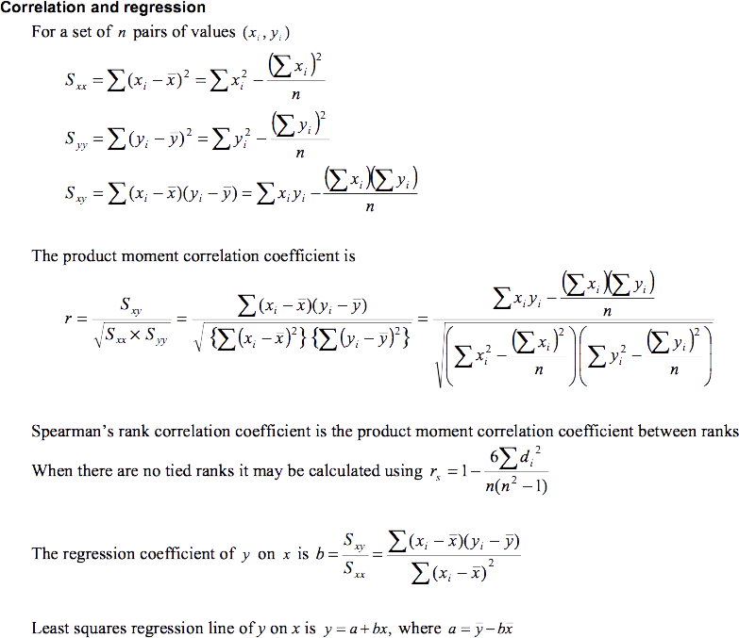

Use the values that you found in parts (a)-(j) together with the excerpt of the formula book above to find;

- The product moment correlation coefficient, r, of x and y.
- The regression coefficient, b, of y on x.
- The equation of the least squares regression line of y on x, in the form
$y=a+bx$.

- Use your values of $\overline{x}$ and $\overline{y}$ to plot the coordinate $\left(\overline{x},\overline{y}\right)$ on the scatter graph.
- Use your equation of the least squares regression line to find a corresponding y value for $x=170$ and plot this coordinate on the scatter graph. Draw in the least squares regression line of y on x. Compare this with your original line of best fit.
Scatter Graphs (and Least Squares Regression Lines) - Answers

The scatter graph shows information about the height and the arm length of some students in Year 11.
X
X
X
X

- On the scattergraph, plot the remaining information from the table below.

Height (cm) | 126 | 132 | 135 | 141 | 152 | 159 | 161 | 166 | 169 | 175
Arm length (cm) | 68 | 75 | 78 | 80 | 90 | 93 | 89 | 93 | 96 | 97

- What type of correlation does this scatter graph show? (strong) positive

- Draw in a line of best fit

A different student in Year 11 has a height of 148 cm.

- Estimate the arm length of this student. 84 cm

(Exam question adapted from Edexcel higher tier paper 1, November 2012)

x_{i} | 126 | 132 | 135 | 141 | 152 | 159 | 161 | 166 | 169 | 175
x_{i}²
y_{i} | 68 | 75 | 78 | 80 | 90 | 93 | 89 | 93 | 96 | 97
y_{i}²
x_{i} y_{i}

Find:

- $\overline{x}=151.6$
- $\overline{y}=85.9$
- $\sum{x_{i}}=1516$
- $\sum{y_{i}}=859$
- $\sum{{x_{i}}^{2}}=232454$
- $\sum{{y_{i}}^{2}}=74677$
- $\sum{x_{i}y_{i}=131711}$
- $\sum{{x_{i}}^{2}}-\frac{{\left(\sum{x_{i}}\right)}^{2}}{n}=2628.4$
- $\sum{{y_{i}}^{2}}-\frac{{\left(\sum{y_{i}}\right)}^{2}}{n}=888.9$
- $\sum{x_{i}y_{i}}-\frac{\left(\sum{x_{i}}\right)\left(\sum{y_{i}}\right)}{n}=1486.6$

Use the values that you found in parts (a)-(j) together with the excerpt of the formula book above to find;

- The product moment correlation coefficient, r, of x and y. 0.973
- The regression coefficient, b, of y on x. 0.566
- The equation of the least squares regression line of y on x, in the form
$y=a+bx$. $y=0.156+0.566x$

- Use your values of $\overline{x}$ and $\overline{y}$ to plot the coordinate $\left(\overline{x},\overline{y}\right)$ on the scatter graph.$\left(151.6, 85.9\right)$
- Use your equation of the least squares regression line to find a corresponding y value for $x=170$ and plot this coordinate on the scatter graph. Draw in the least squares regression line of y on x. Compare this with your original line of best fit. $y=0.156+0.566×170=96.376$

