LOGO

Basic Logo Commands

Command | What it does
FD 100 | Move the turtle forward 100 steps
RT 90 | Move the turtle to the right 90°
LT 90 | Move the turtle to the left 90°
BK 100 | Move the turtle backwards 100 steps
PU | Pick the turtle’s pen up off the paper
PD | Put the turtle’s pen back down on the paper
CS | Clear the screen
HT | Hide the turtle
ST | Show the turtle
REPEAT 3[…] | Repeat the commands 3 times

There must always be a space between commands.

- Try drawing these shapes, use the commands FD, LT and RT to draw these shapes. Start at .

- Enter this set of commands and write down in your book what shape you get:

FD 100 RT 120 FD 100 RT 120 FD 100 RT 120

Clear the screen (CS) and type in REPEAT 3[FD 100 RT 120]. Check that you get the same shape.

- For each of the following, rewrite the commands using the REPEAT command. Enter your command and write down in your book what shape you get.

  - FD 100 RT 45 FD 100 RT 45 FD 100 RT 45 FD 100 RT 45 FD 100 RT 45 FD 100 RT 45 FD 100 RT 45 FD 100 RT 45

  - FD 100 RT 72 FD 100 RT 72 FD 100 RT 72 FD 100 RT 72 FD 100 RT 72 FD 100 RT 72

  - FD 100 RT 60 FD 100 RT 60 FD 100 RT 60 FD 100 RT 60 FD 100 RT 60 FD 100 RT 60

Now look back at the angle and the number of repetitions in each series. What is the connection?

- Enter the following set of commands:

REPEAT 4[REPEAT 3[FD 100 RT 120] RT 90]

What shape does this produce and why?

- Try drawing the following shapes using the repeat command

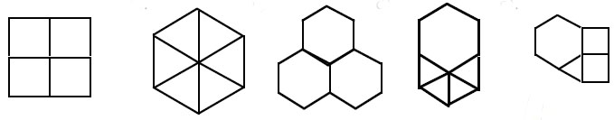

- Programming Logo. Try the following:

TO TRIANGLE
REPEAT 3[FD 100 RT 120]
END

Now type in TRIANGLE and hit enter. What happens? If you’re not sure clear the screen (CS) and type TRIANGLE again.

Try using the same idea to program Logo to draw a square.

- One step further – programming with variables. Type in the following:

TO SHAPE :n :a :b :c
REPEAT :n[FD :a RT 90 FD :b RT 90 FD :c RT 90]
END

Now, similarly to what you did in section 6, type in SHAPE 4 150 70 100. Try other values of n, a, b, c too.

- Some more ideas for you to try:

- Draw a house using LOGO
- Create a row of houses
- Draw a face using LOGO
- Spell your name using LOGO
- Create flags like the Union Jack

More ideas at www.mathsnet.net/logo.html.

