Manipulating Decimals

Unfortunately the decimal point button is missing from this calculator. Show how you could find answers to these calculations without it.

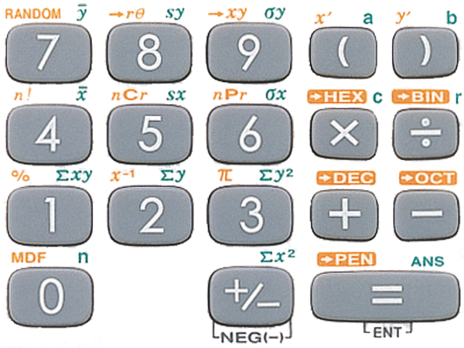

Multiplying:

Dividing:

Now make some questions up of your own and ask a partner to try them

