**Many Three Quick Questions**

1. Find $\frac{dy}{dx}$ given $y=3×2^{4x-1}$
2. Determine the exact value of
$$\int_{0}^{4}{\frac{x}{x^{2}+9}}dx$$

3. Find the value of
$$\int_{\frac{π}{4}}^{\frac{π}{2}}{\frac{sinx}{ln\left(3x+1\right)}dx}$$

4. The block is in equilibrium and the coefficient of friction is 0.4. Find the magnitude of the friction force.



1. If $f\left(x\right)=3sin2x-5cos2x$, what is the range of $f\left(x\right)$?
2. A particle has velocity $v=\left(\begin{matrix}sint+1 \\ e^{2t}\end{matrix}\right)$.

Find an expression for ***s***.

1. Given $f\left(x\right)=x^{2}-6x-5, x≤3$,

What is the range of $f(x)$?

Find $f^{-1}(x)$

1. Events $A$ and $B$ are independent. $P\left(A\right)=0.3$ and $P(B)=0.6$. Determine $P(A∪B)$.
2. Last year, 70% of my cucumber seeds germinated. This year, I think the proportion that germinate will be higher. I plant 20 seeds and do a hypothesis test at the 5% level.  
     
   What are the critical values for my test?  
   What is the probability I incorrectly conclude the proportion is higher?
3. Given ${\left(3+x\right)}^{\frac{1}{2}}≈3+\frac{x}{6}-\frac{x^{2}}{216}$, for what values of x is this valid?  
   Given ${\left(1+3x\right)}^{\frac{1}{2}}≈1+\frac{3}{2}x-\frac{9}{8}x^{2}$*.*  Use a suitable value of $x$ to show $\sqrt{10}≈\frac{2049}{648}$
4. Which method would you use to evaluate each of these integrals?…

|  |  |  |
| --- | --- | --- |
| $\int{\frac{1}{1-x^{2}}dx}$ | $\int{\frac{1-x^{2}}{x}}dx$ | $\int{\frac{x}{1-x^{2}}}dx$ |

1. Simplify $\sin{2x}\cos{x+\cos{2x\sin{x}}}$
2. Information about the types of houses and numbers of children living in each house on a housing estate in Sprowston, is shown below.

Determine whether the events ‘detached house’ and ‘no children’, are independent.

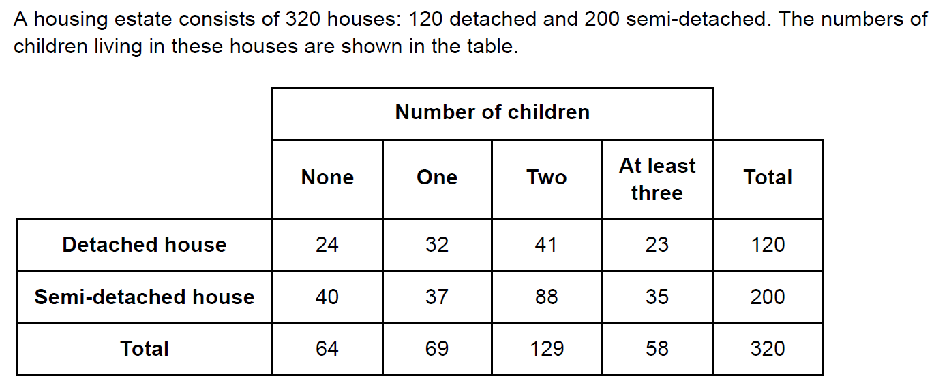

1. Sketch the graph of $y=\ln{x}$
2. Show that
$$\int{\ln{x}dx=x\ln{x}-x+c}$$

3. Use four rectangles to determine lower and upper bounds for

$$\int_{3}^{5}{\ln{x}dx}.$$

Estimate the value of the integral to the maximum possible accuracy.

1. A student draws a circle centre (-3, 1), radius 4, and the line $y+2x=4$ on the same axes.

Describe what they will find, explaining your reasoning.

1. What numbers are these?... 1.23E5 and 4.56E-2 ?
2. Given $f\left(x\right)=\frac{8x+5}{2x+3}$, show that $f\left(x\right)=A+\frac{B}{2x+3}$, giving the values of $A$& $B$.
3. Determine the exact value of
$$\lim_{δx→0}{\sum_{x=2.1}^{6.3}{\frac{2}{x}}dx}$$

4. Given $y=x^{2}2^{x}$, find $\frac{dy}{dx}$.

Find, in terms of $a$, the $x$-coordinates of the stationary points on the curve $y=x^{a}a^{x}$.

1. The diagram shows the graph of $y=f\left(x\right).$ The curve has a maximum point at A and a minimum point B.

Write down the constants $a$ and $b$ such that the curve with equation $y=2f\left(x+a\right)+b$ has a minimum point at the origin *O*.

1. 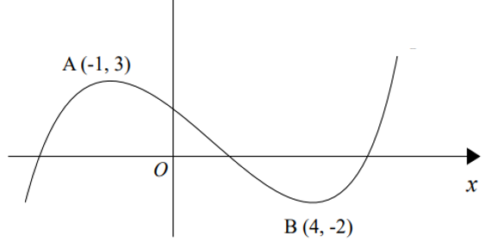
2. Solve $e^{x}-3=4e^{-x}$.
3. Determine the exact value of $2e^{1+3ln2}$
4. Given $f\left(x\right)=x^{3}+4x^{2}-3x-2$,
5. Find the values of $x$ for which $f(x)$ is an increasing function. Give your answer in set notation.
6. Find the values of $x$ for which $f(x)$ is decreasing **and** convex.
7. Suggest suitable substitutions for the following integrations

$\int{\frac{4x-1}{{\left(2x+1\right)}^{5}}}dx$ $\int{\sqrt{9-x^{2}}}dx$ $\int{\frac{1}{1+\sqrt{x}}}dx$

1. The mass of plaice is believed to be normally distributed.

Steve Tyler from the rock band Aerosmith catches 74 plaice and finds his data has an interquartile range of 3.4 to 4.1 kg.

Determine estimates for the mean and standard deviation of plaice mass.

1. A sample of 53 teacher salaries has mean £30,000 and standard deviation £12,000.

Mick Jagger believes teacher salaries could be normally distributed. Is he right?

1. At every chance they get through all of the day and all of the night, The Kinks roll a biased dice 5750 times.

The probability the dice shows a 5 on any one roll is 0.2. The Kinks find that on 29% of days they gets at least X 5’s.

Use a suitable approximation to estimate the value of X.

1. The curve $y=x^{2}+\sin{x}$ has a stationary point with $x$ in the interval [-1, 0].

Use a Newton-Raphson iteration to find an estimate for the x-coordinate of this stationary point, with a starting value $x_{0}=-1,$ and **two** iterations, giving your answer to 3 d.p.

Use a change of sign method to show that this estimate is accurate to 3 d.p.

1. Show that there are no stationary points on the curve ${\left(x+\sin{y}\right)}^{2}=e^{-y}$
2. Solve the equation $|4-2x|=3x-2$.