
Mars Crash
Student Astronaut Brief

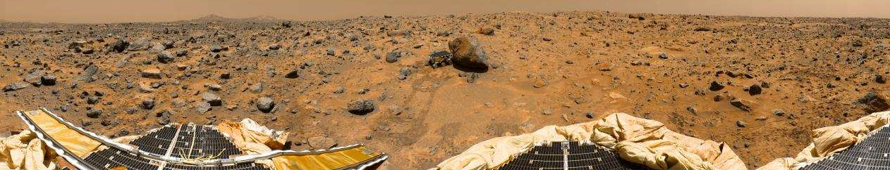
Pathfinder panorama of Mars by NASA/JPL

You have crash landed on Mars. Its local midnight. The habitation module that was sent on a robotic flight from Earth is 50km away. There is a solar flare heading towards Mars. You will receive a fatal dose of radiation if you do not reach the habitation module within in 24 hours. The following is a list of 16 pieces of equipment you have managed to salvage from the crash. You are wearing spacesuits. Whether you reach the habitation module in time or not depends on what you decide to take with you.

Discuss the value of each item and fill in a diamond ranking sheet. Make sure you do it in pencil so that you can change your mind. You should do this very carefully. It should take you at least 30 minutes.

Mobile phone
Box of Mars bars
Star map made for Earth-based astronomers
Compass
Rifle
10 litres of water
20kg tank of oxygen
Orange drink powder
12 x 1.5V alkaline batteries
Rock identification guide
Surf board
Nuclear powered portable heating unit
2 x 20m strong nylon rope
Nintendo
Box of red tipped matches
Solar powered 15V two-way radio
Mars Crash
Diamond Ranking

When you have made a complete ranking, ask your teacher for a comparison table between the Earth and Moon. Look at each line of the table and discuss if it makes any difference to the usefulness of each article on Mars. You will probably need to make another diamond ranking sheet.

Most Useful
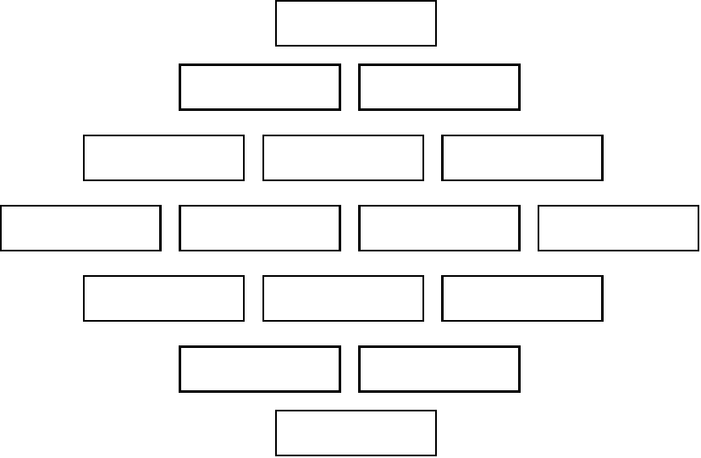
Least Useful

Mars Crash

MARS/EARTH COMPARISON
 | MARS | EARTH
Diameter | 6,786 km | 12,756 km
Distance from Sun (Ave.) | 225 million km | 150 million km
Atmosphere | 7 - 9 millibars;  95% CO₂ 3% N₂ 2%Ar | 1014 millibars;  78% N₂ 21% O₂ 1%Ar
Magnetic field | Extremely weak | Strong
Axial tilt | 25.19º | 23.45º
Revolution period (year) | 687 days | 365 days
Rotation period (day) | 24.62 hrs | 23.93 hrs
Orbital eccentricity | 0.093 | 0.017
Surface gravity | 3.69 m/s² | 9.78 m/s²
Escape velocity | 11,185 mph | 25,055 mph
Surface temperature  Min. Max. Average | -140 ºC 20 ºC -53 ºC | -90 ºC 60 ºC 9 ºC
Solar irradiance | 595 W/m² | 1380 W/m²

Magnetism in Space
Student Evaluation Form

Name…………………………………………..

Ring a face or write a comment to show your feelings. Be honest.

Overall, what did you feel about the course 

How do you feel about the lessons

How do you feel about the homeworks

Has it helped you understand more science

What was the best thing ……………………………………………………...

What was the worst thing …………………………………………………….

Any other comments

…………………………………………………………………………………………

…………………………………………………………………………………………

…………………………………………………………………………………………

…………………………………………………………………………………………

If you enjoyed the course you can help develop more projects like this by joining the Astronomy Club

