Matrices Test

$$A=\left(\begin{matrix}3 & 2 \\ 1 & 4\end{matrix}\right)$$ | $$B=\left(\begin{matrix}2 & 0 \\ 1 & 2\end{matrix}\right)$$ | $$C=\left(\begin{matrix}−1 & 6 & 2 \\ 3 & 1 & −5\end{matrix}\right)$$

- Using the matrices above, find (where possible):

- A+B
- 3A+2B
- B-A
- A+C

- Using the matrices above, multiply (where possible):

- AB
- AC
- CA
- BC

- Solve the following sets of simultaneous equations via matrices using the row reduction method:

- $3x+5y=\text{19}$$2x+7y=\text{20}$
- $−2x+3y=\text{26}$$5x−y=−\text{26}$
- $2a+3b+c=1$$a−b+c=4$$5a+b+3c=\text{10}$

- Copy the coordinate grid and shape.
Apply the following matrix-multiplication transformations to the shape and in each case state exactly how the shape has been transformed.
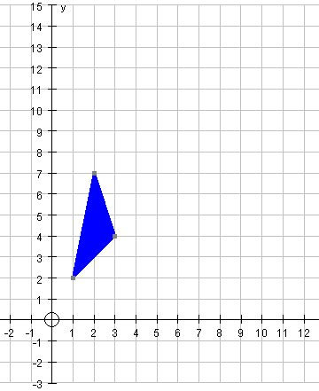
- $\left(\begin{matrix}1 & 2 & 3 \\ 2 & 7 & 4\end{matrix}\right)$$\left(\begin{matrix}x \\ y\end{matrix}\right)$$$\left(\begin{matrix}0 & 1 \\ −1 & 0\end{matrix}\right)$$
- $$\left(\begin{matrix}2 & 0 \\ 0 & 2\end{matrix}\right)$$
- $$\left(\begin{matrix}0 & 1 \\ 1 & 0\end{matrix}\right)$$
- $$\left(\begin{matrix}1 & 0\text{.}5 \\ 0 & 1\end{matrix}\right)$$

