Metric Imperial

Who is taller?

“My names Dave, I’m 5’7’’ ” or “My names Nicole, I’m 170cm”

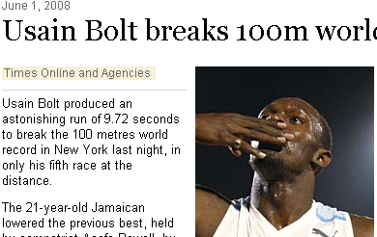
Which is more?

Usain Bolt or 30mph?

http://www.timesonline.co.uk/tol/sport/more_sport/athletics/article4042917.ece

Which is more?

Formula 1 tyre pressure of 1.4 bar (Kg/cm²)
or family car tyre pressure of 29psi

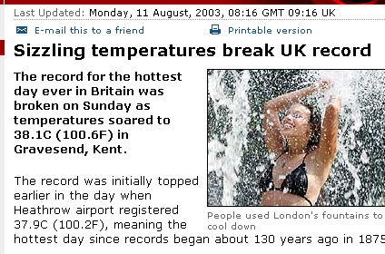
Which is hotter?

The UK’s hottest temperature ever
or Florida temperature of 80° Fahrenheit?

http://news.bbc.co.uk/1/hi/uk/3138865.stm

-40° Celsius = -40° Fahrenheit
100° Celsius = 212° Fahrenheit

Which city has higher population density?

New York City = 27,147 /sq mi
London = 14,724 per km²

http://en.wikipedia.org/wiki/New_York_City
http://en.wikipedia.org/wiki/List_of_English_districts_by_population_density

Compare the price of petrol between UK & USA?

Use these websites to help you:

http://www.petrolprices.com/

http://gasbuddy.com/

