Essential Notes on Moments
Turning forces, torque, Nm

Anticlockwise = +ve Clockwise = -ve

$$Moment= perpendicular distance×force= \left|F\right|∙d$$

Forces through the pivot exert no moment/torque.

Most problems involve finding resultant (translational) force and resultant moment around one or more points, then using these to determine unknown forces or distances. It is possible to use resultant force and resultant moment to calculate position of resultant moment.

Equilibrium ⇒

resultant moment = 0 | and | resultant force = 0
(no turning effect) |  | (no translational effect)

For a system of three forces to be in equilibrium, lines of action of all three forces will meet at a single point.

Resultant of Parallel Forces…

 | Sum of forces | Sum of moments | E.g.
Equilibrium | 0 | 0 | 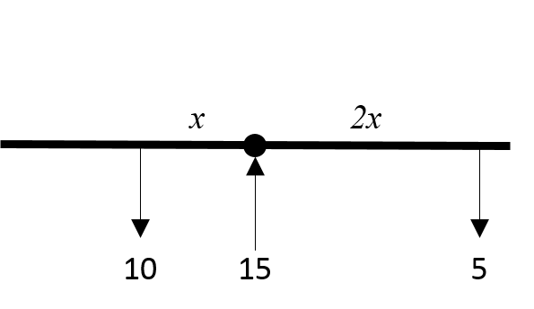
Move and turn | Not zero | Not zero | 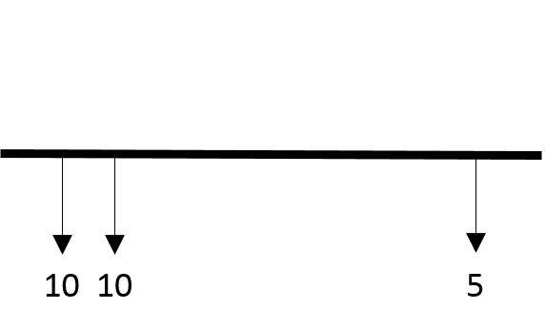
Turn only  (forces are ‘a couple’) | 0 | Not zero | 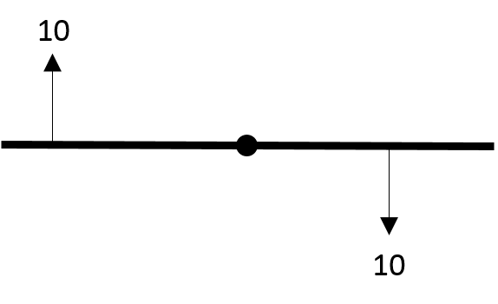

Centre of Mass

$$centre of mass=\overline{R}=\frac{\sum{\left(mass×distance\right)}}{\sum{distances}}=\frac{\sum{mr}}{\sum{r}}≈\frac{\sum{{moments}^{*}}}{\sum{distances}}$$

*ignoring gravity!

- Uniform rod = centre
- Uniform rectangular lamina = centre
- Uniform circular lamina = centre
- Uniform triangular lamina = on median line, vertex: base = 2:1
- Uniform semi-circular lamina = on line of symmetry where $h=\frac{4r}{3π}$

To find centre of mass of composite body, find centre of mass of each composite then find centre of mass of these.

