Essential Notes on Mechanics
For the new A level syllabus

Common Modelling Assumptions

Ignore air resistance
Force of gravity acts constantly

Inextensible | ⇒ | no stretching
Thin | ⇒ | no diameter or thickness
Light | ⇒ | no mass
Rigid | ⇒ | no bending
Smooth | ⇒ | no friction
Particle | ⇒ | no size

Newtons Laws of Motion

- Every particle continues in a state of uniform motion unless acted upon by an external force.
- The net force is equal to the rate of change of momentum. $F=\text{ma}$
- Every action has an equal and opposite reaction

Suvat

$$v=u+\text{at}$$ | (no $s$)
$$s=\text{ut}+\frac{1}{2}{\text{at}}^{2}$$ | (no $u$)
$$s=\text{vt}−\frac{1}{2}{\text{at}}^{2}$$ | (no $v$)
$$s=\frac{1}{2}(u+v)t$$ | (no $a$)
$$v^{2}=u^{2}+2\text{as}$$ | (no $t$)

Equilibrium

Result force equals zero

Friction

$F=μR$ where $0<μ<1$
Pulleys and Tension

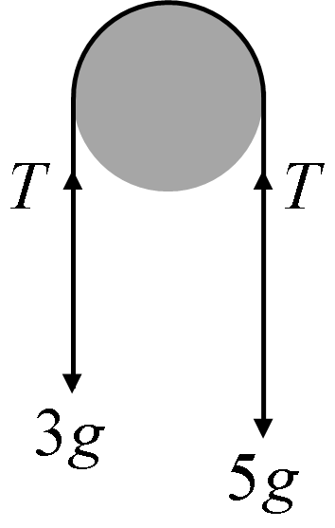

Projectiles

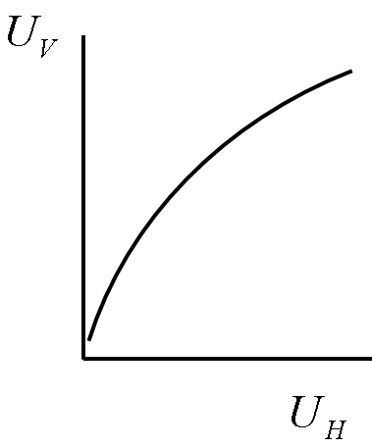

$U_{H}$ acts constantly | $U_{V}$ subject to $g$ms⁻²
Care required with stating which is positive vertical direction.

Vectors

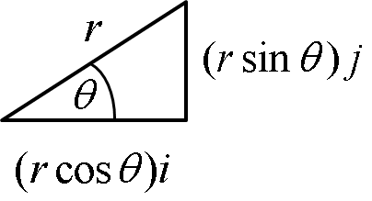

$$r=\text{ai}+\text{bj}$$ | $$\left|r\right|=\sqrt{a^{2}+b^{2}}$$ | $$\text{tan}θ=\frac{b}{a}$$

Calculus in Kinematics

← Differentiate ← | Displacement |  |  | ← Integrate ←
← Differentiate ← | Velocity | 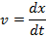 |  | ← Integrate ←
← Differentiate ← | Acceleration | 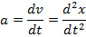 |  | ← Integrate ←

Note that when , .
When integrating, use initial/boundary conditions to find the value.

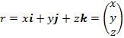

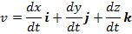

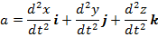

Moments (turning forces, torque, Nm)

Anticlockwise = +ve Clockwise = -ve

Forces through the pivot exert no moment/torque.

Most problems involve finding resultant (translational) force and resultant moment around one or more points, then using these to determine unknown forces or distances. It is possible to use resultant force and resultant moment to calculate position of resultant moment.

Equilibrium ⇒

resultant moment = 0 | and | resultant force = 0
(no turning effect) | and | (no translational effect)

