Parametric Integration

Find $\int{y}dx$ between $t=0$ and $t=2π$, for the parametric equations below…

$x=4sint$ $y=3cost$ | 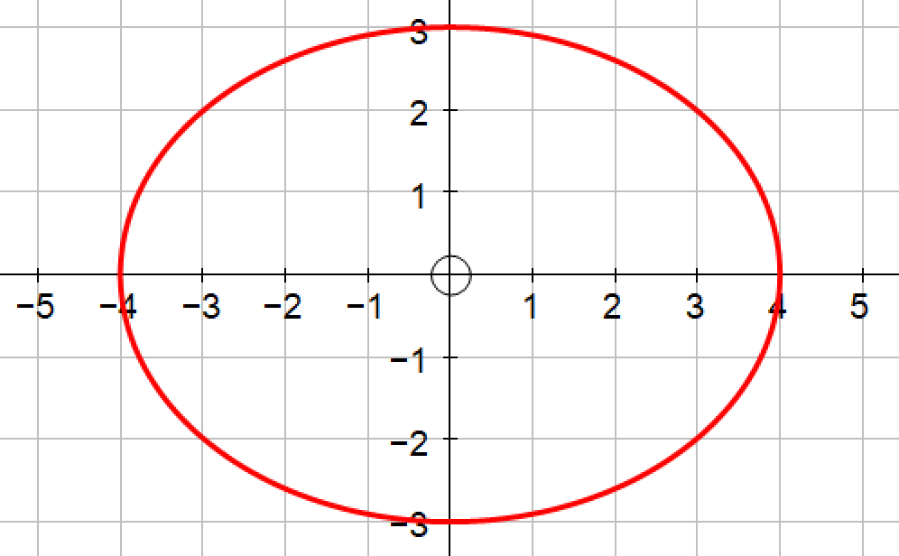

$$\int{y}dx=\int{3cost}dx$$

$$x=4sint$$
$$⇒\frac{dx}{dt}=4cost$$
$$⇒dx=4cost dt$$

$$\int{y}dx=\int{3cost}dx$$
$$=\int{3cost}×4cost dt$$
$$=12\int{\cos^{2}t} dt$$
$$cos2t=2\cos^{2}t-1⇒\cos^{2}t=\frac{cos2t+1}{2}$$

Integration becomes…

$$12\int{\cos^{2}t} dt=6\int{cos2t+1} dt$$
$$=6{\left[\frac{sin2t}{2}+t\right]}_{0}^{2π}$$
$$=6\left[\left(\frac{sin4π}{2}+2π\right)-\left(\frac{sin0}{2}+0\right)\right]$$
$=12π$
Now try these…

- Find $\int{y}dx$ between $t=0$ and $t=2π$, for $x=3sint$ and $y=5cost$.

- Find $\int{y}dx$ between $t=2$ and $t=3$, for the parametric equations below…
$x=t+\frac{1}{t}$ $y=t-\frac{1}{t}$. | 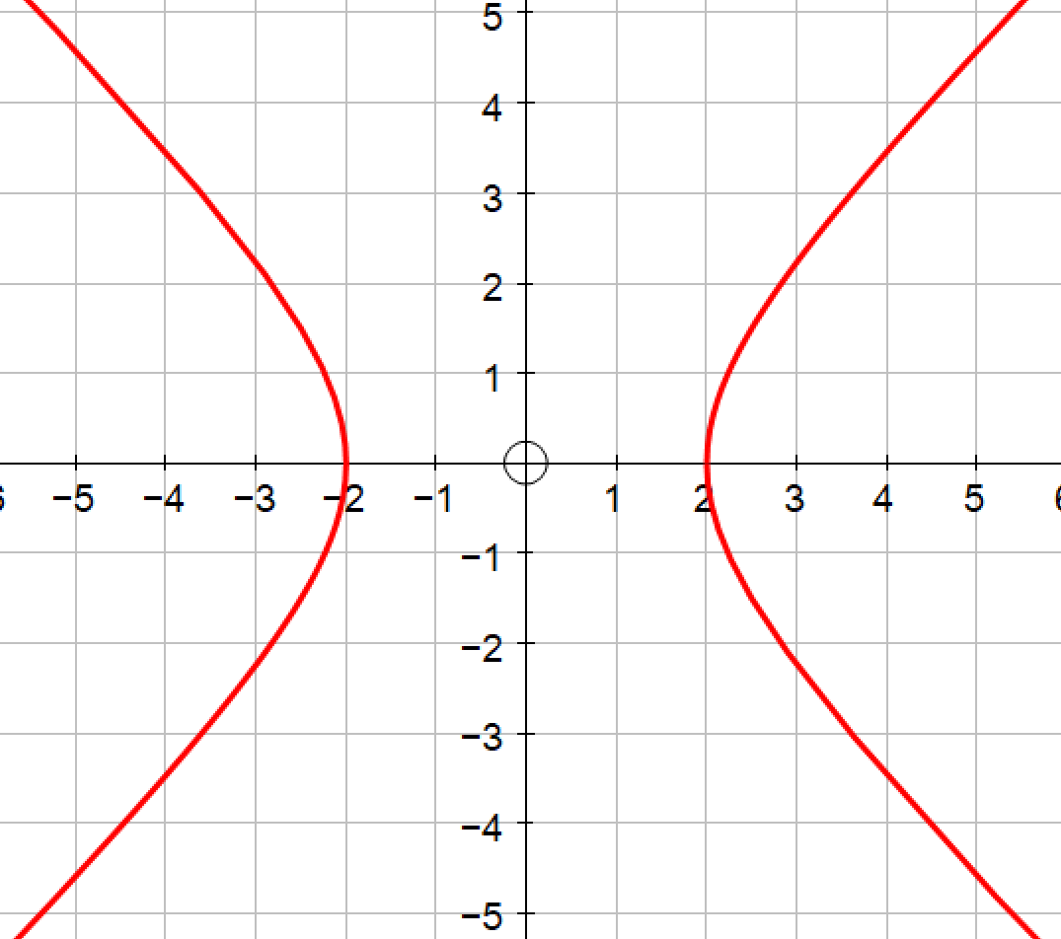

- Find the area bounded by the x-axis and the curve with parametric equations below between $0≤t≤\frac{π}{2}$.
$x=sint$ $y=sin2t$ | 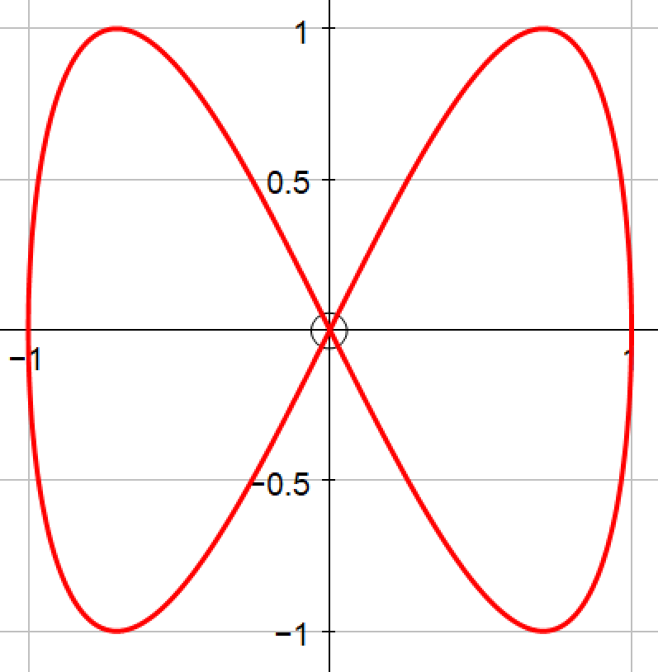

- Find the positive integral bounded by the x-axis and the curve with parametric equations below…
$x=t-2sint$ $y=1-2cost$ | 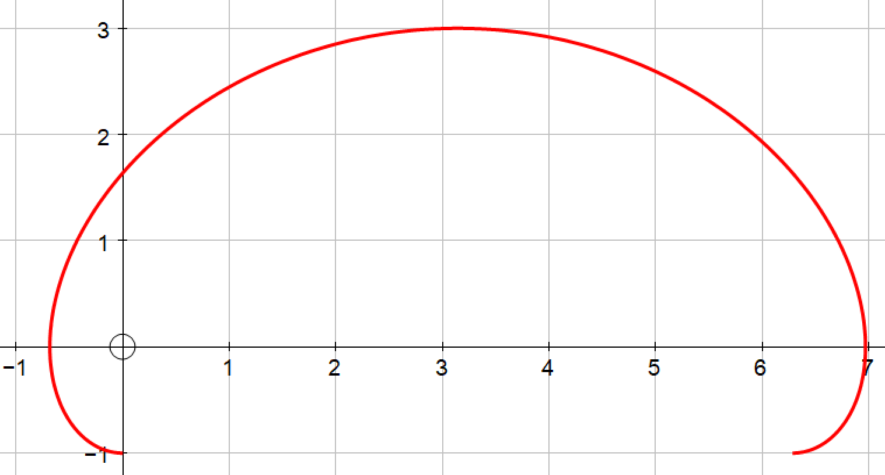

- The trajectory of a ball thrown from the top of a tower is modelled by the parametric equations $x=20t$ and $y=50+15t-2t^{2}$.
Find the area of the region underneath the flight of the ball.

Answers =

- $15π$
- $ln\left(\frac{4}{9}\right)+\frac{185}{72}$
- $\frac{2}{3}$
- $4π+3\sqrt{3}$

