Know Your Payslip

Know the meaning of and be able to find the following details from a standard payslip:

Gross
Net
Period
Tax Code
BACS
Taxable
Cumulative
PAYE
NI

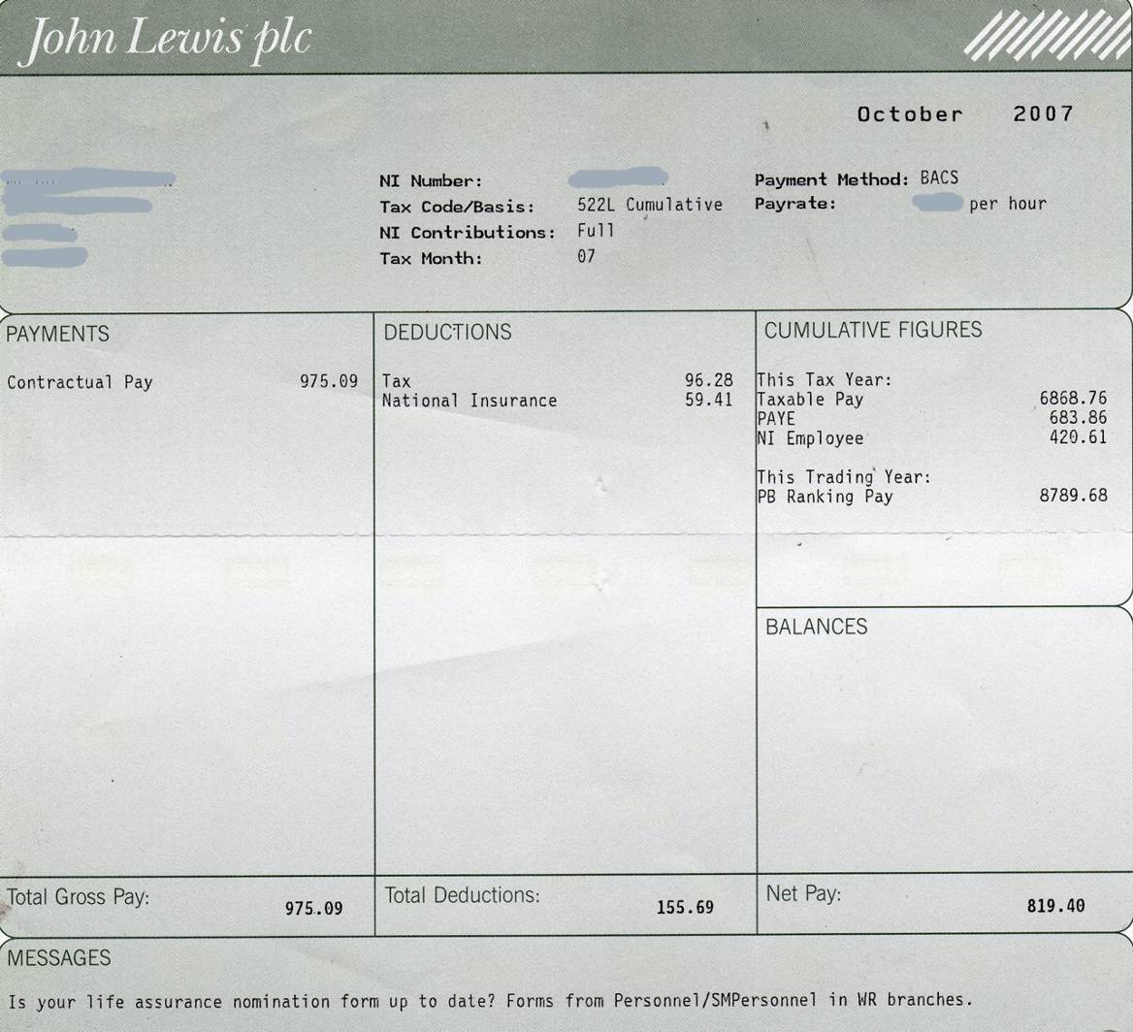

Know Your Payslip - Answers

Know the meaning of and be able to find the following details from a standard payslip:

Gross – earnings before deductions (such as tax, national insurance and pension contributions) are taken off.
Net – earnings after all deductions. This is the amount that goes into your bank account.
Period – what week, month or other period the payslip is for.
Tax Code – a three-digit number which represents your personal allowance (which is the amount that you can earn before paying income tax). This allowance differs slightly for different people. To convert to personal allowance figure, ignore the letter and multiply by ten, eg 522L becomes £5220.
BACS – the method by which you are paid. BACS stands for Bankers’ Automatic Clearing Service. Read as ‘its paid directly into your bank account’.
Taxable – the amount of money on which income tax is to be paid. Items such as pension contributions are not taxable so are deducted from a gross salary to leave the taxable amount.
Cumulative – figures for the tax year to date. The UK tax year runs starts/ends on 5th April.
PAYE – ‘Pay As You Earn’. The tax is taken from your salary before you receive it making it easy and convenient for you, your employer and the taxman. This figure will be the amount of income tax paid each period.
NI – National Insurance. This is your contribution to the national health system (NHS), sometimes seen as another tax. Whilst income tax is a little difficult to work out, NI contributions are much more complicated.

