Top 11 Mathematical Reading Books

1 | 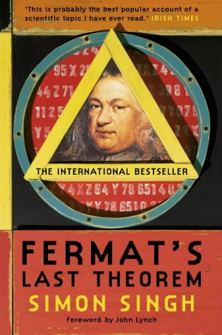 | 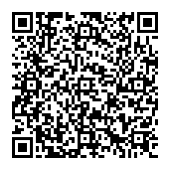 | Fermats Last Theorem  Simon Singh |  | Suitable for:  Yr11+ |  | 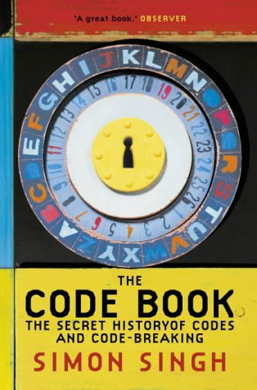
2 |  | The Code Book  Simon Singh |  | Suitable for:  Yr9+ |  | 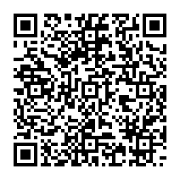
3 | 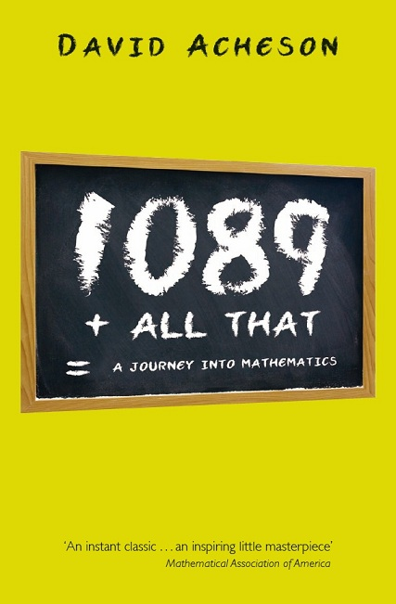 | 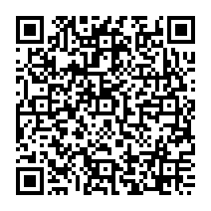 | 1089 And All That  David Acheson |  | Suitable for:  Yr11+ |  | 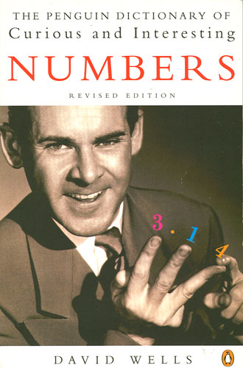
4 |  | The Penguin Book of Curious and Interesting Numbers  David Wells |  | Suitable for:  Yr7+ |  | 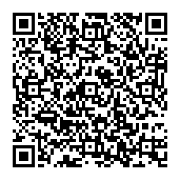
5 | 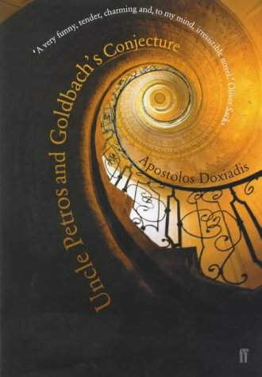 | 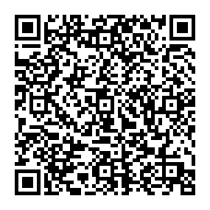 | Uncle Petros and Goldbach’s Conjecture  Apostolos Doxiadis |  | Suitable for:  Yr9+ |  | 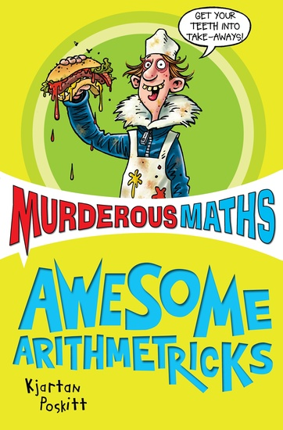
6 |  | Murderous Maths  Kjartan Poskitt |  | Suitable for:  Y7-11 |  | 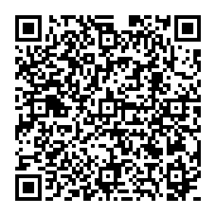
7 | 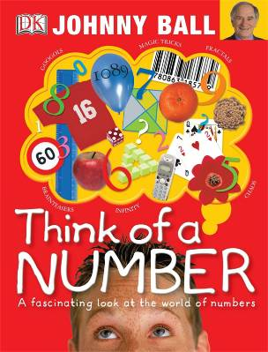 | 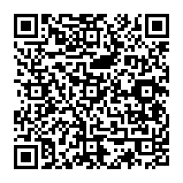 | Think of a Number  Johnny Ball |  | Suitable for:  Yr7-10 |  | 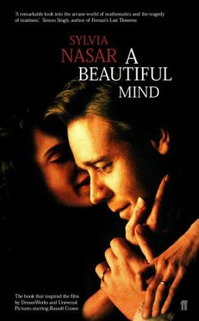
8 |  | A Beautiful Mind  Sylvia Nasar |  | Suitable for:  Yr7+ |  | 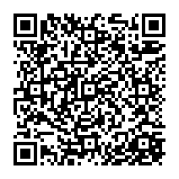
9 | 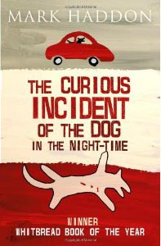 | 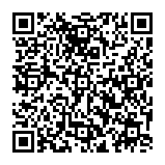 | The Curious Incident of the Dog in the Night-Time – Mark Haddon |  | Suitable for:  Yr9-12 |  | 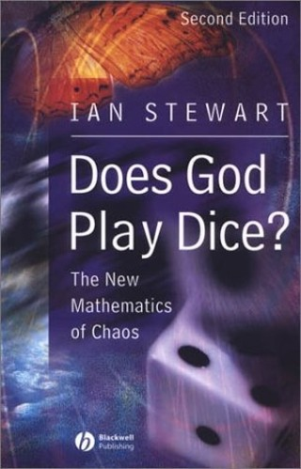
10 |  | Does God Play Dice  Ian Stewart |  | Suitable for:  Yr10+ |  | 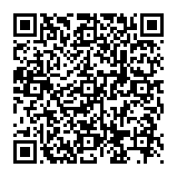
11 | 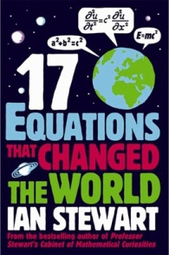 | 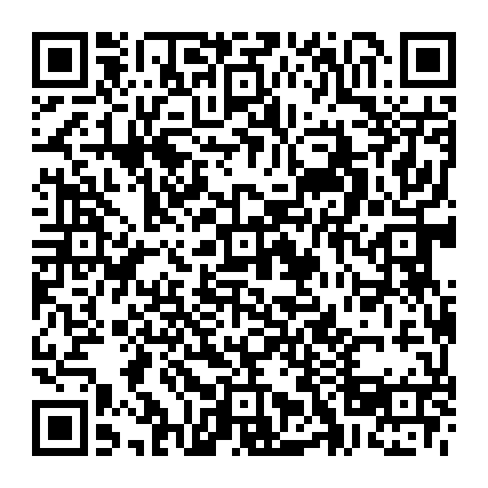 | 17 Equations that Changed the World – Ian Stewart |  | Suitable for:  Sixth formers

Top 10 Mathematical Reading Books

1 |  | Fermats Last Theorem – Simon Singh  http://www.amazon.co.uk/Fermats-Last-Theorem-confounded-greatest/dp/1841157910/ref=sr_1_1?s=books&ie=UTF8&qid=1340886188&sr=1-1
2 |  | The Code Book – Simon Singh  http://www.amazon.co.uk/The-Code-Book-History-Code-breaking/dp/1857028899/ref=sr_1_4?s=books&ie=UTF8&qid=1340886252&sr=1-4
3 |  | 1089 And All That – David Acheson  http://www.amazon.co.uk/1089-All-That-Journey-Mathematics/dp/0199590028/ref=sr_1_1?s=books&ie=UTF8&qid=1340886288&sr=1-1
4 |  | The Penguin Book of Curious and Interesting Numbers – David Wells  http://www.amazon.co.uk/Penguin-Dictionary-Curious-Interesting-Numbers/dp/0140261494/ref=sr_1_1?s=books&ie=UTF8&qid=1340886332&sr=1-1
5 |  | Uncle Petros and Goldbach’s Conjecture – Apostolos Doxiadis  http://www.amazon.co.uk/Petros-Goldbachs-Conjecture-Apostolos-Doxiadis/dp/0571205119/ref=sr_1_1?ie=UTF8&qid=1340886492&sr=8-1
6 |  | Murderous Maths – Kjartan Poskitt  http://www.amazon.co.uk/Murderous-Collection-Fundamental-Formulas-Universe/dp/B005HVGZHY/ref=sr_1_5?s=books&ie=UTF8&qid=1340886437&sr=1-5
7 |  | Think of a Number – Johnny Ball  http://www.amazon.co.uk/Think-Number-Johnny-Ball/dp/1405358025/ref=sr_1_3?s=books&ie=UTF8&qid=1340886786&sr=1-3
8 |  | A Beautiful Mind – Sylvia Nasar  http://www.amazon.co.uk/A-Beautiful-Mind-Sylvia-Nasar/dp/0571212921/ref=sr_1_1?s=books&ie=UTF8&qid=1340886841&sr=1-1
9 |  | The Curious Incident of the Dog in the Night-Time – Mark Haddon  http://www.amazon.co.uk/The-Curious-Incident-Dog-Night-Time/dp/1849920419/ref=sr_1_3?ie=UTF8&qid=1341311367&sr=8-3
10 |  | Ian Stewart – Does God Play Dice?  http://www.amazon.co.uk/Does-God-Play-Dice-Mathematics/dp/0140256024/ref=sr_1_10?s=books&ie=UTF8&qid=1341395957&sr=1-10
11 |  | Guiness Book of World Records  http://www.amazon.co.uk/Guinness-World-Records-2012/dp/1904994687/ref=sr_1_1?s=books&ie=UTF8&qid=1341415253&sr=1-1

