Scatter Diagrams

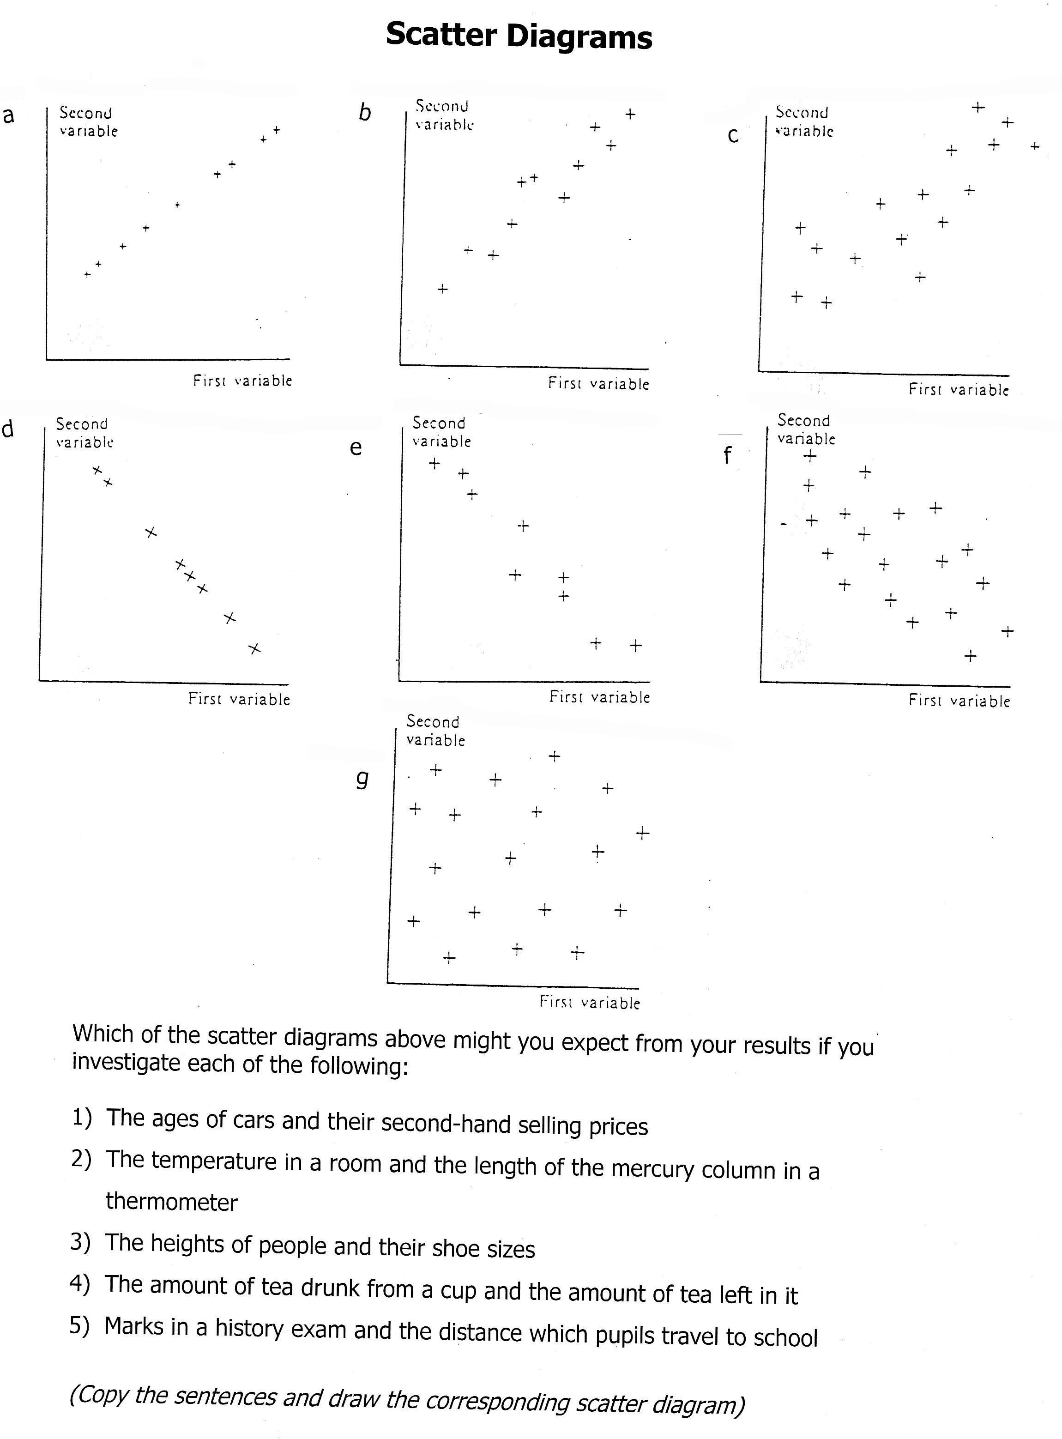

Which of the scatter diagrams above might you expect from your results if you investigate each of the following?

- The ages of cars vs their second hand selling price
- The temperature in a room vs the length of the mercury column in a thermometer
- The heights of people and their shoe sizes
- The amount of tea drunk from a cup vs the amount left in it
- Marks in a history exam vs the distance which the pupils travel to school

(Copy the sentences and draw the corresponding scatter diagram)

