Seasons on Saturn

Mathematical concepts addressed:

Measurement & Geometrical Reasoning, Trigonometry, Transformations of graphs.

Internet links:

For the resource materials: www.colmanweb.co.uk/spacemaths
Hubble Space Telescope: http://hubblesite.org/newscenter/archive/releases/2001/15/,
http://hubblesite.org/newscenter/archive/releases/2009/12/

Just as we have different seasons on Earth as it rotates around our Sun, Saturn also has seasons as it rotates. The reason for this is because Saturn's equator is tilted relative to its orbit by 27 degrees, very similar to the 23-degree tilt of the Earth. As Saturn moves along its orbit, first one hemisphere, then the other is tilted towards the Sun. These Hubble Space Telescope images, captured from 1996 to 2000, show Saturn's rings opening up from just past edge-on to nearly full as it moves from autumn towards winter in its Northern Hemisphere.

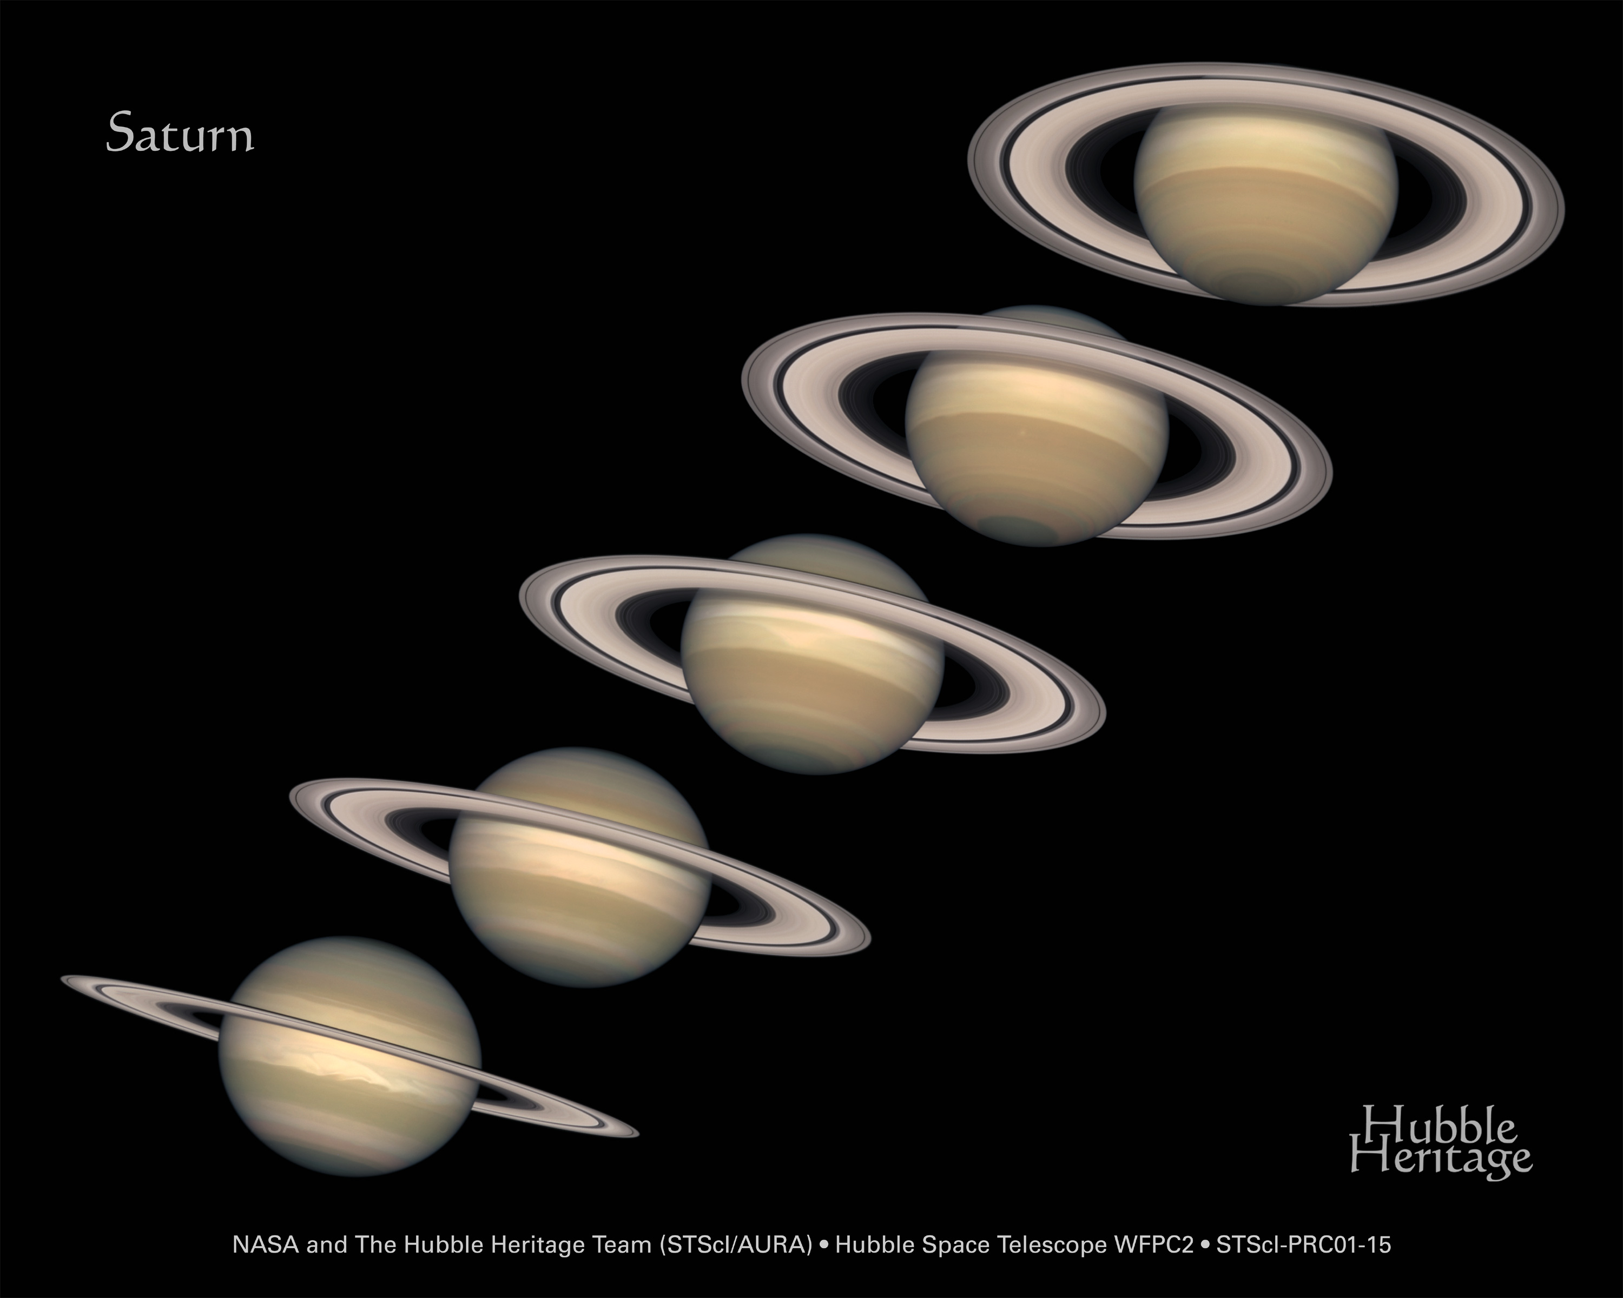
Seasons on Saturn

By making measurements of these images and using trigonometry you will find the angles, relative to the rings, that the Hubble Space Telescope viewed Saturn and then use these to calculate the time it takes Saturn to complete one orbit (its orbital period) and when Hubble will next view Saturn edge-on.

Task 1 – Calculate the Angles
Assuming the rings are perfectly circular then they are as high as they are wide. But the apparent height of them changes as Hubble views Saturn from different angles.
If Hubble views Saturn in the same plane as the rings then they would appear to have no height.
If Hubble were to view Saturn from directly below, or above, then the rings would appear to have a height equal to their width.
The apparent height of the rings varies with the angle that Saturn is viewed from. We can therefore calculate the angle that Saturn is observed using the apparent height of the rings. The diagram below and the MS Powerpoint ‘Saturn Trigonometry’ presentation explain how to do this.
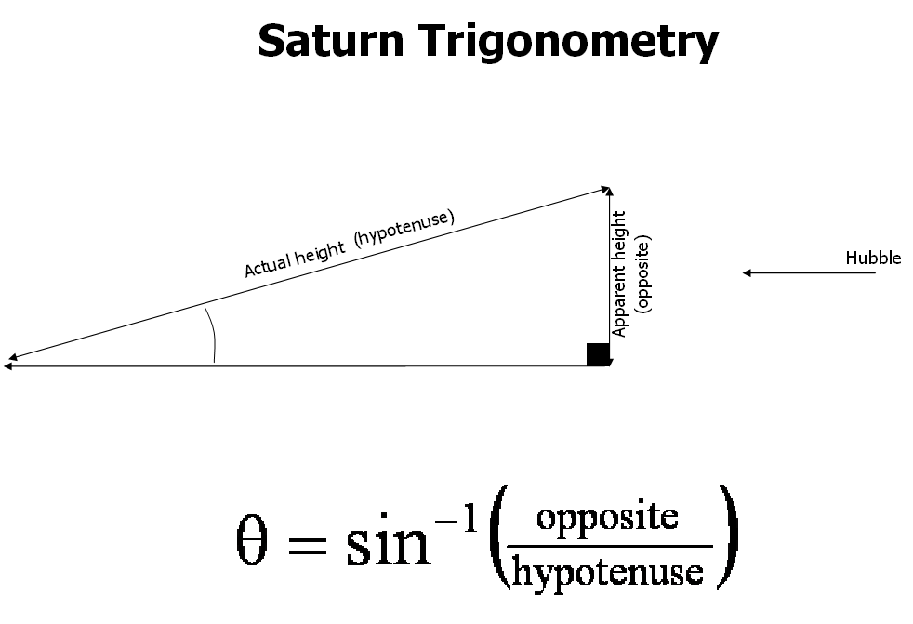

Make measurements of the five images of Saturn to calculate the angles at which Hubble viewed them.

Task 2 – Find the Orbital Period

The angle at which Saturn is tilted varies in a sinusoidal pattern, like the sine curve below.

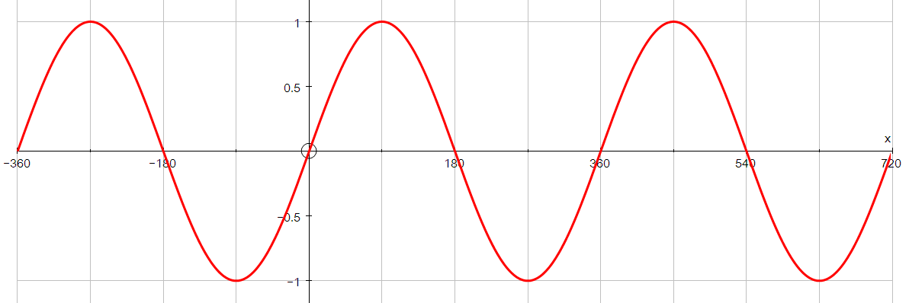
Period

Using the angles that you have calculated together with their dates, we can adjust this curve to match our data and use this to predict Saturn’s orbital period.
Input your angles into the MS Excel file ‘Saturns Rings’ and transform the sine curve to fit your data by shifting and stretching it horizontally and vertically.
Conclusion and Checking

The period of your graph is Saturn’s orbital period, this is the number of Earth years equivalent to one Saturn year. Check your estimate with the actual value on Wikipedia.

You can also read from your graph when the angle was last 0° and when it will next be 0°. Hubble made images when the angle was last 0°. Check your estimate with the date of the image ‘Edge-On Last’ to see if it matches your prediction.

Use your graph to determine when the next view of Saturn across the ring plane will occur. You may like to confirm you prediction at using further Hubble images of Saturn on the Hubblesite website.

Congratulations you are now prepared for this rare astronomical event!

