Triple Variable Simultaneous Equations

Solve these sets of simultaneous equations:

- $$2a+b+c=\text{11}$$
$$a+2b+3c=\text{20}$$
$$3a+3b+2c=\text{23}$$

- $$2x+y+z=0$$
$$x+4y−3z=0$$
$$x−3y=\text{16}$$

- $$p+q+r=6$$
$$2p+q−r=1$$
$$p−q+r=2$$

- $$2s+3t+u=1$$
$$s−t+u=4$$
$$5s+t+3u=\text{10}$$

- $$7x+y+z=−1$$
$$x−3y+2z=0$$
$$x+4y−3z=4$$

- $$2d−3e+5f=−1$$
$$3d−4e+2f=1$$
$$5d+3f=7e$$

- $$\text{10}m+\text{20}n+\text{40}λ=1$$
$$3m+7n+\text{10}λ=0$$
$$\text{25}m+\text{12}n+\text{37}λ=0$$

What about these?

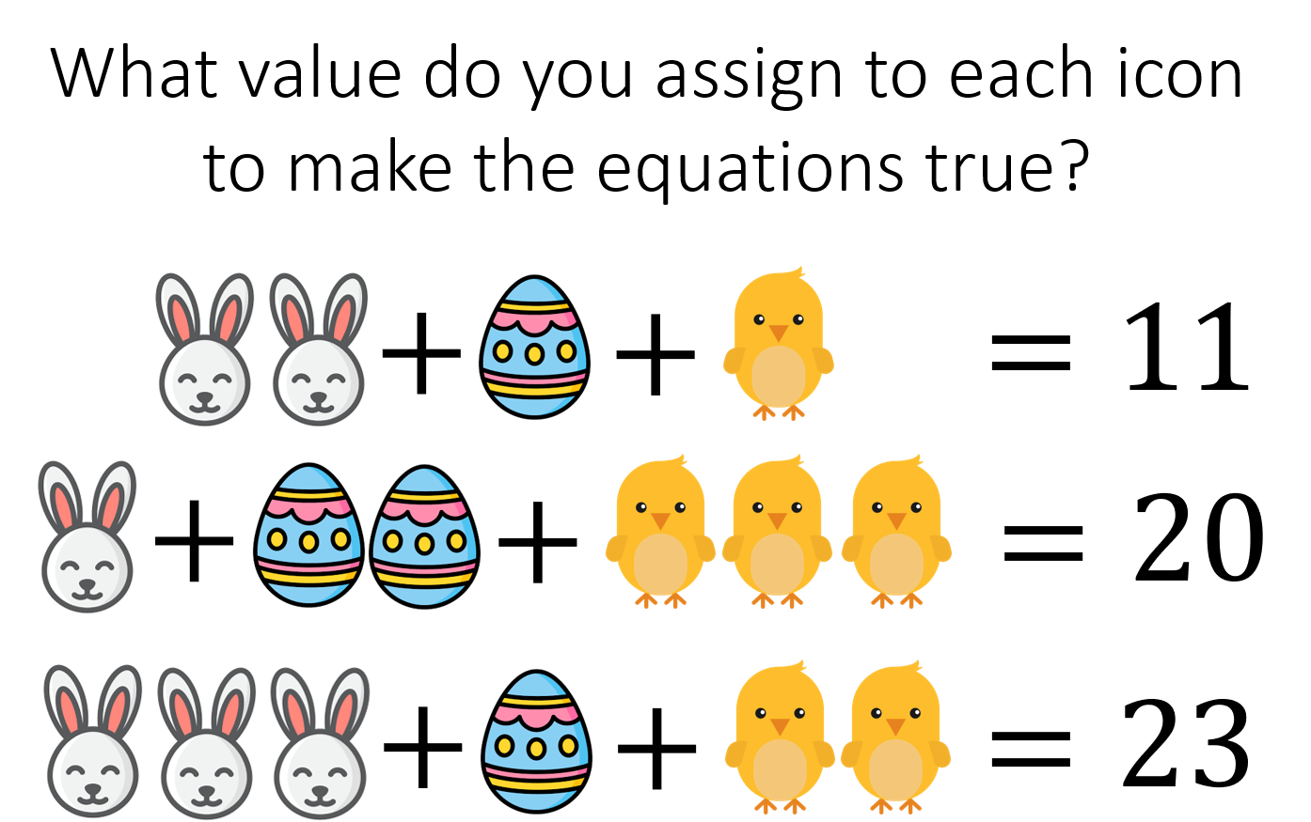  17 | 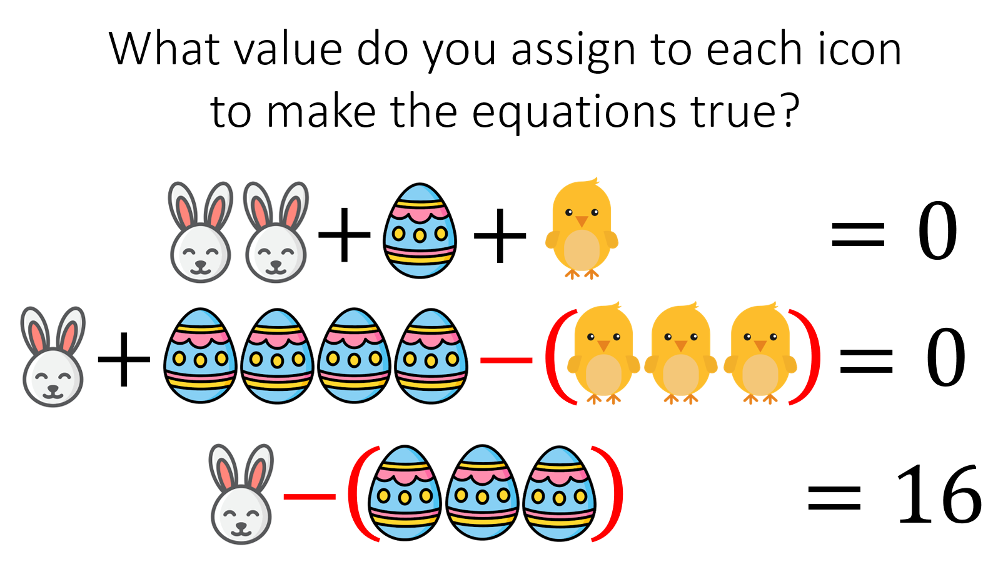

Try these…

$$a+b+c+d=0$$  $$2a+b+2c+d=−1$$  $$a+b−c−d=0$$  $$a+2b−c−2d=1$$ | 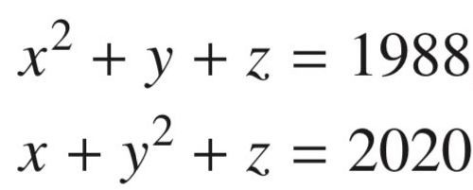
Triple Variable Simultaneous Equations

Solve these sets of simultaneous equations:

- $$2a+b+c=\text{11}$$
$$a+2b+3c=\text{20}$$
$$3a+b+2c=\text{23}$$
a=2, b=3, c=4
- $$2x+y+z=0$$
$$x+4y−3z=0$$
$$x−3y=\text{16}$$
x=4, y=-4, z=-4
- $$p+q+r=6$$
$$2p+q−r=1$$
$$p−q+r=2$$
1,2,3
- $$2s+3t+u=1$$
$$s−t+u=4$$
$$5s+t+3u=\text{10}$$
1,-1,2

- $$7x+y+z=−1$$
$$x−3y+2z=0$$
$$x+4y−3z=4$$
1,-3,-5
- $$2d−3e+5f=−1$$
$$3d−4e+2f=1$$
$$5d+3f=7e$$
7,5,0
- $$\text{10}m+\text{20}n+\text{40}λ=1$$
$$3m+7n+\text{10}λ=0$$
$$\text{25}m+\text{12}n+\text{37}λ=0$$
-0.1, -0.1, 0.1

What about these?

Rabbit = 2  Egg = 3  Chick = 4 | Rabbit = 4  Egg = -4  Chick = 4

Try these…

a = 5  b = 4  c = -6  d = -3 | x = 16  y= 17  z = 1715

