Sketch Graphs

Match each of the situations below to the sketch graph that most accurately describes it.

In all situations the dependent variable is plotted along the y axis whilst time is plotted along the x axis.

(One graph is used twice)

- The distance travelled by a car travelling at constant speed, plotted against time.

- The amount of fuel left in the petrol tank of a car moving at constant speed, plotted against time.

- The distance travelled by an accelerating racing car, plotted against time.

- The distance you would run if you started sprinting and gradually slowing down, plotted against time.

- The temperature of a cup of tea left to cool to room temperature, plotted against time.

- The amount of infection left in the body as it responds to treatment, slowly at first then more rapidly, plotted against time.

- The amount of dollars received from a Bureau De Change, plotted against number of pounds sterling.

- Another example… , plotted against time.
A
B
C
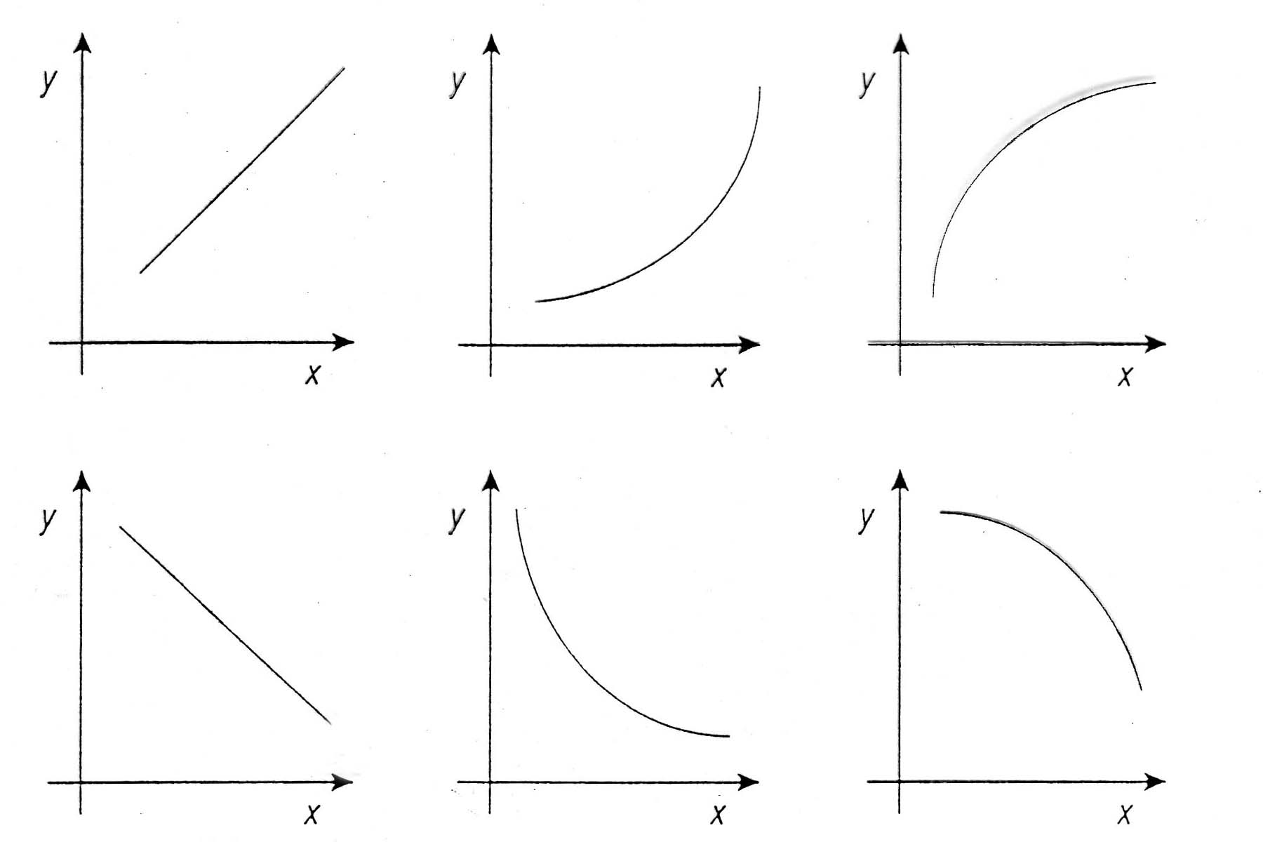
D
E
F
Sketch Graphs – Answers

1 - A

2 - D

3 - B

4 - C

5 - E

6 - F

7 -

