Sketch Graphs

Use the grids below to draw graphs of each function:
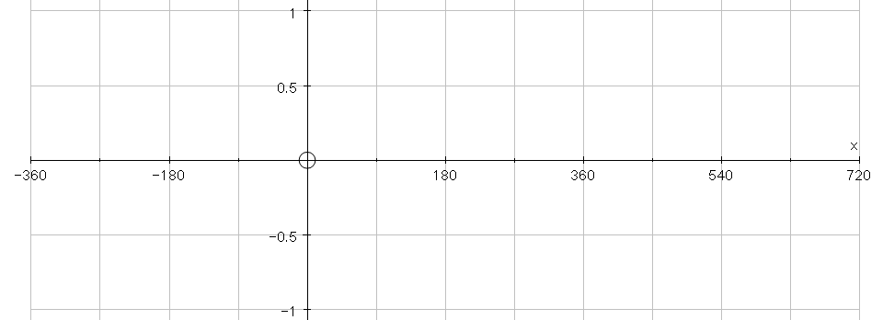
$$y=\text{sin}x$$

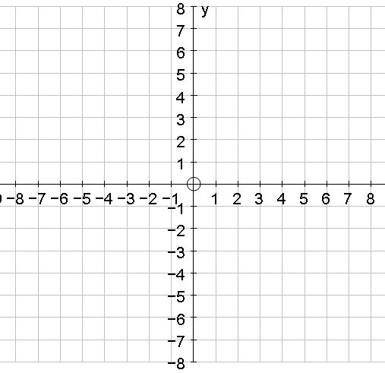
$$y=x^{2}$$

$$y=\frac{1}{x}$$
$$y=x^{3}$$

$$y=\sqrt{x}$$

