Solving Equations - Unknowns on Both Sides

1.
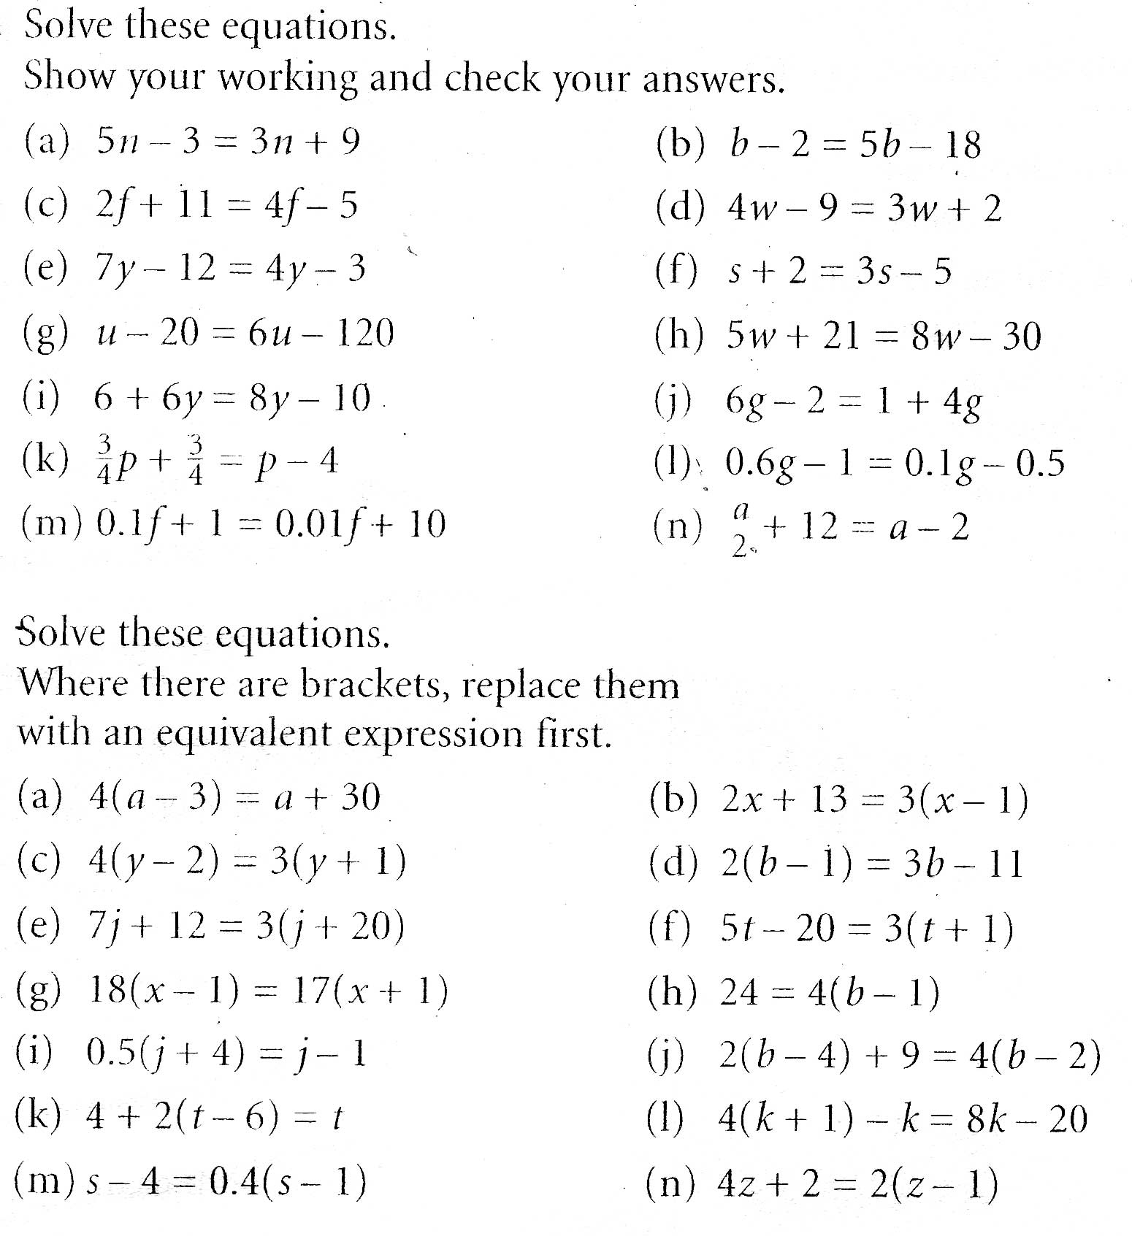

2.

