**Stats 1 Formula**

Measure of location: $\overline{x}$ vs μ

|  |  |
| --- | --- |
| Sample | Population |
| $$\overline{x}=\frac{\sum{x_{i}}}{n}$$ | $$μ=\frac{\sum{x_{i}}}{n}$$ |
| $$\overline{x}=\frac{\sum{x_{i}f_{i}}}{\sum{f_{i}}}$$ | $$μ=\frac{\sum{x_{i}f_{i}}}{\sum{f_{i}}}$$ |
| $$\overline{x}=\frac{\sum{\left(x_{i}-a\right)}}{n}+a$$ | $$μ=\frac{\sum{\left(x_{i}-a\right)}}{n}+a$$ |

Measure of spread:

|  |  |
| --- | --- |
| Sample | Population |
| $$s^{2}=\frac{1}{n-1}\sum{{\left(x-\overline{x}\right)}^{2}}$$ | $$σ^{2}=\frac{1}{n}\sum{{\left(x-μ\right)}^{2}}$$ |
| $$s^{2}=\frac{1}{n-1}\left\{\sum{x^{2}}-\frac{{\left(\sum{x}\right)}^{2}}{n}\right\}$$ | $$σ^{2}=\frac{1}{n}\left(\sum{x^{2}}\right)-μ^{2}$$ |
| $$s^{2}=\frac{1}{n-1}\left\{\sum{{fx}^{2}}-\frac{{\left(\sum{fx}\right)}^{2}}{n}\right\}$$ | $$σ^{2}=\frac{1}{n}\left(\sum{{fx}^{2}}\right)-{\left\{\frac{\left(\sum{fx}\right)}{n}\right\}}^{2}$$ |

 ⇔ 

1 standard deviation includes 2/3 of data

2 standard deviations include 95% of data

3 standard deviations include ‘almost all’ data

“a quantity expressing by how much the members of a group differ from the mean value for the group”

Probability

Mutually Exclusive

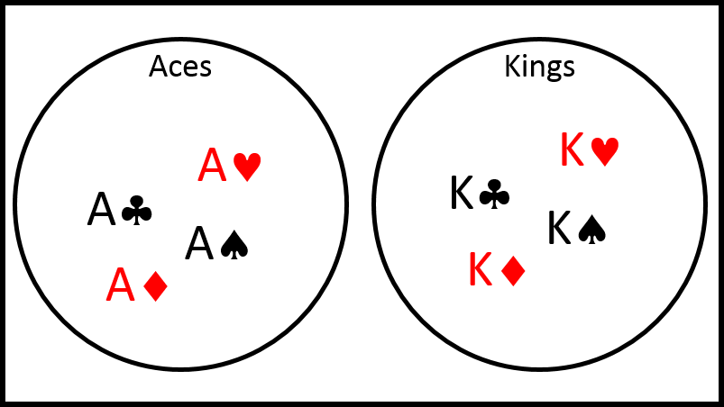

$$P\left(A ∪ B\right)=P\left(A\right)+P\left(B\right)$$

$$P\left(A ∩ B\right)=P\left(A\right)×P\left(B\right)$$

$$P\left(A ∩ B∩C\right)=P\left(A\right)×P\left(B\right)×P\left(C\right)$$

Non-Mutually Exclusive

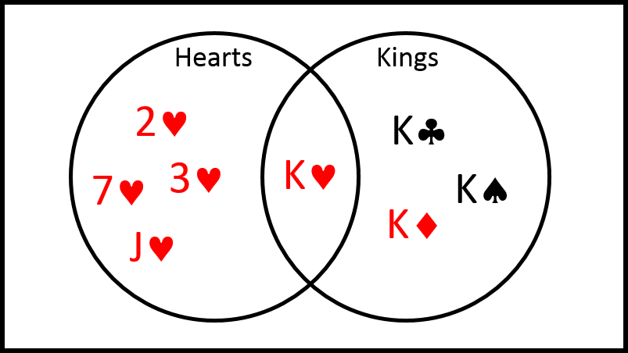

$$P\left(A ∪ B\right)=P\left(A\right)+P\left(B\right)-P\left(A∩B\right)$$

$$P\left(A ∩ B\right)=P\left(A | B\right)×P\left(B\right)$$

⇔

$$P\left(A | B\right)=\frac{P\left(A∩B\right)}{P\left(B\right)}$$

Exclusive – no overlap of possible events

Exhaustive – all possible events are accounted for

If *any* of the following are true then they are *all* true & *events are independent*:

$$P\left(A | B\right)=P\left(A | B'\right)$$

$$P\left(A | B\right)=P\left(A\right)$$

$$P\left(A | B'\right)= P\left(A\right)$$

$$P\left(B| A\right)=P\left(B | A'\right)$$

$$P\left(B | A\right)=P\left(B\right)$$

$$P\left(B | A'\right)= P\left(B\right)$$

$$P\left(A ∩ B\right)=P\left(A\right)×P\left(B\right)$$

Binomial distribution (a discrete distribution):

 

Expectation & Variance of Binomial distribution:







Normal distribution (a continuous distribution):

$$Z\sim N\left(μ,σ^{2}\right)$$

The standard normal distribution: $Z\sim N\left(0 , 1\right)$

Conversion: $Z=\frac{X-μ}{σ}$

To find μ and/or σ using given probabilities:

1. Draw a sketch or curve
2. Use the probabilities table to find corresponding z value
3. Use the z value together with the conversion to find μ and/or σ. Finding both μ and σ will involve solving simultaneous equations.

Estimation

|  |  |
| --- | --- |
| Sample mean = $\overline{x}$ | Sample variance = $s^{2}$ |
| Unbiased estimator of  population mean = $\overline{X}$ (ie the distribution of many sample means) | Unbiased estimator of  population variance = $\overline{S}$ (ie the distribution of many sample variances) |

|  |  |
| --- | --- |
|  |  |

|  |  |  |  |  |  |
| --- | --- | --- | --- | --- | --- |
| Confidence Interval | 90% | 95% | 98% | 99% | 99.8% |
| z | 1.6449 | 1.9600 | 2.3263 | 2.5758 | 3.0902 |

$$\overline{x}±"\text{z}"\frac{σ}{\sqrt{n}}$$

Product Moment Correlation Coefficient:





 

Regression:

y on x







x on y





