Mathematics of a Total Solar Eclipse

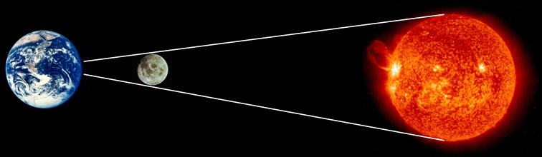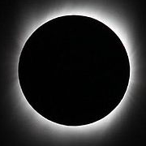
(Not to scale!)

A solar eclipse occurs when the Moon passes between the Earth and the Sun. A total solar eclipse occurs when the path of the Moon produces a relatively small area of shadow on the Earth known as the ‘umbra’ where it completely covers the face of the Sun. The view of a solar eclipse from this area is quite spectacular.

The Moon completely covers the face of the Sun as its distance and size just happens to be in the same proportions as that of the Sun. This brings about an interesting mathematical situation involving similar triangles concerning the sizes of and distances to the Sun and the Moon. But first some practice…

Task 1

Find the missing sides in each figure below:

5cm  x  15cm  6cm | 3ft  12ft  x  6ft | 4cm  33in  11in  x
x  25cm  36cm  64cm | x  16km  8km  3km | x  30ft  10ft  8in
84miles  28miles  7miles  x | 18m  4m  x  45m | 63cm  49cm  x  7km
4  6  x 8 | 10cm  3.5cm  x 650km | 50cm  4cm  x 110,400km

Task 2

Now try these metric imperial conversions. State which measurements each conversion is for.

8  16  5  x | 1  12.5  x  2.5 | 1  x  2.2  4x

Task 3 - The Total Solar Eclipse

If we know three of our Sun/Moon Size/Distance figures then we’re able to find the fourth.

- Use the figures below to show how to find the distance between the Earth and the Sun, and hence distance to the Sun, during a total solar eclipse.

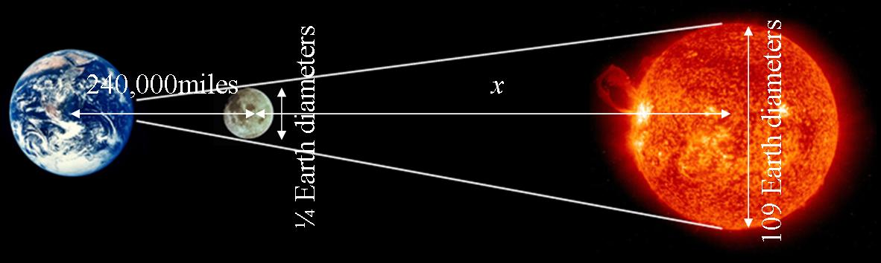

- Use the figures below to find the diameter of the Sun, and hence the Earth.

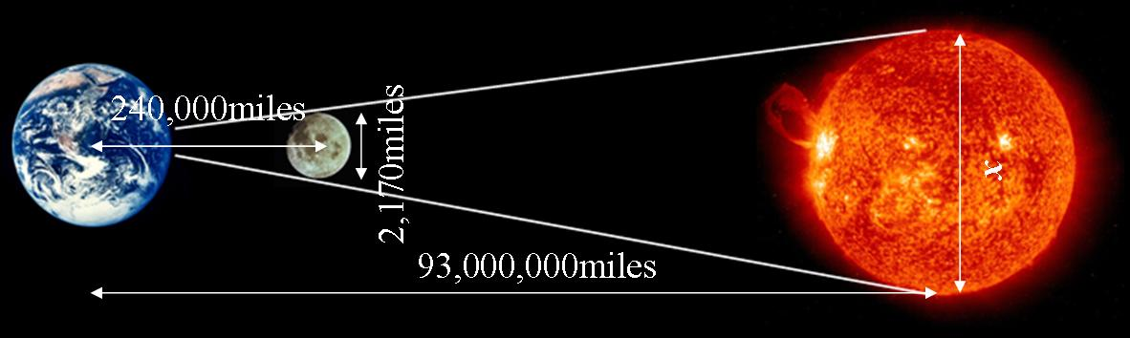

- Using a pinhole camera with a distance of 1m between the ‘camera’ and ‘projection screen’, how large would you expect the image of the Sun to be?

Internet Links

Moon http://en.wikipedia.org/wiki/Moon
Earth http://en.wikipedia.org/wiki/Earth
Sun http://en.wikipedia.org/wiki/Sun, http://sohowww.nascom.nasa.gov/
Solar eclipse http://en.wikipedia.org/wiki/Solar_eclipse, http://csep10.phys.utk.edu/astr161/lect/time/eclipses.html
Umbra http://en.wikipedia.org/wiki/Umbra
NASA’s Eclipse page http://eclipse.gsfc.nasa.gov/solar.html
Solar eclipse on Youtube http://www.youtube.com/watch?v=XMyqPxFh5Zw
Distance to the Sun http://en.wikipedia.org/wiki/Astronomical_unit
Mathematics of a Total Solar Eclipse - Answers

Task 1

5cm  7  15cm  6cm | 3ft  12ftm  9  6ft | 4cm  33in  11in  16
9  25cm  36cm  64cm | 2  16km  8km  3km | 2  30ft  10ft  8in
84miles  28miles  7miles  14 | 18m  4m  6  45m | 63cm  49cm  2  7km
4  6  16 8 | 10cm  3.5cm  350 650km | 50m  4cm  9600 110,400km

Task 2

8  16  5  5 | 1  12.5  6  2.5 | 1  6.6  2.2  4x
Miles / Kilometres | Inches / Centimetres | Kilograms / Pounds weight

Task 3

- x = 103,440,000miles Distance to Sun = 103,464,000miles

Actual distance to Sun is 93,500,000miles, 10.7% error. Our answer is different as figures were rounded in question. Actual figures: Moons diameter = 0.27 Earth, distance to Moon = 240,249miles.

- x = 840,875 ≈ 841,000miles Using Sun = 109 Earths, Earth Diameter ≈ 7,700miles.

Actual diameter of Sun is 870,000miles, 3.5% error. Actual Earth diameter is 8,000miles, 3.3% error.

- Image around 9mm diameter. This is calculated using proportional figures of part (b).

