Mathematics of a Total Solar Eclipse

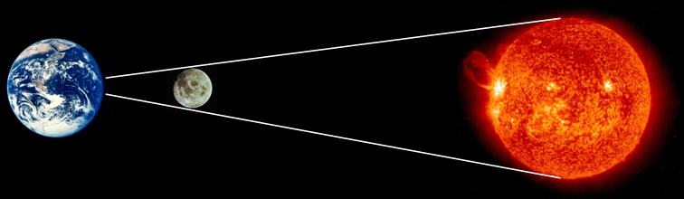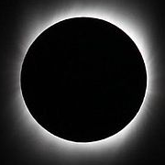
(Not to scale!)

A solar eclipse occurs when the Moon passes between the Earth and the Sun. A total solar eclipse occurs when the path of the Moon produces a relatively small area of shadow on the Earth known as the ‘umbra’ where it completely covers the face of the Sun. The view of a solar eclipse from this area is quite spectacular.

The Moon completely covers the face of the Sun as its distance and size just happens to be in the same proportions as that of the Sun. This brings about an interesting mathematical situation involving similar triangles concerning the sizes of and distances to the Sun and the Moon. But first some practice…

Task 1

Find the missing sides in each figure below:

2cm  x  8cm  4cm | 7ft  4.5ftm  x  10.5ft | 11cm  9in  6in  x
x  7cm  4cm  10cm | x  3km  3km  9km | x  10.5ft  3ft  9in
36miles  20miles  5miles  x | 12.5m  100m  x  30m | 35cm  7cm  x  10km
4  7  x 18,000 | 215cm  15cm  x 1,000,000km | 10m  1cm  x 79.92km

Task 2

Now try these metric imperial conversions. State which measurements each conversion is for.

8  16  5  x | 1  12.5  x  2.5 | 1  x  2.2  4x

Task 3 - The Total Solar Eclipse

If we know three of our Sun/Moon Size/Distance figures then we’re able to find the fourth.

- Use the figures below to show how to find the distance between the Earth and the Sun, and hence distance to the Sun, during a total solar eclipse.

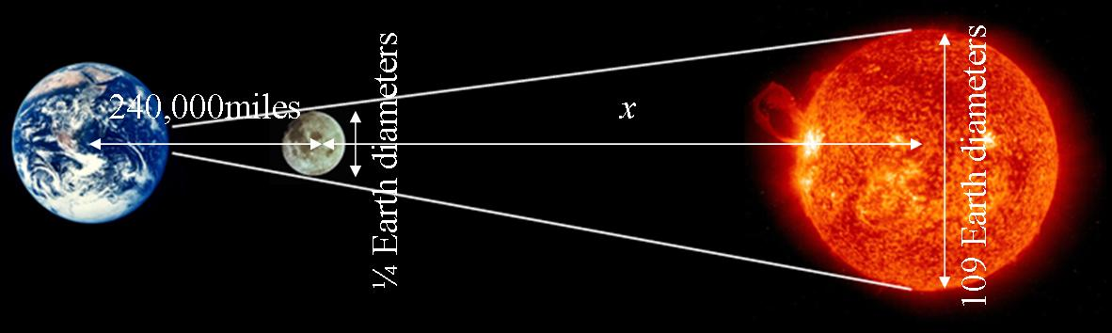

- Use the figures below to find the diameter of the Sun, and hence the Earth.

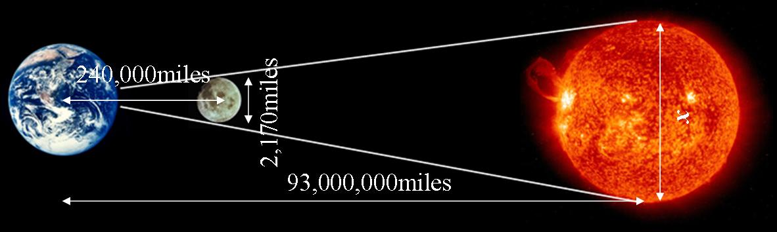

- Using a pinhole camera with a distance of 1m between the ‘camera’ and ‘projection screen’, how large would you expect the image of the Sun to be?

Internet Links

Moon http://en.wikipedia.org/wiki/Moon
Earth http://en.wikipedia.org/wiki/Earth
Sun http://en.wikipedia.org/wiki/Sun, http://sohowww.nascom.nasa.gov/
Solar eclipse http://en.wikipedia.org/wiki/Solar_eclipse, http://csep10.phys.utk.edu/astr161/lect/time/eclipses.html
Umbra http://en.wikipedia.org/wiki/Umbra
NASA’s Eclipse page http://eclipse.gsfc.nasa.gov/solar.html
Solar eclipse on Youtube http://www.youtube.com/watch?v=XMyqPxFh5Zw
Distance to the Sun http://en.wikipedia.org/wiki/Astronomical_unit
Mathematics of a Total Solar Eclipse - Answers

Task 1

2cm  3  8cm  4cm | 7ft  4.5ftm  10  10.5ft | 11cm  9in  6in  27.5
2  7cm  4cm  10cm | 2  3km  3km  9km | 2  10.5ft  3ft  9in
36miles  20miles  5miles  4 | 12.5m  100m  140  30m | 35cm  7cm  40  10km
4  7  24,000 18,000 | 215cm  15cm  75,000 1,000,000km | 10m  1cm  80 79.92km

Task 2

8  16  5  5 | 1  12.5  6  2.5 | 1  6.6  2.2  4x
Miles / Kilometres | Inches / Centimetres | Kilograms / Pounds weight

Task 3

- x = 103,440,000miles Distance to Sun = 103,464,000miles

Actual distance to Sun is 93,500,000miles, 10.7% error. Our answer is different as figures were rounded in question. Actual figures: Moons diameter = 0.27 Earth, distance to Moon = 240,249miles.

- x = 840,875 ≈ 841,000miles Using Sun = 109 Earths, Earth Diameter ≈ 7,700miles.

Actual diameter of Sun is 870,000miles, 3.5% error. Actual Earth diameter is 8,000miles, 3.3% error.

- Image around 9mm diameter. This is calculated using proportional figures of part (b).

