Transposed Data

 |  |  |  |  |  |  |  |  |  |  |  | 992 | 996 | 998 | 1000 | 1002 | 1006

The data in the above data set is all centred around the number 1000. When calculating mean, standard deviation etc. with data such as this, it may be easier to first transpose the data, in this case by subtracting 1000, as below
Translate

 |  |  | -8 | -4 | -2 | 0 | 2 | 6

Notice that this data is all multiples of two so, if you wished, you could then divide each of these figures by two before calculating mean, standard deviation etc., as below
Stretch

-16 |  | -8 |  | -4 |  | 0 |  | 4 |  | 12

After calculating the mean and/or standard deviation of transposed data we then need to adjust these figures back to original data. The table below illustrates which values (measurements) are affected by data transposition…

 | Translation | Stretch by factor $x$
Mean |  | by factor $x$
Variance |  | by factor $x^{2}$
Standard Deviation |  | by factor $x$

Try this exam question here…

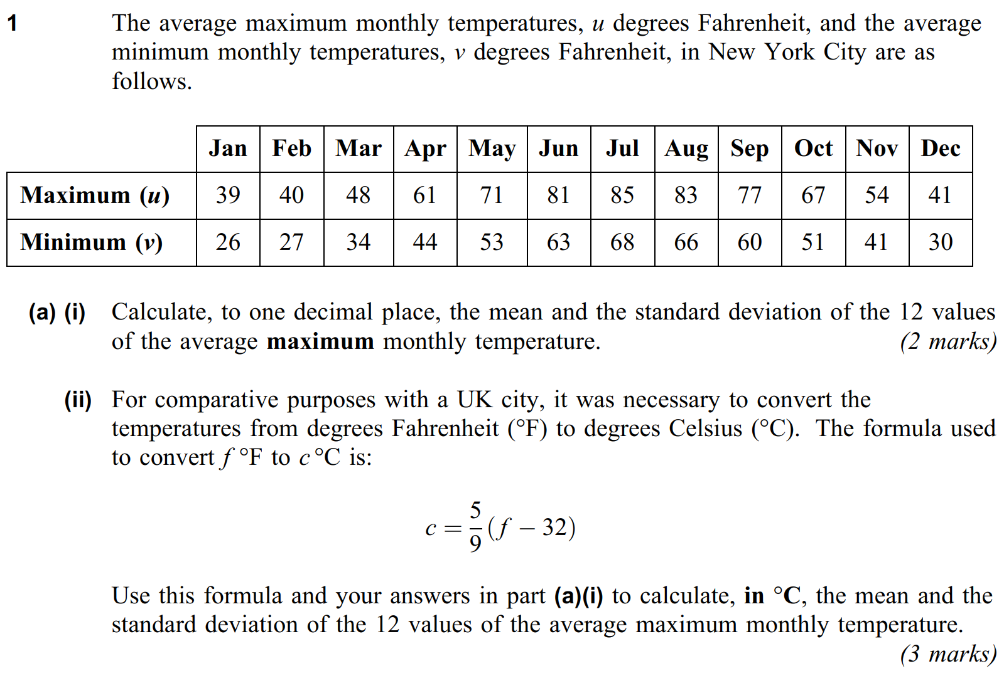
(AQA Stats 1, June 2013, Qu1)
Two More Questions…

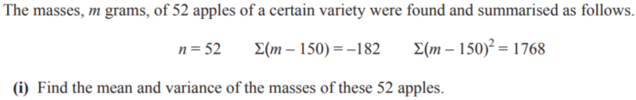

Transposed Data - Answers

 | Mean | Variance | Standard Deviation
Original Data | 999 | 19.67 | 4.43
Transposed by -1000 | -1 | 19.67 | 4.43
Then halved | -0.5 | 4.92 | 2.22

The markscheme for the harder question…

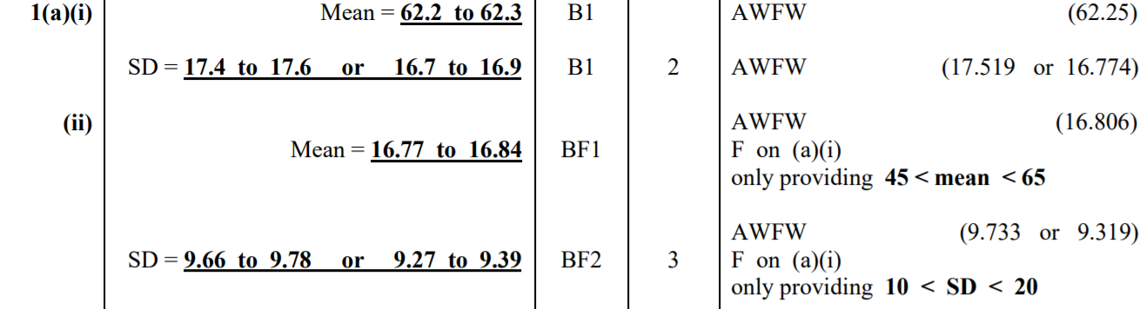

The other two questions…

- Mean = 1.528,
- Standard deviation = 0.014697

- Mean = 146.5,
- Variance = 21.75

