Trig Compound Angles Recap

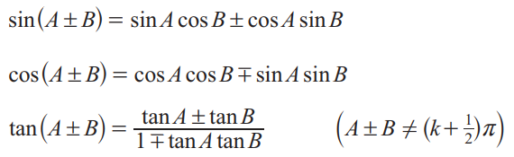

Derive the following…

- $sin2x=$
- $cos2x=$ (the formula in terms of $cosx$ only please)
- $sin3x=$

- Rearrange your formula for $cos2x$above to make $\cos^{2}x$ the subject

Without a calculator, find the exact value of…

- $cos15°$
- $sin105°$
- $tan75°$

Given that C and D are acute angles and that $cosC=\frac{12}{13}$ and that $cosD=\frac{3}{5}$, without a calculator find the exact values of…

- $sinC$
- $tanC$
- $cos\left(C+D\right)$
- $cot\left(C+D\right)$

Trig Compound Angles Recap - Answers

Derive the following…

- $sin2x=2sinxcosx$
- $cos2x=2\cos^{2}x-1$ (the formula in terms of $cosx$ only please)
- $sin3x=3sinx-4\sin^{3}x$

- Rearrange your formula for $cos2x$above to make $\cos^{2}x$ the subject $\cos^{2}x=\frac{cos2x+1}{2}$

Without a calculator, find the exact value of…

- $cos15°=\frac{1+\sqrt{3}}{2\sqrt{2}}=\frac{\sqrt{6}+\sqrt{2}}{4}$
- $sin105°=\frac{1+\sqrt{3}}{2\sqrt{2}}=\frac{\sqrt{6}+\sqrt{2}}{4}$
- $tan75°=\frac{1+\sqrt{3}}{\sqrt{3}-1}=2+\sqrt{3}$

Given that C and D are acute angles and that $cosC=\frac{12}{13}$ and that $cosD=\frac{3}{5}$, without a calculator find the exact values of…

- $sinC=\frac{5}{13}$
- $tanC=\frac{5}{12}$
- $cos\left(C+D\right)=\frac{16}{65}$
- $cot\left(C+D\right)=\frac{16}{63}$

