Network Graphs – The London Underground

The London Underground transport system consists of 11 different lines connecting 270 stations¹ with many different possible routes between.

Today’s Tube map was created by Harry Beck, in 1933, and is based on an electrical circuit diagram². As does any mathematical network graph it reduces the underground system to a set of nodes and lines (or arcs).

For this activity you will need an up to date copy of the London Underground Tube map from Transport for London (TfL) together with an annoted version showing travel times between stations. All maps can be downloaded from the links below:

- http://www.tfl.gov.uk/gettingaround/14091.aspx (website)
- http://www.tfl.gov.uk/gettingaround/1106.aspx (pdf)
- http://www.steveprentice.net/tube/TfLSillyMaps (website)
- http://www.steveprentice.net/tube/TfLSillyMaps/travel_times.jpg (jpg)

You will also need to be familiar with Dijkstra’s algorithm³ for finding a shortest path, as summarised on the next page:

Dijkstra’s Algorithm (to find minimum path between two given nodes):

- Give start node permanent value of zero.
- For all arcs leaving node: if ‘previous permanent value + weight of new arc’ < temp min value, write in or update, else leave existing.
- Choose node with least minimum temporary value and make permanent
- Repeat 2 and 3 until reach destination.

Trainlines

Task 1A: Match the colours to the words.

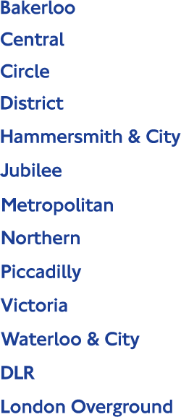

Task 1B: Station notation.

Explain the difference and reasons behind the use of different symbols at different stations, such as those seen in the image below;

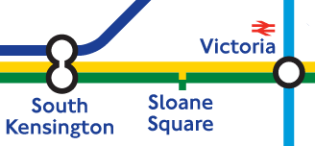

On the next page… Task 2, Shortest Paths

Shortest Paths

For each of the journeys below, complete task 2A, 2B and 2C.

- Liverpool Street to Brixton
- Liverpool Street to Wembley Park
- Liverpool Street to Westminster
- Waterloo to Wembley Park
- St Paul’s to Westminster
- Wembley Park to West Hampstead
- Blackfriars to Covent Garden
- South Kensington to Liverpool Street
- Kings Cross St Pancras to Finsbury park
- Mornington to Barbican
- Heathrow to Waterloo
- Heathrow to Kings Cross St Pancras
- Heathrow to Euston
- Heathrow to Victoria
- Heathrow to Liverpool Street

Task 2A: Find the quickest route by counting stations in between.

Using a London Underground Map, count the number of stops (or stations) on each journey above. Use Dijkstra’s algorithm to find the shortest journeys (or shortest paths) between the following pairs of stations.

Task 2B: Find the quickest route by journey time.

In reality, a better estimate for the shortest path (or route) would be given by finding the quickest time between stations. Using Dijkstra’s algorithm again, repeat task 2 but use the times between stations map instead.

- Does this change any of your journey choices from the previous task?

Task 2C: Changes take time.

Line changes on the underground cost time. Refine your model of shortest paths once more by adding a penalty of 5 minutes for every line change made.

- Does this change any of your journey choices from the previous tasks?
- Can you find any routes that contradict this method?

On the next page… Task 3, Further Tasks

Further Tasks

Task 3: Analysing routes and efficiencies further

- Name a pair of stations requiring a minimum of two line changes.
- Name a pair of stations requiring a minimum of three or more line changes.
- What are the criteria for finding a pair of stations in each of the questions above? Make suggestions and think carefully about your wording to ensure that no examples can be found to contradict them.
- What is the maximum number of changes that need to be made in order to travel from any point on the London Underground to any other point? Use your answer to give a reason on how efficient the London Underground is at enabling people to travel from any place in London to any other place quickly and easily.
- What is the maximum shortest path possible on the London Underground that does not include any closed paths or repeated arcs?

Task 4: A Simple Complete Graph

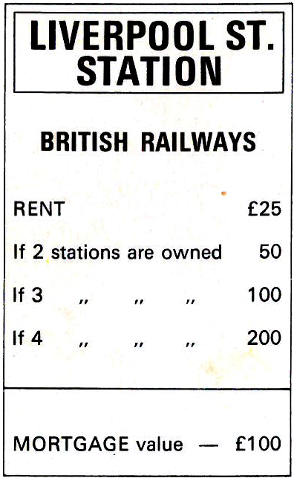 | 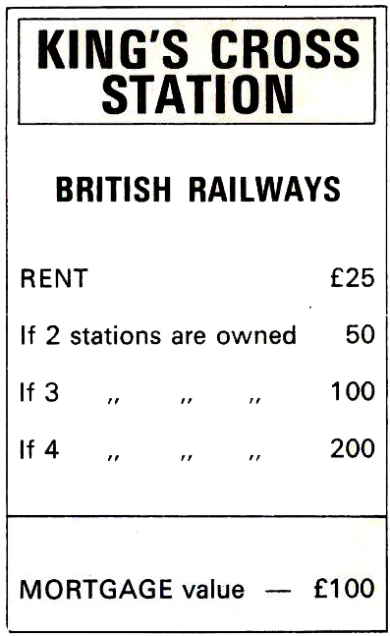 | 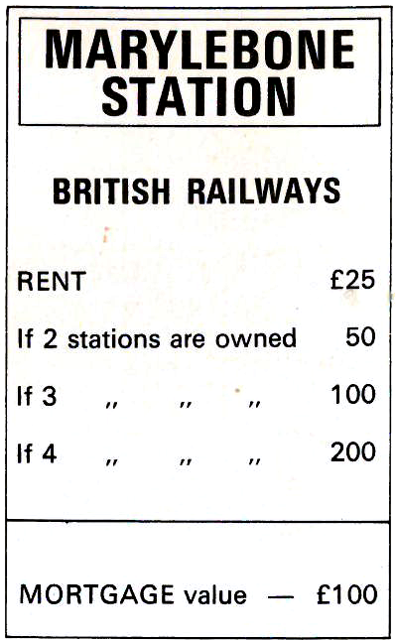 | 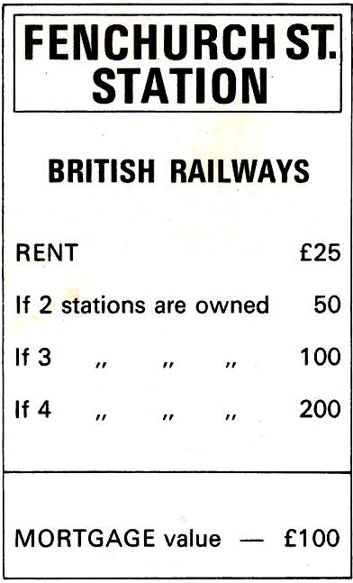  *This station is a part of Tower Hill and Tower Gateway Stations

Create a simple complete graph, as below, to show the shortest paths (by time including changes, as in exercise 2C) between the four stations on the standard London Monopoly¹⁰ board.
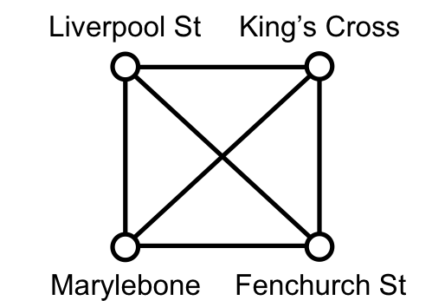

Task 5: Route Inspection

For your simple complete graph above, find the shortest journey that travels along all arcs and returns to your starting position (ie the Chinese Postman problem¹¹). You should use the summary of the route inspection technique below to help you.

Type of Graph | No. of Odd Nodes | Shortest Trail Distance
Eulerian / traversable | Connected graph with  all nodes of even order | Total of weights
Semi-Eulerian /  semi traversable | Connected graph with  exactly 2 nodes of odd order | Total weight + shortest path between odd nodes
Non-Eulerian /  cannot be traversed | Connected graph with  >2 nodes of odd order | Total weight + min total of shortest paths between pairs of odd nodes

Where, to find additional arc weights:

- Identify all nodes of odd order.
- Identify all possible permutations of pairs of odd nodes
- Find shortest paths between pairs of odd nodes and hence total shortest paths for each permutation of pairs.
- Choose permutation with minimum total additional weight.

- How does this task relate to the London Underground? Think about what person or profession may be required to perform such a journey.
- What may make this task further complicated in real life?
- Change the diagram and repeat this task to take this change in account.

Extension, Task 6: A twist on the Travelling Salesman Problem^{4, 5}

Without using the Circle line itself, find the shortest journey which visits all stations on the circle line and returns to your starting place.

On the next page… Task 7 and then 8, the Million Dollar Question
Extension, Task 7: University Interview Day

Find the shortest paths to each of the London Russell Group universities below from your ‘local’ (or nearest), London train station.

- Imperial College London
- King’s College London
- London School of Economics and Political Science
- Queen Mary University, London
- University College London

- How much time should you, sensibly, allow for each of these journeys?

Big Extension, Task 8: The $1million Question^{4, 5}

Devise an algorithm for finding the shortest journey that visits all stations on the London Underground and returns to your starting place. Be able to state, and support with reasons, why this is the shortest possible route. To generalise, be able to apply the same algorithm to any other network and always achieve the shortest possible route.

You may like to begin with a simplified version of this problem which ignores all stations beyond which there are no line changes possible, as per the network diagram below:

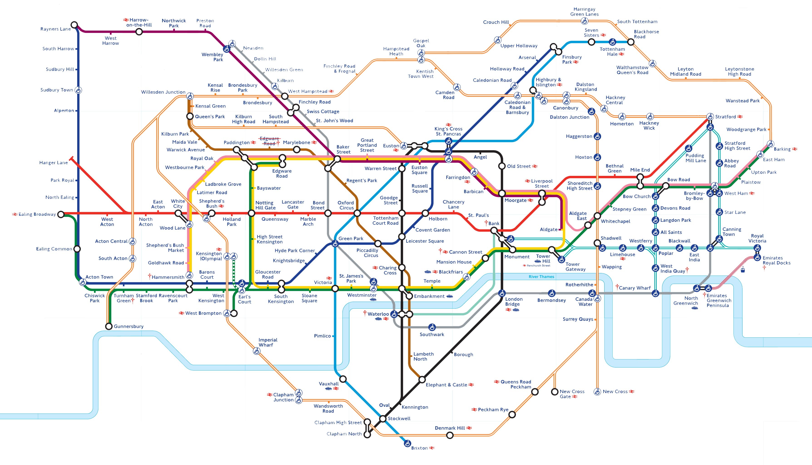

If you do manage to complete this question with a generalised method, please let us know (or at least tell someone else who is trustworthy). You may be eligible for a prize of $1million dollars from the Clay Maths Institute⁵, USA. There is a huge history behind this as yet unsolved mathematics problem, known as the ‘P vs NP Problem’^{6, 7}, and there are big consequences when, or if, it is solved. One of these will be for internet security as any solution to the P vs NP problem will imply that the RSA algorithm for internet security^{8, 9} can also be broken.

Key words

Algorithm
Arc = line
Chinese Postman,
Eulerian, semi-eulerian, traversable, semi-traversible, non-traversible,
Node = station
Permanent value / Temporary value
Route, Journey
Shortest Path
Simple graph, complete graph, simple complete graph
Traveling Salesman

Network Graphs – The London Underground

Learning Ladder and Feedback

Learning Phase | Success Criteria | Literacy | Assessment & Interventions
Mastered | I can record my methods consistently and efficiently to show how I use Dijkstra’s algorithm to find shortest journeys (or shortest paths) and shortest times between different pairs of stations on the London Underground.  I can record my methods consistently and efficiently to show how I can complete the route inspection problem to the shortest paths between the four stations on the standard London Monopoly board. | I can justify my choice of journey times and distances. I can explain how my method of recording steps through an algorithm is clear, precise and easy to follow.  I can relate a mathematical model to real life context and suggest improvements and/or extensions to a problem with clear and mathematically accurate reasoning.
Connecting | I can refine a mathematical model by altering parameters (such as adding 5 minute line-change times) and show how I have used Dijkstra’s algorithm to find shortest journeys (or shortest paths) and shortest times between different pairs of stations on the London Underground.  I can show how I can complete the route inspection problem to the shortest paths between the four stations on the standard London Monopoly board. | I can record my method for finding shortest journey accurately and consistently for others to follow.  I can create and use clear and accurate diagrams and graphs and relate my solutions to real life contexts.
Establishing | I can Use Dijkstra’s algorithm to find the shortest journeys (or shortest paths) and shortest times between different pairs of stations on the London Underground.  I can create a simple complete graph to show the shortest paths between the four stations on the standard London Monopoly board. | I can say which journey is best by finding the shortest time or the shortest distance over a route.  I can create clear and accurate diagrams and graphs.

Feedback Opportunities

Peer Assessment

Self Assessment

Teacher Assessment

Intervention Actions  1.  2.  3. | Attempted | Achieved

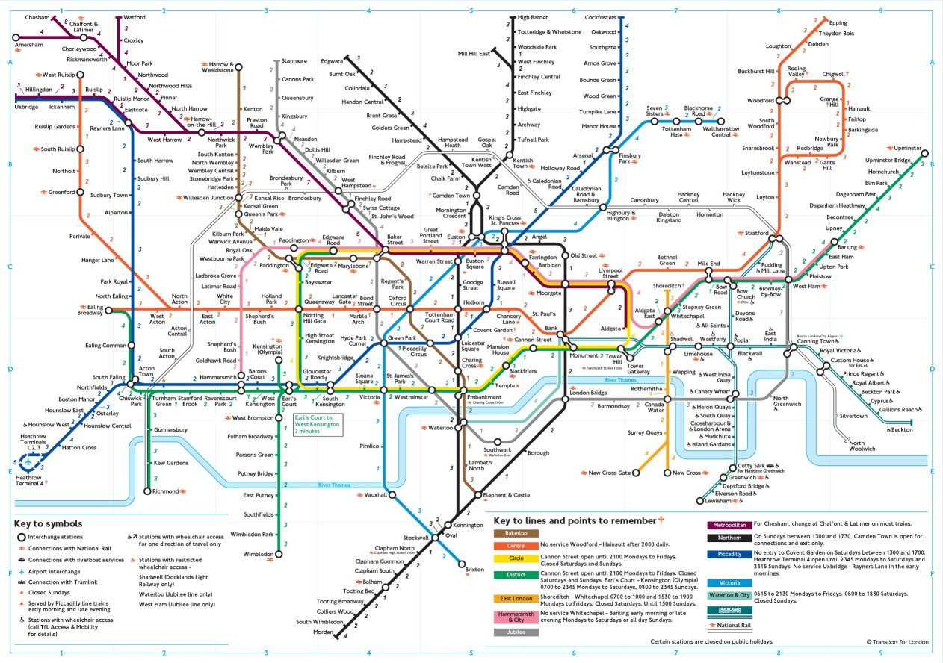
Links and References

¹http://www.tfl.gov.uk/corporate/modesoftransport/londonunderground/1608.aspx
²http://www.tfl.gov.uk/corporate/projectsandschemes/2443.aspx
³http://en.wikipedia.org/wiki/Edsger_W._Dijkstra
⁴http://www.tsp.gatech.edu//index.html
⁵http://www.claymath.org/millennium/P_vs_NP/
⁶http://en.wikipedia.org/wiki/P_versus_NP_problem, ⁷http://simple.wikipedia.org/wiki/P_versus_NP
⁸http://en.wikipedia.org/wiki/RSA_(algorithm)
⁹http://simple.wikipedia.org/wiki/RSA_(algorithm)
¹⁰http://en.wikipedia.org/wiki/Monopoly_(game)
¹¹http://en.wikipedia.org/wiki/Route_inspection_problem

Maps

http://www.tfl.gov.uk/gettingaround/14091.aspx (website)
http://www.tfl.gov.uk/gettingaround/1106.aspx (pdf)
http://www.steveprentice.net/tube/TfLSillyMaps (website)
http://www.steveprentice.net/tube/TfLSillyMaps/travel_times.jpg (jpg)
http://homepage.ntlworld.com/clivebillson/tube/tube.html (website, tube map history)
http://www.clarksbury.com/cdl/maps.html (website, tube map history)

Universities

Imperial College London
http://www3.imperial.ac.uk/theoreticalphysics/aboutus/gettinghere
King’s College London
http://www.kcl.ac.uk/medicine/research/divisions/diiid/centres/cmcbi/contact.aspx
London School of Economics and Political Science
http://www.lse.ac.uk/mapsAndDirections/howToGetToLSE.aspx
Queen Mary University, London
http://www.qmul.ac.uk/undergraduate/openday/gettinghere/
University College London
https://www.ucl.ac.uk/locations/public-transport/

Answers

Task 1A: Match the colours to the words.

Task 1B: Station notation.

Explain the difference and reasons behind the use of different symbols at different stations, such as those seen in the image below;

The left hand and right hand symbols denote a station where change of line is possible. The left hand symbol may suggest or imply a short (often subway) walk between platforms of the different lines.
The middle symbol denotes a station where there is no change of line possible.

Task 2A, 2B and 2C

 |  | 2A Stations | 2B Time | 2C Time + Changes
1 | Liverpool Street to Brixton | 6 | 16 (via Waterloo & City) | 29 (via Oxford Circus)
2 | Liverpool Street to Wembley Park | 9
3 | Liverpool Street to Westminster
4 | Waterloo to Wembley Park
5 | St Paul’s to Westminster
6 | Wembley Park to West Hampstead
7 | Blackfriars to Covent Garden
8 | South Kensington to Liverpool Street
9 | Kings Cross St Pancras to Finsbury park
10 | Mornington to Barbican
11 | Heathrow to Waterloo
12 | Heathrow to Kings Cross St Pancras
13 | Heathrow to Euston
14 | Heathrow to Victoria
15 | Heathrow to Liverpool Street

Task 3: Analysing routes and efficiencies further

- Name a pair of stations requiring a minimum of two line changes.
E.g. Seven Sisters (Victoria line) and Preston Road (Metropolitan line).
- Name a pair of stations requiring a minimum of three or more line changes.
- What are the criteria for finding a pair of stations in each of the questions above? Make suggestions and think carefully about your wording to ensure that no examples can be found to contradict them.
For a minimum of two changes; the stations must a) be on a pair of lines that never meet (or cross) and b) not share any other lines which meet or cross.
- What is the maximum number of changes that need to be made in order to travel from any point on the London Underground to any other point? Use your answer to give a reason on how efficient the London Underground is at enabling people to travel from any place in London to any other place quickly and easily.
Finding journeys requiring more than 2 line changes is quite challenging which suggests that London is very well connected. However, a journey made by minimising the number of lines changes may not always be the shortest path.
- What is the maximum shortest path possible on the London Underground that does not include any closed paths or repeated arcs?

Task 4: A Simple Complete Graph

Create a simple complete graph, as below, to show the shortest paths (by time including changes, as in exercise 2C) between the four stations on the standard London Monopoly board.

25
15
9
13
6
21

Task 5: Route Inspection

For your simple complete graph above, find the shortest journey that travels along all arcs and returns to your starting position (ie the Chinese Postman problem).

- How does this task relate to the London Underground?
Workers on the Tube, checking the lines for example.
- What may make this task further complicated in real life?
There are two sets of tracks on each line, going in opposite directions, like a pair of one-way streets. For workers checking the lines, they would therefore need to check both directions which would make their Chinese Postman problem more complicated.
- Change the diagram and repeat this task to take this change in account.

Extension, Task 6: A twist on the Travelling Salesman Problem^{4, 5}

Without using the Circle line itself, find the shortest journey which visits all stations on the circle line and returns to your starting place.

Extension, Task 7: University Interview Day⁶

Find the shortest paths to each of the London universities below from your ‘local’ (or nearest), London train station.

Answers will vary here depending on choice of local London train station. Tube stops for each university are;

- Imperial College London – South Kensington and Gloucester Road
- King’s College London – London Bridge
- London School of Economics and Political Science – Holborn
- Queen Mary University, London – Stepney Green and Mile End
- University College London – Gower Street, Euston Square, Warren Street, Euston, Russell Square

- How much time should you, sensibly, allow for each of these journeys?

Answers will vary here depending on choice of local London train station. Sensibly, add 30 minutes or double journey time allowed in previous exercise.

Big Extension, Task 8: The $1million Question^{4, 5}

Devise an algorithm for finding the shortest journey that visits all stations on the London Underground and returns to your starting place. Be able to state, and support with reasons, why this is the shortest possible route. To generalise, be able to apply the same algorithm to any other network and always achieve the shortest possible route.

You may like to begin with a simplified version of this problem which ignores all stations beyond which there are no line changes possible, as per the network diagram below:

