Vectors

Think of a vector like someone giving you directions (“go east for 2 miles”) or like a path.

They have a direction and a size.

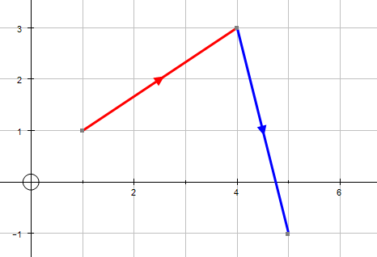
a
b
A
B
C
$$\vec{\text{AB}}$$
$$\vec{\text{BC}}$$

In the illustration above, the red vector (the one on the left) goes from A to B. We can call it a (or $\vec{\text{AB}}$) and the blue vector (the one on the right) we’ll call b (or $\vec{\text{BC}}$).

Vectors are usually written as ‘column vectors’. So:

a = $\left(\begin{matrix}3 \\ 2\end{matrix}\right)$ b = $\left(\begin{matrix}1 \\ −4\end{matrix}\right)$ In general $\left(\begin{matrix}x \\ y\end{matrix}\right)$

They can also be written in i, j, k notation. So:

a = 3i+2j b = i - 4j In general i + j

The vector a takes us on a path from the coordinates (1,1) to (4,3).

To go the opposite way, i.e. from (4, 3) to (1, 1) would be –a, (or $−\vec{\text{AB}}$) or $\left(\begin{matrix}−3 \\ −2\end{matrix}\right)$.

We can add vectors. Imagine following the vectors a and then b. We’d begin at (1,1) and end at (5,-1). This is a vector of:

$\left(\begin{matrix}5−1 \\ −1−1\end{matrix}\right)$ = $\left(\begin{matrix}4 \\ −2\end{matrix}\right)$
We get the same result by adding the vectors:

a+b (or $\vec{\text{AB}}$ + $\vec{\text{BC}}$) = $\left(\begin{matrix}3 \\ 2\end{matrix}\right)$ + $\left(\begin{matrix}1 \\ −4\end{matrix}\right)$ = $\vec{\text{AC}}$ = $\left(\begin{matrix}4 \\ −2\end{matrix}\right)$

The answer, $\vec{\text{AC}}$, $\left(\begin{matrix}4 \\ −2\end{matrix}\right)$, we call the ‘resultant vector’. It’s the result of doing a+b (or $\vec{\text{AB}}$ then $\vec{\text{BC}}$).

Furthermore, just like adding, it’s probably obvious that a+b = b+a. They both end up at the same point even though they took different routes there:

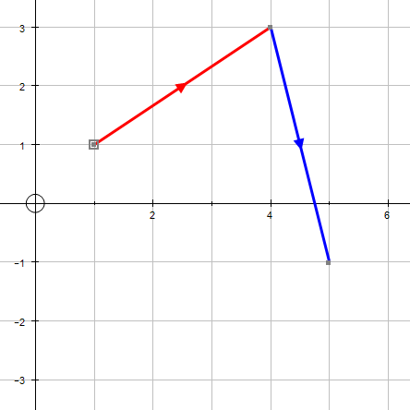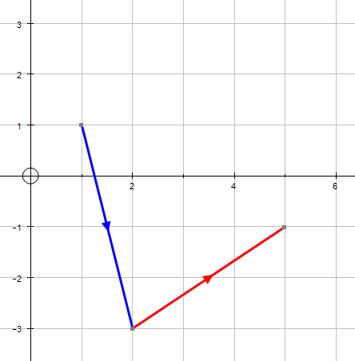
a
a
b
b

This is not so with subtracting, but you already know that. (e.g. 5 – 2 ≠ 2 – 5)

We can multiply a vector by a scalar:

2a (or 2$\vec{\text{AB}}$) = 2$\left(\begin{matrix}3 \\ 2\end{matrix}\right)$ = $\left(\begin{matrix}6 \\ 4\end{matrix}\right)$

Notice same direction, twice the size (hmm, size, see further down).

Obviously we can do combinations of these, such as:

3a – 2b (or 3$\vec{\text{AB}}$ - 2$\vec{\text{BC}}$) = 3$\left(\begin{matrix}3 \\ 2\end{matrix}\right)$ –2$\left(\begin{matrix}1 \\ −4\end{matrix}\right)$ = $\left(\begin{matrix}9 \\ 6\end{matrix}\right)$ – $\left(\begin{matrix}2 \\ −8\end{matrix}\right)$ = $\left(\begin{matrix}7 \\ \text{14}\end{matrix}\right)$

Continues…
Parallel Vectors

If two vectors are parallel then one is a multiple of the other. The following vectors are all parallel…

 |  | 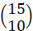 | 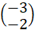 | 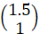

Magnitude of a Vector (i.e. Size of a Vector) For ‘magnitude’, read ‘size’.

If a vector was a path it may be nice to know how long the path is. Same with vectors, and using Pythagoras we can work this out. The size of a, called the ‘modulus’ of a, denoted by ⏐a⏐, is found by:

⏐a⏐ = ⏐$\vec{\text{AB}}$⏐ = $\sqrt{3^{2}+2^{2}}$= $\sqrt{\text{13}}$

Be careful, the size of a+b will be the size of ⏐(a+b)⏐, not ⏐a⏐+⏐b⏐. I.e.:

⏐(a+b)⏐ = $\left|\left(\begin{matrix}3 \\ 2\end{matrix}\right)+\left(\begin{matrix}1 \\ −4\end{matrix}\right)\right|$ = $\left|\left(\begin{matrix}4 \\ −2\end{matrix}\right)\right|$ = $\sqrt{4^{2}+−2^{2}}$ = $\sqrt{\text{20}}$ = $\sqrt{4}\sqrt{5}$ = $2\sqrt{5}$

*Using knowledge of surds.

The midpoint of a vector is halfway along it, i.e. half of it. E.g. the midpoint of a is:

$\frac{1}{2}$a = $\frac{1}{2}$$\vec{\text{AB}}$ = $\frac{1}{2}$$\left(\begin{matrix}3 \\ 2\end{matrix}\right)$ = $\left(\begin{matrix}1\text{.}5 \\ 1\end{matrix}\right)$

Using this idea we can find the midpoint of a+b, or $\vec{\text{AC}}$ (see how this is handy now?):

$\frac{1}{2}$a + $\frac{1}{2}$b = $\frac{1}{2}$$\left(\begin{matrix}3 \\ 2\end{matrix}\right)$ + $\frac{1}{2}$$\left(\begin{matrix}1 \\ −4\end{matrix}\right)$ = $\left(\begin{matrix}1\text{.}5 \\ 1\end{matrix}\right)$ + $\left(\begin{matrix}0\text{.}5 \\ −2\end{matrix}\right)$ = $\left(\begin{matrix}2 \\ −1\end{matrix}\right)$

Or using $\vec{\text{AC}}$:

$\frac{1}{2}$$\left(\begin{matrix}4 \\ −2\end{matrix}\right)$ = $\left(\begin{matrix}2 \\ −1\end{matrix}\right)$

In pictures:

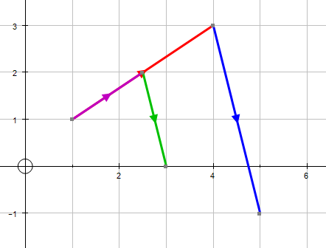
$\frac{1}{2}$a
$\frac{1}{2}$b
B
A
C

The purple vector is $\frac{1}{2}$a, the green vector is $\frac{1}{2}$b. The midpoint is $\left(\begin{matrix}2 \\ −1\end{matrix}\right)$ away from
A (and $\left(\begin{matrix}−2 \\ +1\end{matrix}\right)$ away from C, i.e. it’s in the middle!). Be careful though. You’ll see that (2 -1) does not represent the coordinates of the midpoint of $\vec{\text{AC}}$. To find the coordinates of the midpoint of$\vec{\text{AC}}$we need to add $\frac{1}{2}$a + $\frac{1}{2}$b onto OA:

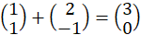

Reducing to vectors in terms of a and b.

If we consider vectors as paths, labelled as a, b etc, and we do calculations in terms of a and b then we don’t actually need the coordinate grid.

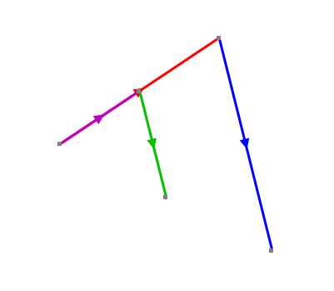
A
$\frac{1}{2}$a
$\frac{1}{2}$b
C
B

The illustration above shows the midpoint of $\vec{\text{AC}}$as in the previous example but without the grid. We can show that this is the midpoint by the calculation:

$\frac{1}{2}$$\vec{\text{AB}}$ + $\frac{1}{2}$$\vec{\text{BC}}$ = $\frac{1}{2}$$\vec{\text{AC}}$

A new dimension. We can extend our learning of vectors to include 3 dimensional vectors, such as:

p = $\left(\begin{matrix}4 \\ −4 \\ 3\end{matrix}\right)$ q = $\left(\begin{matrix}2 \\ 3 \\ 4\end{matrix}\right)$ In general $\left(\begin{matrix}x \\ y \\ z\end{matrix}\right)$ or i + j + k

We can add, subtract, multiply, find the midpoint etc of these vectors just as we did with the 2D ones.

p+q = $\left(\begin{matrix}4 \\ −4 \\ 3\end{matrix}\right)$ + $\left(\begin{matrix}2 \\ 3 \\ 4\end{matrix}\right)$ = $\left(\begin{matrix}6 \\ −1 \\ 7\end{matrix}\right)$

3p – 2q = 3$\left(\begin{matrix}4 \\ −4 \\ 3\end{matrix}\right)$ – 2$\left(\begin{matrix}2 \\ 3 \\ 4\end{matrix}\right)$ = $\left(\begin{matrix}\text{12} \\ −\text{12} \\ 9\end{matrix}\right)$ – $\left(\begin{matrix}4 \\ 6 \\ 8\end{matrix}\right)$ = $\left(\begin{matrix}8 \\ −\text{18} \\ \text{17}\end{matrix}\right)$

Midpoint of p+q = $\frac{1}{2}$(p+q) = $\frac{1}{2}$$\left(\begin{matrix}6 \\ −1 \\ 7\end{matrix}\right)$ = $\left(\begin{matrix}3 \\ −0\text{.}5 \\ 3\text{.}5\end{matrix}\right)$

3D vectors are helpful because they still operate in the same way as 2D vectors whilst illustrations of them become difficult to understand. The 3 images below show the same vectors, p and q, from different points of view:

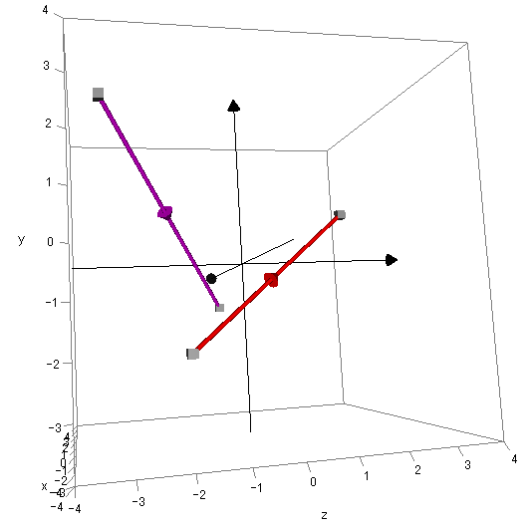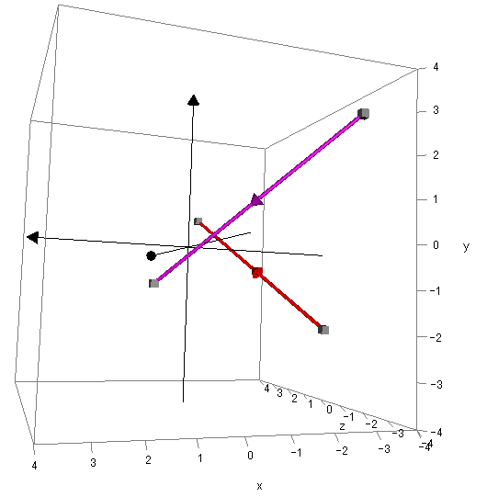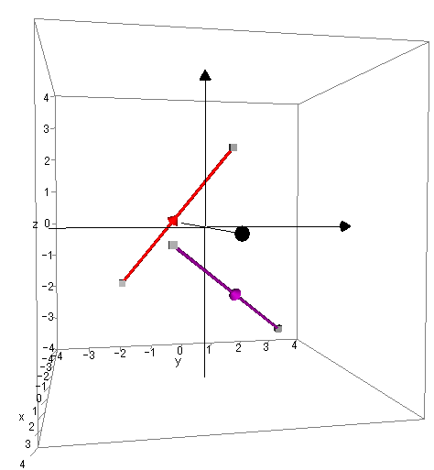
q
q
q
p
p
p

2D representations of 3D concepts do not work well!

Graphing software, such as Autograph (used here), illustrate 3D vectors well as the POV can be moved, rotated and zoomed to provide a better idea of what’s happening. They can also be fun to play with, although not so much as a Nintendo Wii! (Hmm, computer games, very much based on vectors themselves).

That’s it, for GCSE, hurrah!

Or for A level see the next page…

The Unit Vector

The unit vector is the vector in a particular direction and of just one-unit in length. To find this, we take our original vector values and divide by the size of the vector.

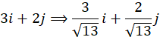

Angle between a vector and the positive x-axis

To find the angle between a vector and the x-axis, we consider the vector as a triangle

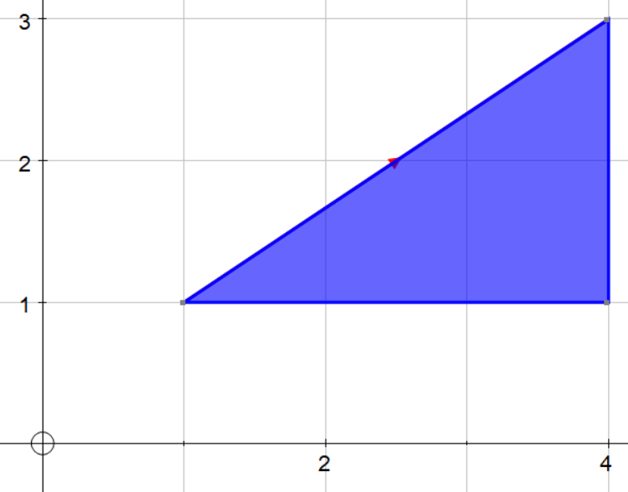

Where…
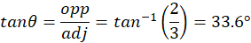

Magnitude-Direction Form (aka Polar Form)

Angles measured anti-clockwise from +ve x-axis.

Component Form | Magnitude-Direction Form
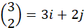 | 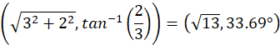

For notes on extension material see http://www.colmanweb.co.uk/Assets/Resources/VectorScalarProducts.doc

